# Approving Purchase Orders

Contents

Approving Purchase Orders 1

General information 3

Approval notifications 3

Approving in Banner 3

Forms Table 8

Approving in Knightline (Self-Service Banner) 9

Terminology 12

## General information

When a buyer completes a PO or change order the document is forwarded to Banner’s approval queues. The approval queues contain the structure for routing PO’s and change orders to appropriate approvers based on the PO’s dollar amounts and organization codes. A PO or change order may require multiple approvals and will not print or encumber until all necessary approvals are complete.

There are two distinct ways to view Banner data; Internet Native Banner (INB) or Self Service Banner (SSB). At SNC, Internet Native Banner is generally called Banner and Self Service Banner is called Knightline. Approvals can be made through Banner or Knightline.



## Approval notifications

To ensure that PO’s are not held up in the approvals process, it is important that all approvers understand the necessity of reviewing PO’s awaiting approval in a regular and timely manner. Unfortunately, baseline Banner has no automatic notification process. To assist with notifications a custom script will run daily and email a notification to each approver when something is pending approval.

## Approving in Banner

When you first logon to Banner the Approvals Notification Form (FOIAINP) will display automatically when you access any other Banner form if you have PO’s waiting for approval. An approver may also go directly to the User Approval Form (FOAUAPP) to view any documents awaiting their approval.

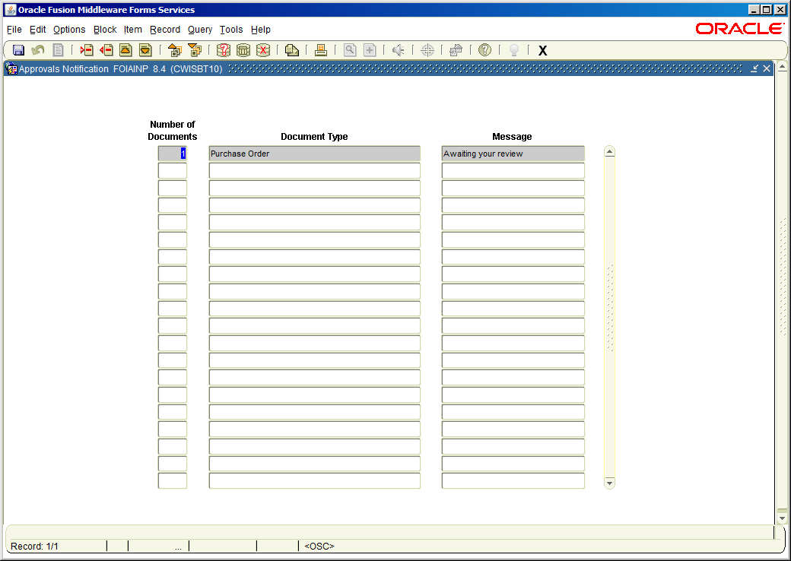

From the Approvals Notification Form click **User Approval** from the **Options** menu to access the User Approval Form (FOAUAPP). Perform a **Next Block** function to access documents awaiting your approval.

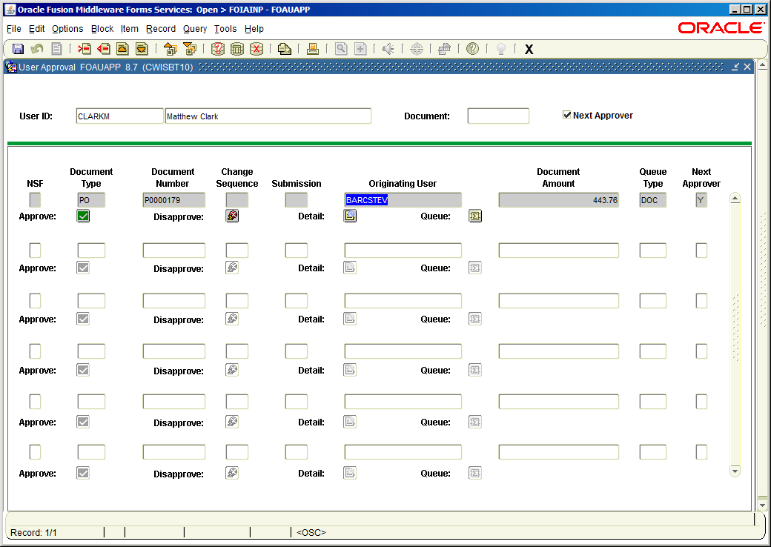

By default, the form displays PO’s for which you are the next approver, this is the recommended setting. If you uncheck the **Next Approver** box you can view all PO’s you may approve including those where a lower level approval has not yet been completed. A higher level approver can bypass a lower level approver by approving first.

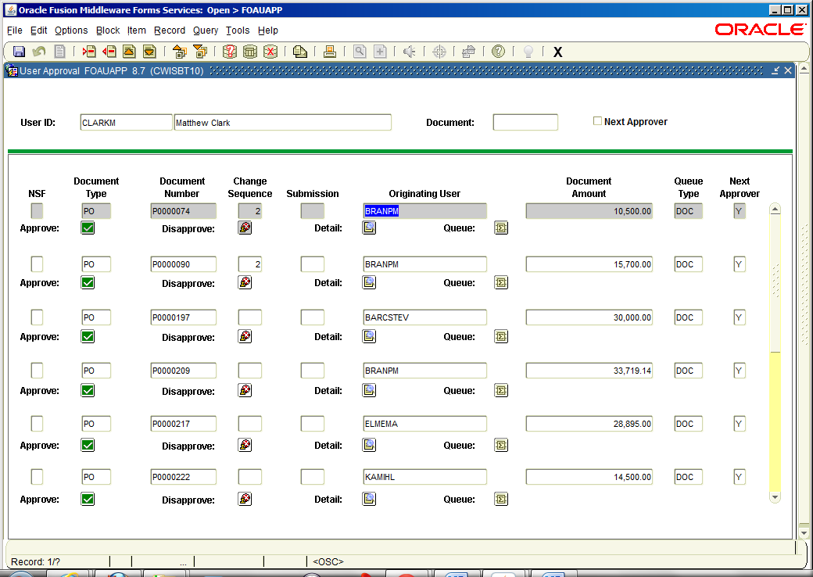

The Next Approver box is checked by default. This is the recommended setting. Uncheck to view all PO’s you may approve including those where a lower level approval has not yet been completed.

The User Approval Form enables approving or disapproving a PO, viewing PO details and viewing all of the queues/levels responsible for approving the PO.

It is strongly recommended that approvers click on the **Detail** button to review each PO’s item and accounting information before taking any action.



Click the Detail icon for PO information

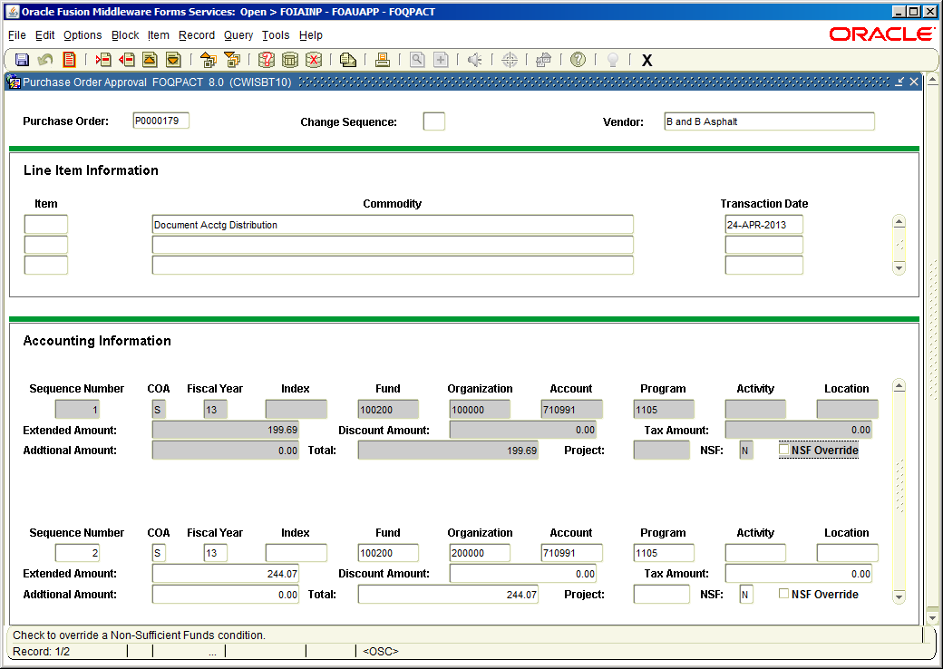

PO Details

The vendor, item descriptions, accounting and amounts should be reviewed. Exit the form to get back to the User Approval Form.



Click the Details icon to review PO details

Click the Disapprove icon to disapprove a PO

Click the Queue icon to view remaining approvals

Click the Approve icon to approve a PO

To approve a PO click the Approve icon. The PO will proceed to the next approver in the queue or if all approvals are complete will be posted. Posting is set up to occur every 90 seconds and will create the encumbrance record in the accounting system as well as allow the PO to print.

To disapprove a PO click the Disapprove icon. A pop up window will appear with a message stating that the PO is disapproved. It is good form to type an explanatory message as to why the PO was not approved. The message will be forwarded to the PO originator and any previous approvers using the Banner mail function. When a PO is disapproved it becomes incomplete. The originator or approver may then access the document to make changes or delete it entirely. Since most Banner users don’t use or are unaware of the Banner mail function it is highly recommended that anyone disapproving a PO contact the originator to inform them of the situation.

To view remaining approvals for a PO click the **Queue** icon which displays the Document Approval Form (FOAAINP). A PO can also be approved from this form.

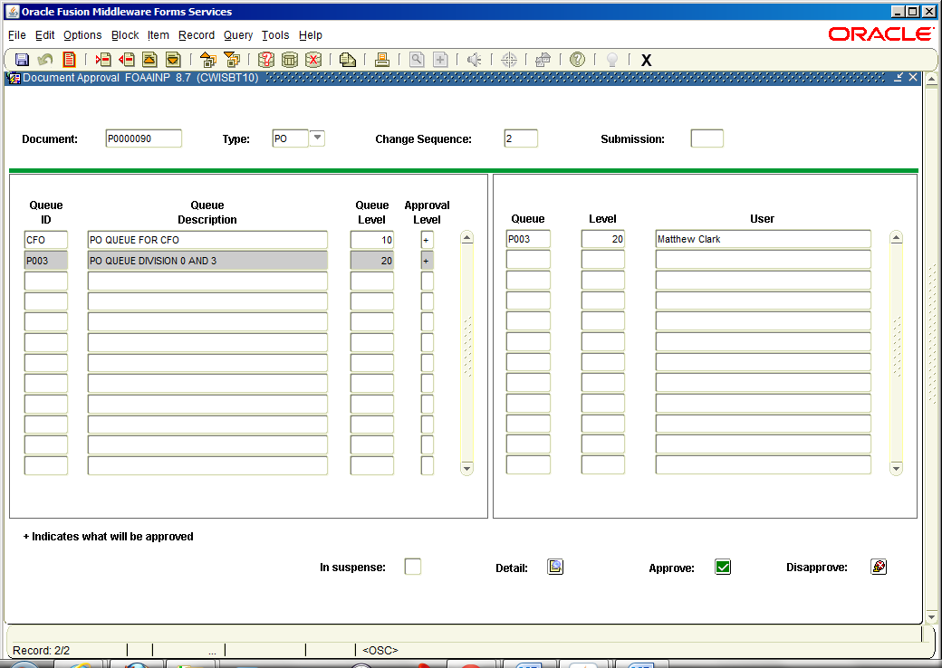

### Forms Table

|  |  |  |
| --- | --- | --- |
| **Form** | **Full Name** | **Use this form to . . .** |
| FOAUAPP | User Approval Form | approve a document or navigate to summary information of a PO for review and subsequent approval. |
| FOAAINP | Document Approval Form | display all the queues/levels responsible for the approval of a specified PO. |
| FOIAINP | Approvals Notification Form | display all documents that await your approval. |
| FOIAPPH | Document Approval History Form | view the approval history for a specified PO. |
| FOIAPHT | Approval History Form | view documents sorted by Document Code. A document that has been denied appears with a queue ID of DENY. |

## Approving in Knightline (Self-Service Banner)

Logon to Knightline and click the **Finance** link then click **Approve Documents**.

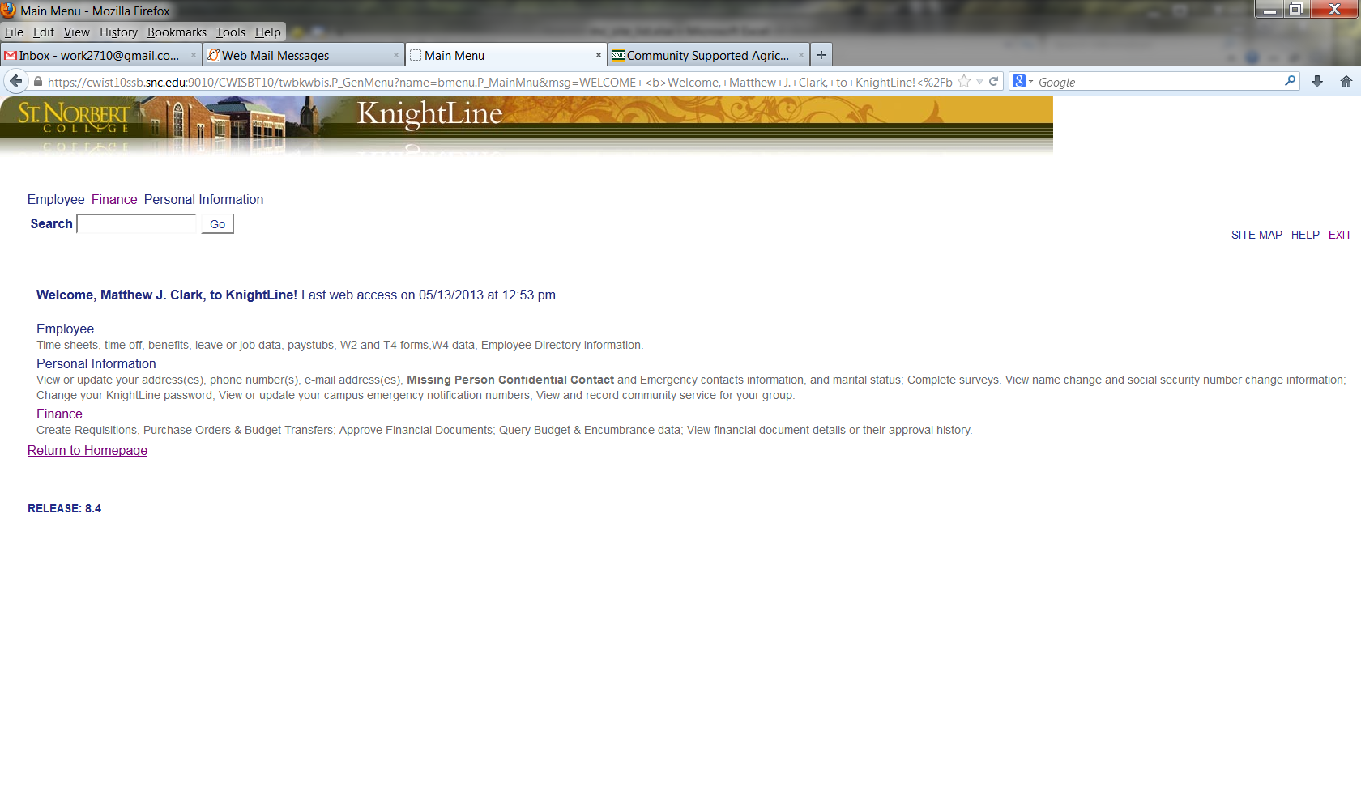

Click the Finance link

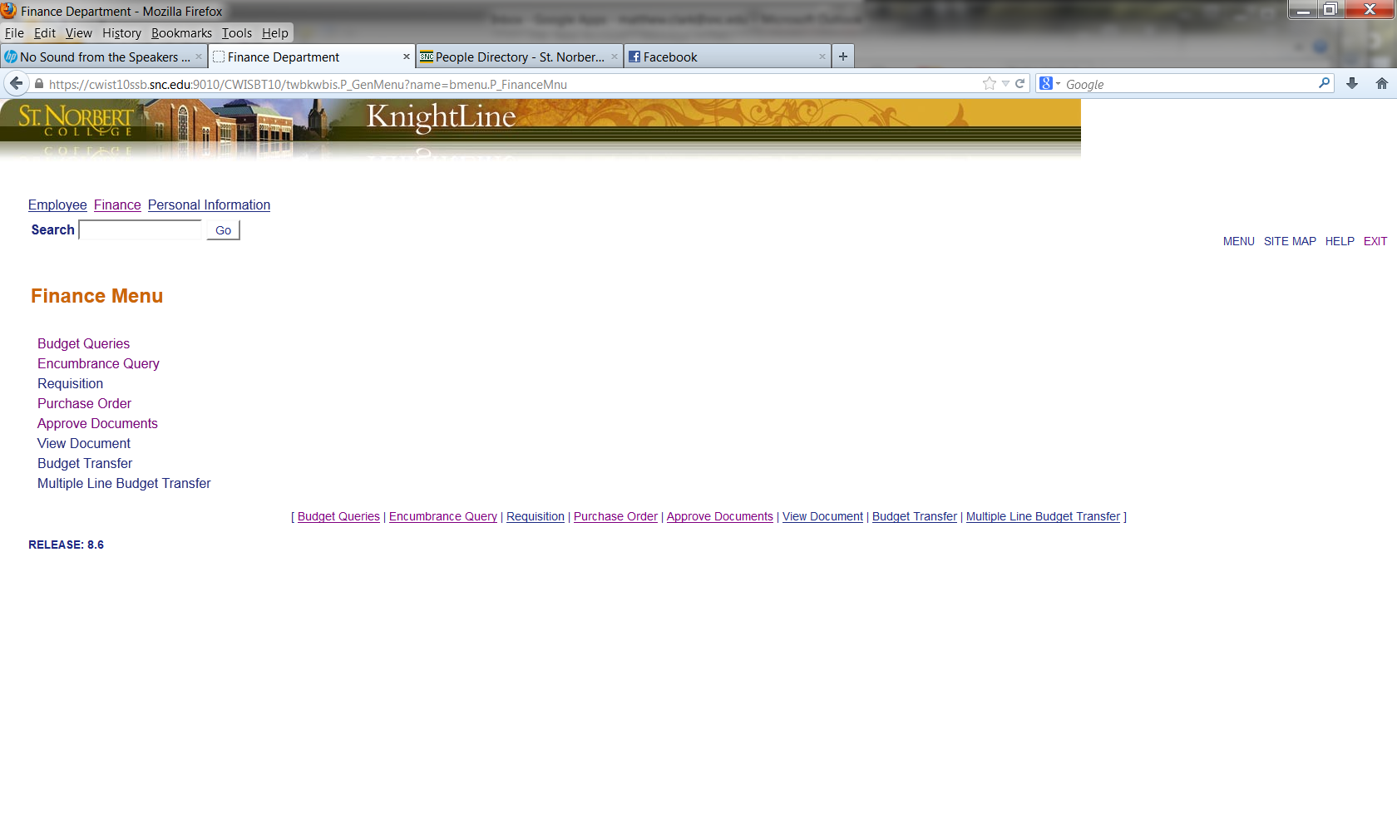

Click Approve Documents

Enter approval parameters.

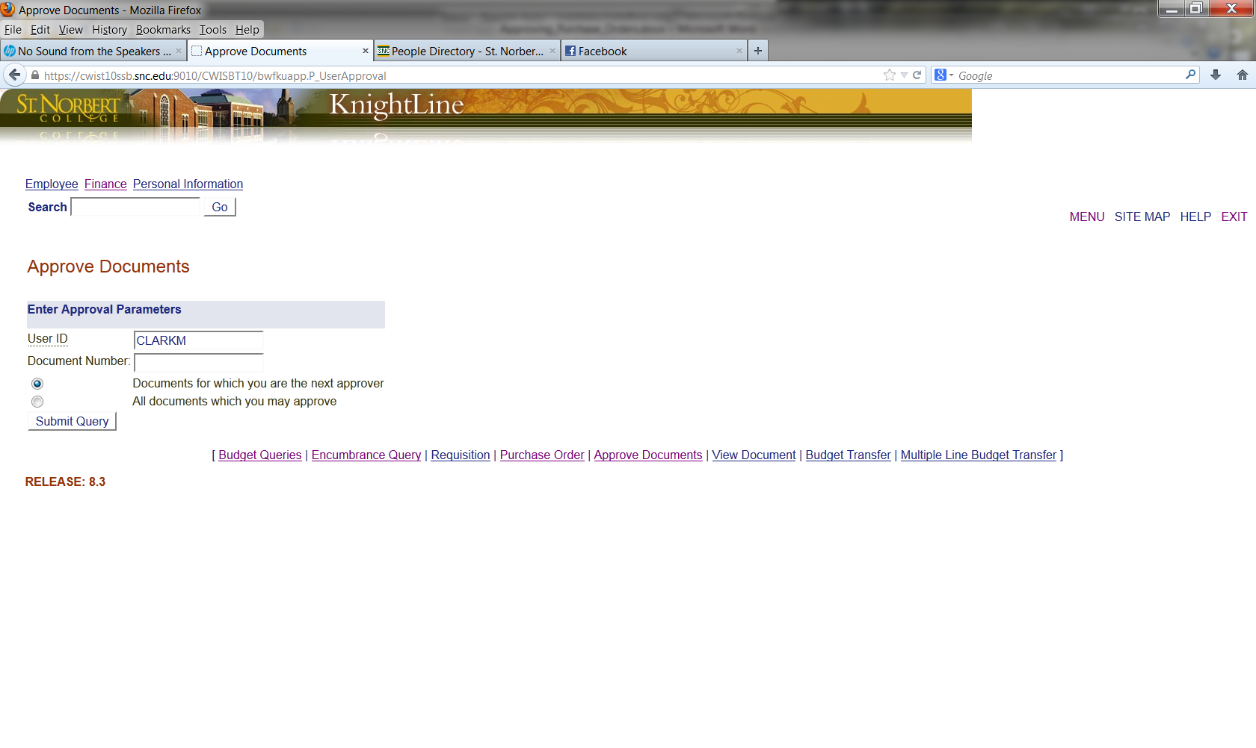

The **Document Number** field is blank by default. If you want to access a specific PO number, you may enter it here; otherwise leave this field blank.

There are two radio buttons below the **Document Number** field. These are labeled:

**Documents for which you are the next approver** (recommended) – The default selection, this option will list all documents for which you are the next approver, including documents that have been approved by any approvers that gave approval before the document was submitted to your approval queue.

**All documents which you may approve** – This option will list all documents for which you are an approver, including those that are awaiting approval from lower level approvers. A higher level approver can bypass a lower level approver by approving first.

Click the **Submit Query** button to view documents pending approval.

Similar to Banner you are able to approve or disapprove a PO, view PO details and view all of the queues/levels responsible for approving the PO.

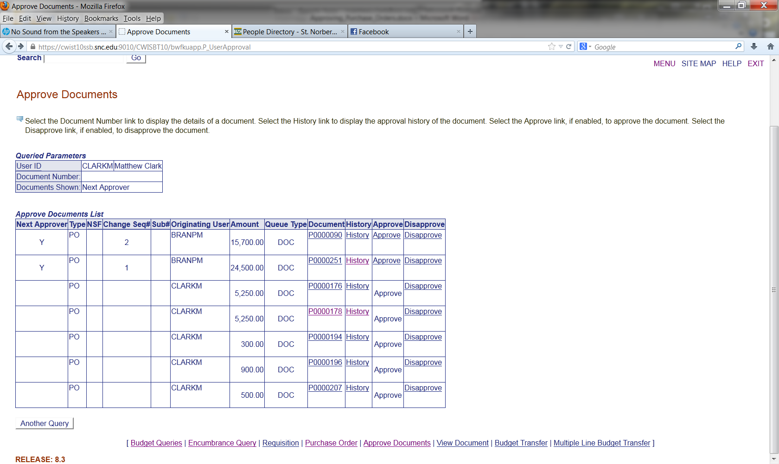

Select the **Document Number** link to display the details of a document. Select the **History** link to display the approval history of the document. Select the **Approve** link, if enabled, to approve the document. Select the **Disapprove** link, if enabled, to disapprove the document.

It is highly recommended that PO details be reviewed prior to approving. Also, it is a good practice to include explanatory text in the box provided for any disapproved PO’s. There is no automatic notification to the PO originator when a PO is disapproved. If you disapprove a PO, please contact the originator with an explanation and further instructions.

## Terminology

**Buyer**: An individual generating a purchase order in the Banner system.

**Commodity**: The good or service that is being purchased. In Banner, commodities can be either user-defined, or the NIGP (National Institute of Governmental Purchasing) code may be used.

**Commodity level accounting**: A way of processing purchase orders in which each “line” (commodity) of the PO will have its own accounting distribution.

**Document level accounting**: A way of processing purchase orders in which the accounting distribution entered on the purchase order applies to the whole purchase order.

**Encumbrance**: An encumbrance is a commitment of budget relating to a specific purchase order. The encumbrance is established when a purchase order is approved. The encumbrance is reduced or eliminated when an invoice is paid against the purchase order or when the encumbrance is cancelled.

**Purchase order**: A commercial document used to request a vendor to supply a good or service in return for payment. Banner has three types of purchase orders:

* **Regular Purchase Order** – Will encumber funds in Banner. All commodities have quantity and unit price.
* **Standing Purchase Order** – Will encumber funds in Banner. Commodities have dollar value assigned to them. This type of PO is useful when you are paying for contracts, services or travel.
* **Blanket Purchase Order** – Does not encumber funds in Banner. Commodities will be assigned quantity and unit prices to them.

**Vendor**: A person or company selling goods or providing services. Typically, Banner Finance requires a vendor record for anyone to whom a payment is made.