SNC-Logo-blackStudent Credit Refund ACH Authorization Form

(Authorizing Automated Clearing House (ACH) electronic direct deposit of student account refunds)

**Please Print** – All fields are required

|  |  |  |  |
| --- | --- | --- | --- |
| Student Name: |  | SNC ID #: |  |

|  |  |  |
| --- | --- | --- |
| Financial Institution name: |  | |
| Financial Institution phone #: |  | |
| Account Type (check one)    **REQUIRED**: **If Checking is selected attach voided check, if Savings is selected attach deposit slip** | | Nine digit routing transit #: |
| Account #: |

I authorize St. Norbert College to initiate entries to my account at the financial institution listed above for the purpose of student account refunds and, if necessary, adjustments for any entries made in error. I have verified the account number and bank routing/transit number listed on this page with my financial institution. This authorization will remain valid until the Bursar Office receives written notification of termination.

|  |  |  |  |
| --- | --- | --- | --- |
| Student signature: |  | Date: |  |

**Return completed form to the Bursar Office, Todd Wehr Hall 128. Incomplete documents will be returned for completion. Refunds by Direct Deposit will not begin until a complete and valid form is received.**

**REQUIRED: ATTACH VOIDED CHECK OR SAVINGS DEPOSIT SLIP (Sample).**

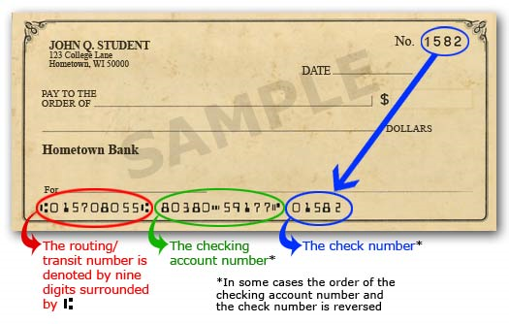

Office Use Only

GOAEMAL __________

GXADIRD __________