Business Objects Overview

Business Objects is a reporting tool that allows end-users to run reports created internally using data linked to the college’s Banner database.

Business Objects can be accessed from https://cwispboweb10.snc.edu/BOE/BI

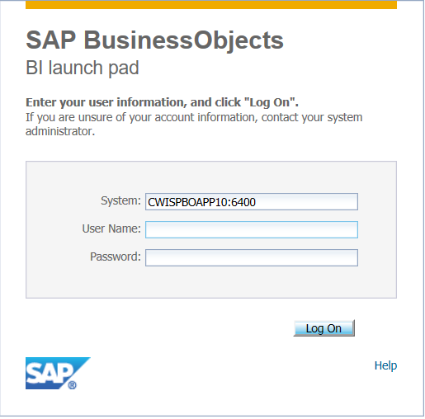
Log in with network username and password

The Home tab (upper left) is the default view.

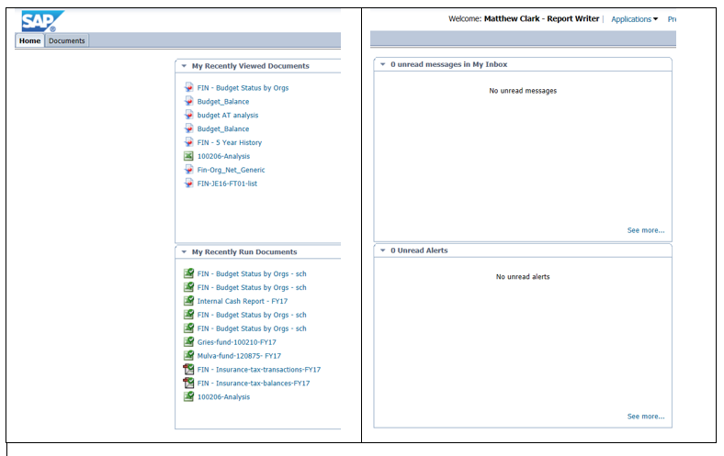

Select the Documents tab to be able to view a directory structure and access specific reports:

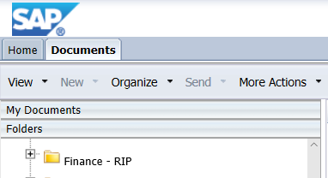

Reports are contained in a directory structure similar to Windows Explorer. Finance reports are located in the following path: Public Folders > Finance Public > General Reports

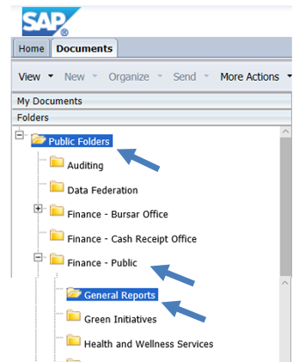 | 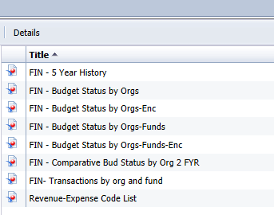  Available reports

To run a report, double click its title in the right pane. If query input data is required a “Prompts” window will display. Enter any required information in the “Prompts” window. When all prompt information is selected click “OK”.

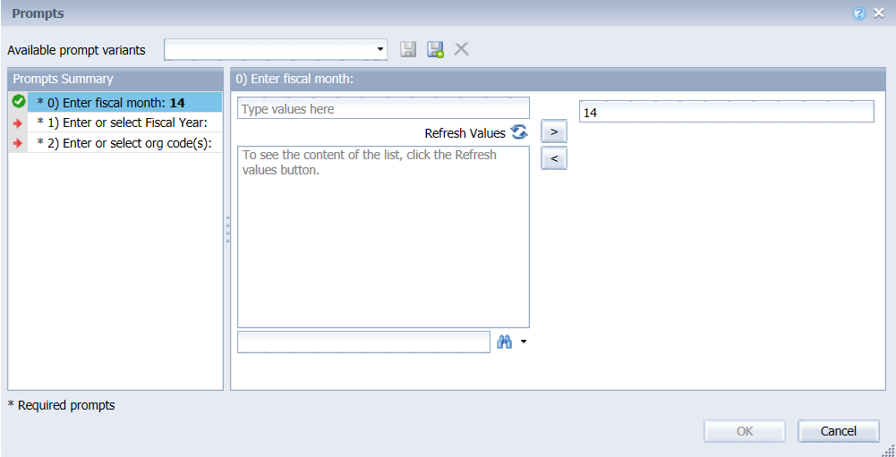
This example shows the prompt window for the report named FIN – Budget Status by Orgs.

After clicking OK from the Prompts window, report data will display in the main display panel. Data can be exported to Excel or Adobe (pdf).

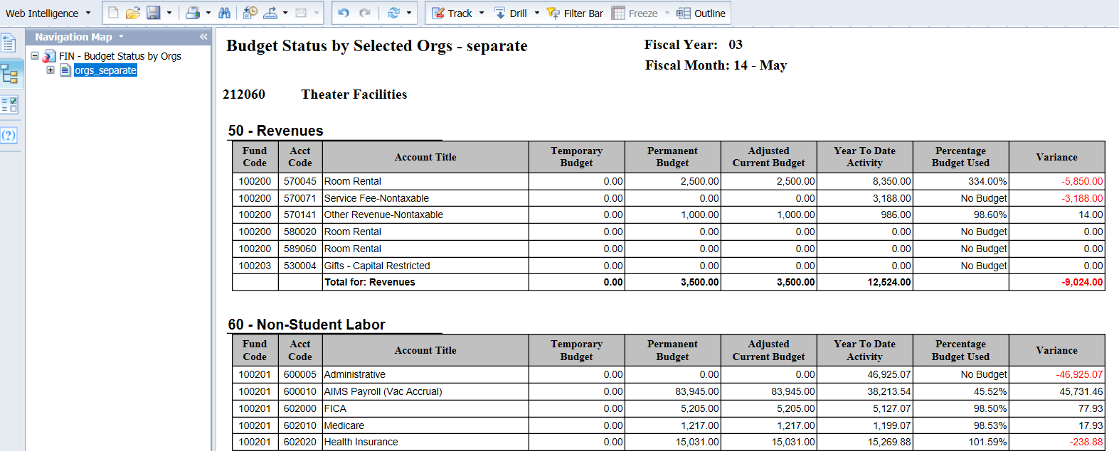

To export report data to Excel, click the down arrow to the left of the Export icon, then choose Export Document As and Excel (.xlsx).

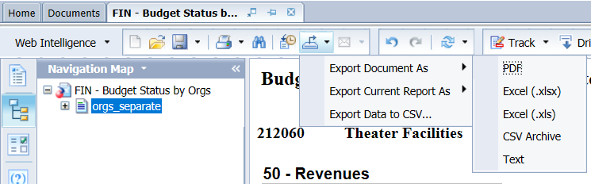

The report will display within Excel. No formulas are created when data is exported to Excel.

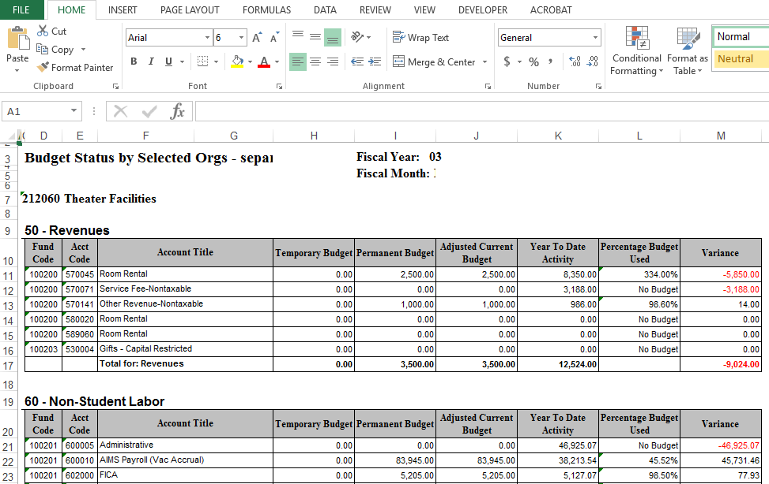

To exit the report in Business Objects, click 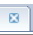 in the right corner of the report tab:

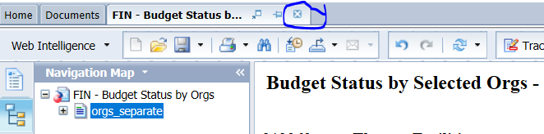

To exit Business Objects, click “Log off” in the upper right section of the window.

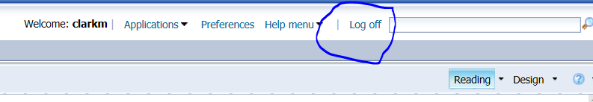

Scheduling Reports

Business Objects includes a feature that allows reports to be scheduled at future specified times and emailed to selected recipients.

The scheduling window has eight sections:

- Instance Title
- Recurrence
- Prompts
- Formats
- Caching
- Events
- Scheduling Server Group
- Destinations

For financial reports, only the following five are used. The others can be left to default values.

- Instance Title
- Recurrence
- Prompts
- Formats
- Destinations

For example, to schedule a report named FIN- Budget Status by Orgs, start by selecting the report by clicking its title (don’t double click) then choose “Schedule” from the More Actions drop down list on the menu bar. The Schedule pane will then display the eight scheduling sections.

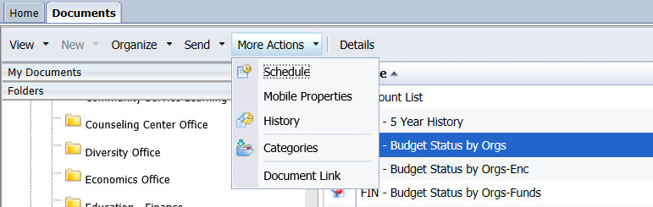
Select a report by clicking its title

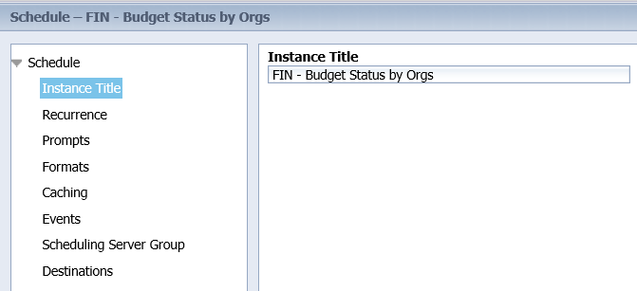
Scheduling sections

The first section is Instance Title which can be left to the default value of the report name or changed to something else. The Instance Title is a name for the schedule. The next section is Recurrence which has choices for when and/or how often to run the report. For this example the choice will be 5th day of the month. Many other choices are available. Start and End time of day and dates will also need to be completed.

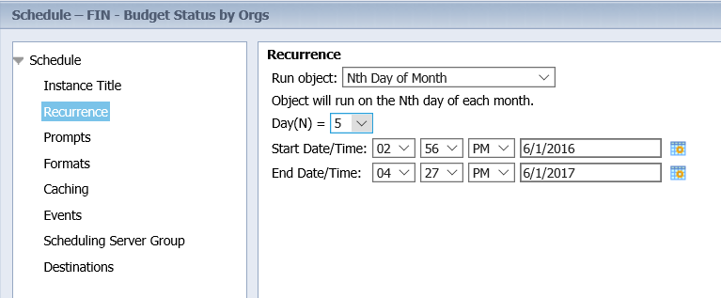

Click the “Prompts” scheduling item to select any necessary parameters.

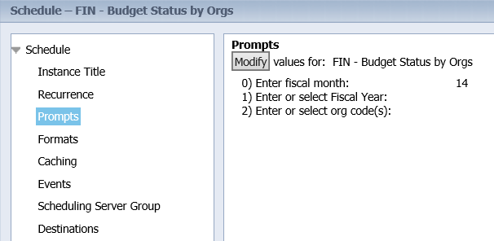

Click the “Modify” button to view the “Prompts” window. Make necessary prompt choices and click “Apply”.

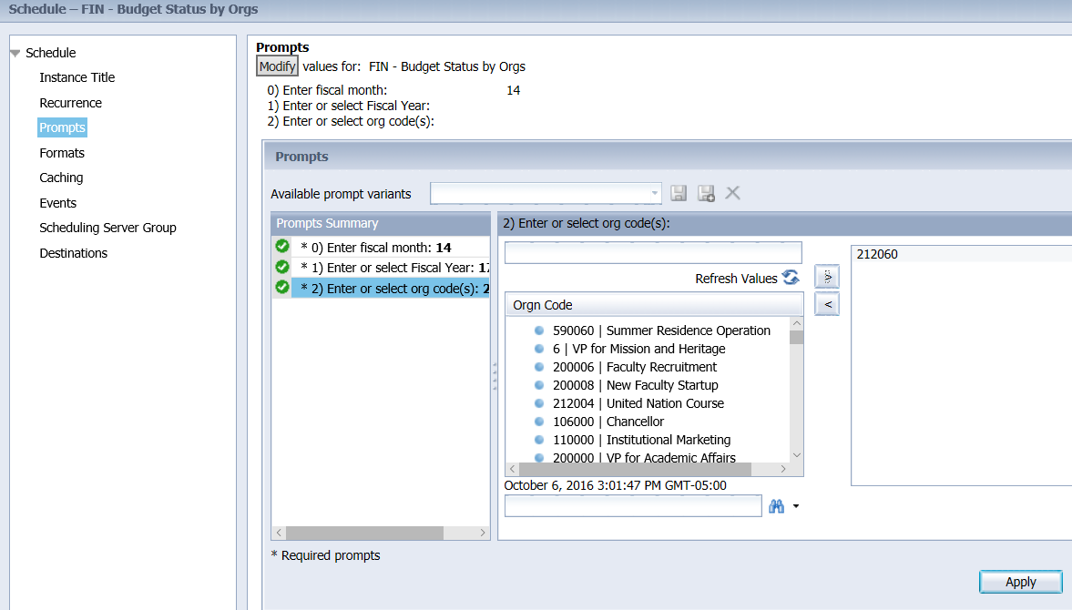

Next click the “Formats” section to choose the report output format. The default value is Web Intelligence. Always change to Microsoft Excel or Adobe Acrobat.
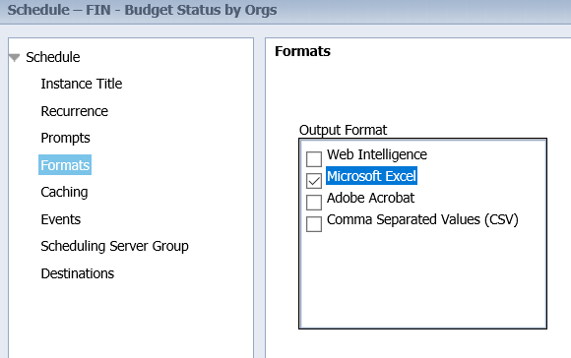

The last section is “Destinations”. The default selection is Default Enterprise Location. Change to Email.

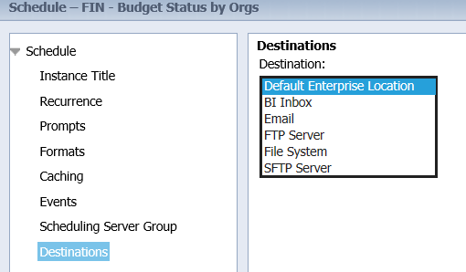

A window will then display for inputting email data. Each option in the email window is addressed in the table below:

Input Field | Type | Value
Keep an instance in the history | checkbox | Recommend not checking this box. Checking will retain a copy of report output within Business Objects but this shouldn’t be needed since copies are emailed and can be retained within the email.
Use default settings | checkbox | Leave unchecked
From: | text box | This field is optional. If an email address is input here it will be displayed as the “from” email address when the email is received by the recipient.
To: | text box | Input one or more valid email addresses separated by commas
CC: | text box | If desired, input one or more valid email addresses separated by commas. This field is optional.
Subject: | text box | Enter a subject line for the email OR click the arrow to the right of “Add Placeholder” and select a subject. A combination of both entered and selected subject text may be used.
Message: | text box | Enter a message for the email OR click the arrow to the right of “Add Placeholder” and select a message. A combination of both entered and selected message text may be used.
Add attachment | checkbox | Must be checked
File Name: | option button | Recommend leaving the default selection of “Use Automatically Generated Name”.
Add File Extension | checkbox | Must be checked
Enable SSL | checkbox | Leave unchecked

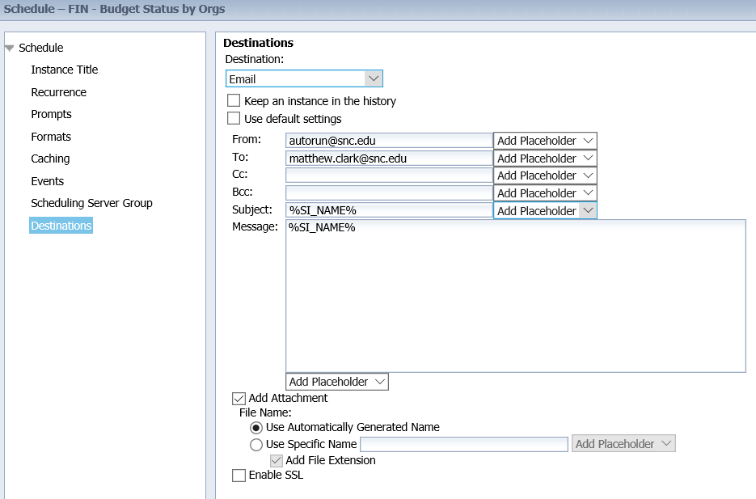

To complete the schedule, click the “Schedule” button in the lower right of the window. The report should then run at the scheduled date(s)/time(s) and be emailed according to the user-selected setup configuration.

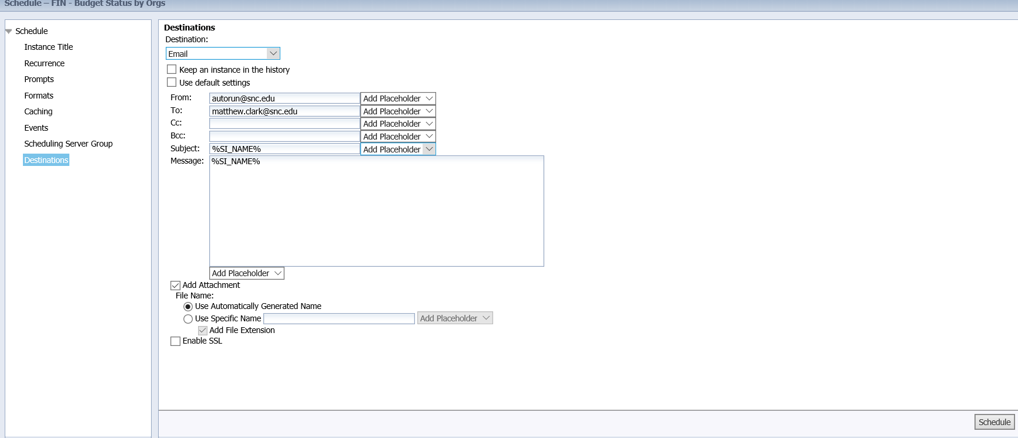

A history panel will display when the schedule is complete with a row representing the schedule. To exit the history panel, click the “X” in the upper right corner of the panel.

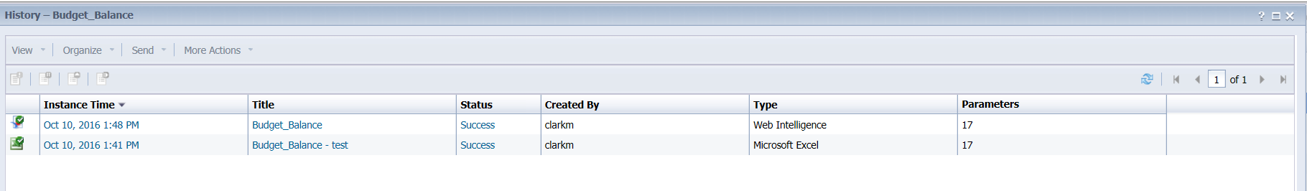

To create a new schedule from an existing one or to replace a schedule; select a report and click “History” from the “More Actions” menu drop down. A list of saved output will display and if a schedule instance is active it will be listed with a status of “recurring”. Schedules that are complete are no longer available. Select the recurring instance row then select “Reschedule” from the “More Actions” menu drop down. Select the Replace section and choose from the following options:

- Replace existing schedule
- Create new schedule from existing schedule

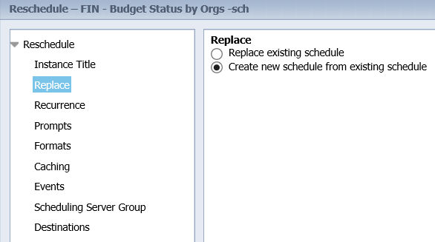

Complete remaining scheduling sections.

Deleting a Report Schedule

To delete a schedule start by selecting the report that is the subject of the schedule. For example, to delete a schedule for the report named FIN- Transactions by org and fund, select the report by clicking its title (don’t double click) then choose “History” from the “More Actions” menu drop down. A list of saved output will display along with any active schedules. Schedules are identified with a status of “recurring”.

Multiple users may have created schedules for the same report. Each user’s schedules are identified by the specific username in the “Created By” column.

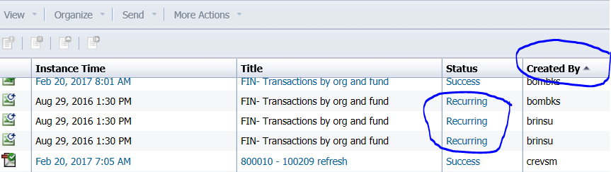

Users may only delete their own schedules. To delete a schedule, select the schedule title (single click) then click “Delete” from the “Organize” menu drop down.
