Payment Elections
Overview
This job aid will show the process for adding/updating your payment elections. If you want your direct deposit into multiple accounts, you must ADD all accounts first, then you can distribute amongst the accounts by amount or percentage.

Initiate Add Payment Elections
Security Role(s): Employee as Self

- From the Workday Landing Page, select View All Apps.

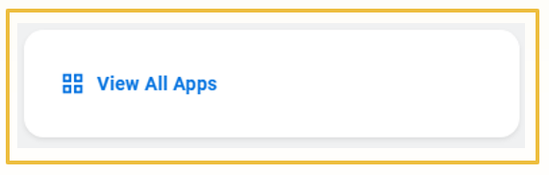
- Select the Pay application.

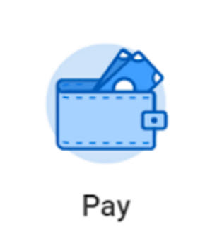

- Under the Actions section of the Pay application, select Payment Elections.

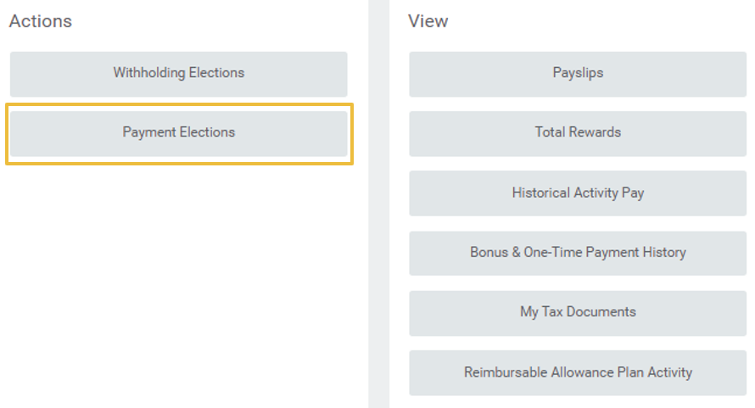

- Below the Accounts grid, select Add.

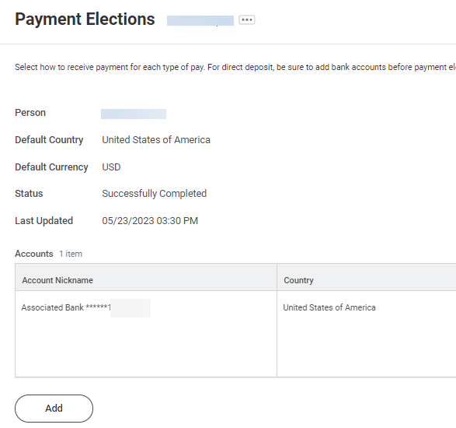

- In the Add Account page, scroll down to the Account Information section and enter your account information including your Routing Transit Number, Account Type, and Account Number. Select OK.
Note: fields marked by a red asterisk are required.

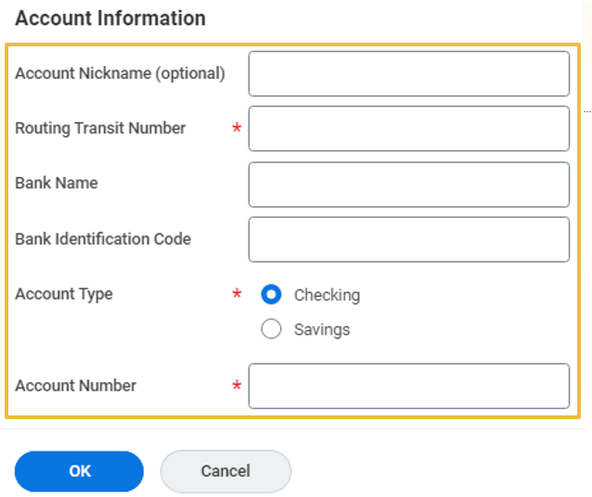

- Once you are back on the Payment Elections page, to add more bank accounts, select Add and repeat steps 4 and 5 until you have added all of your desired accounts.

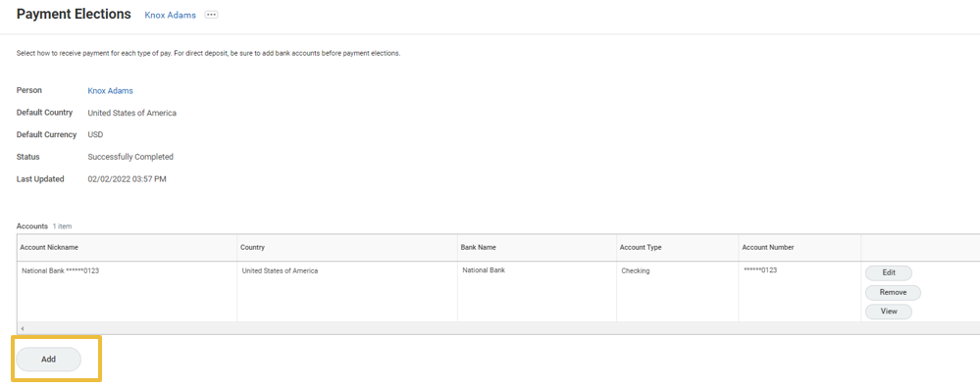

- In the Payment Elections grid, you will notice rows for two different Pay Types:
  - SNC Staff and Faculty is the payment election for your Payroll payments.
  - Expense Payment Election Rule is the payment election for any reimbursement payment you receive as a result of an approved Expense Report in Workday.

- Select Edit to modify how your payment election is distributed amongst your various accounts.

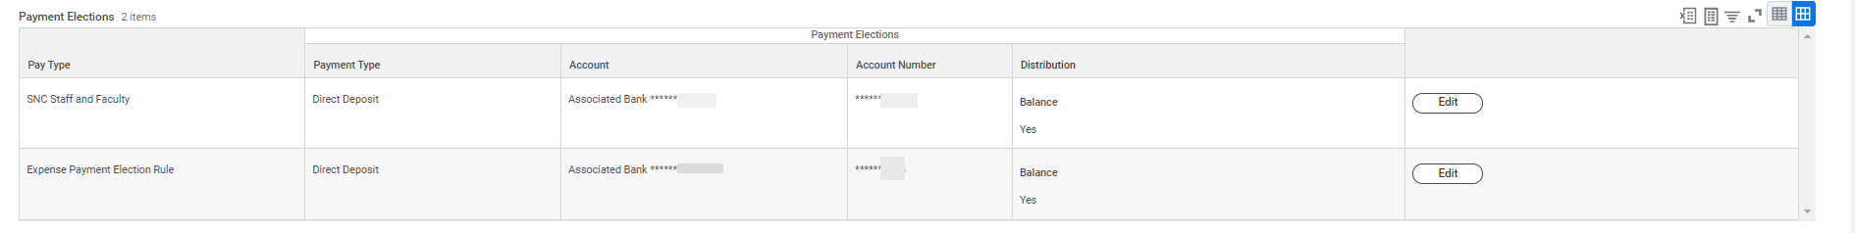

- Select the plus icon to add a bank account for a portion of your direct deposit.
Note: If you have not added multiple accounts, you will not have an option to distribute as shown in step 10.

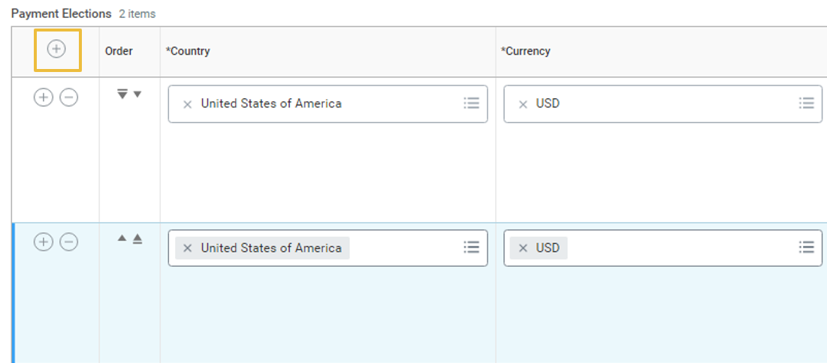

- Enter the following information
  - Country
  - Currency
  - Payment Type
  - Select the Account from the list you entered previously

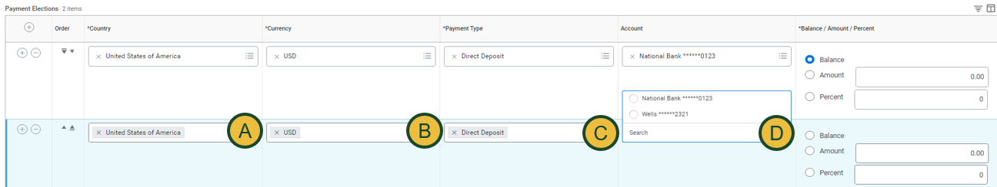

- In the last table of the column, you are required to select how your direct deposit will be distributed. Here are a few examples:
  - Distribute 50% into one account and 50% into another account.
  - Distribute $500 into one account and the balance into another account. (shown in the graphic below)
Select OK to apply your changes.

