Microfilm ScanPro1000 Instructions
- Turn on BOTH the PC and Microfilm Scanner (switch on back of unit) and login to SNC network on PC using your network Username and Password.
- To load Microfilm (roll) or microfiche (cards), pull the black metal tray above the words, ‘Microfilm ScanPro1000,’ toward you until glass lifts.
- Thread roll as shown on left reel, thread film between glass plates and wind around right roll by inserting film into slot on right reel and turning clockwise a few turns to secure film.
- Open “Powerscan” program on the computer.
- After film is secure you will use the ‘Motorized Roll Film Control’ found on the bottom right hand of your computer screen to advance film. If you are confused about threading film, watch the ‘Threading Video’ found on the Film Control panel.
- Push tray back in.
- Use on screen icons and instructions (hold mouse over icon to read) to adjust film type, angle, focus, contrast, print, save, etc..
- Pull tray forward or back to adjust screen image manually.

Below is the Film Selection Wizard screen. For most microfilm (ours in the library), select 35mm. For microfiche, the card with small pictures, insert between the glass face down with title toward you.

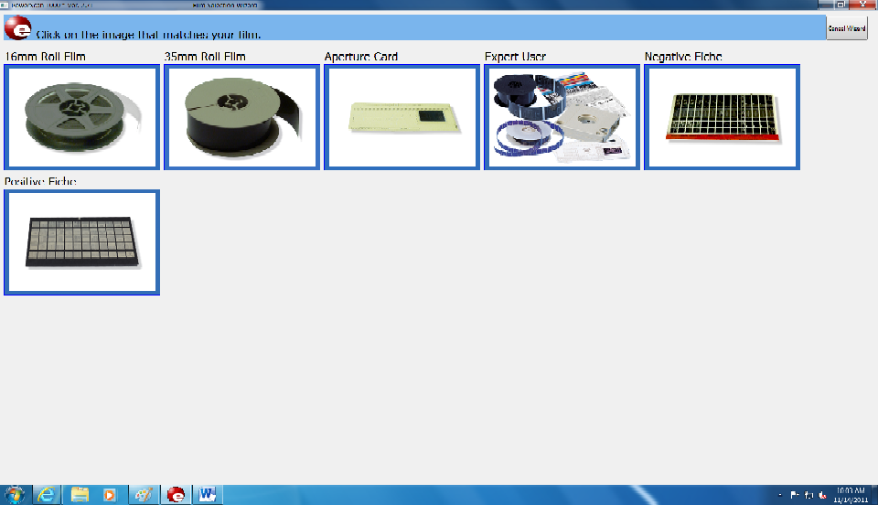

- The HOME screen of PowerScan is shown below.
- Use the motorized roll film carrier (lower right corner) to forward and reverse the film.
- To be able to see words on pages, most users will need to adjust the Brightness and Contrast shown below. You may use the other tabs (Adjust and File) as needed.

Clicking the ADJUST tab below will show the following options: zoom (hold down button to adjust), film type (negative or positive) change if you have white letters with a black background for printing, film orientation, rotate 90 (use to turn film) and mirror (useful if film is on roll backward).
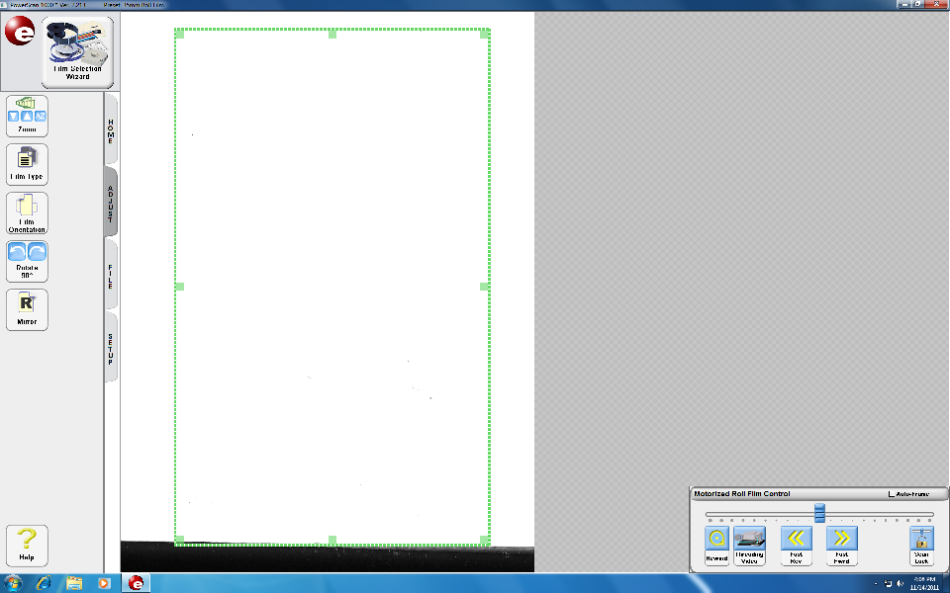
The FILE tab, contains options for saving and printing.

To print:
- Size green dotted box by dragging corners to fit around item to be printed. Your selection will print as close to 8x11 as is possible while keeping perspective. Click on desired printer.
- Accept print box, click ‘OK.’
*Mulvaref is installed in PowerScan as Printer 1.
To save:
- Select “Scan to drive”
- Select desired drive (J:\), personal drive (M:\) with 6 character username, E:\, or Flash drive (USB ports in front and back of CPU to connect flash drive)
- To save to (M:\), (G:\), or (J:\) drives, you must Login to drives by double-clicking G,J,M Drive icon on the computer desktop.
- Give document a name and save.

DON’T FORGET to restart computer when you are finished in order to log off from your drives.

