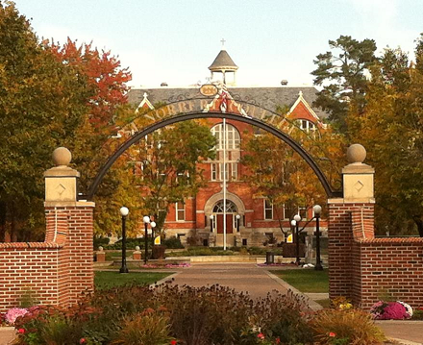
Guidance As You Develop Your Speech
Student Commencement Speaker Auditions 2024

Please remember to email your speech to peggy.shallue@snc.edu
no later than 4:00 p.m. on Monday, March 25th

- The best commencement speeches generally address the following three topics.
  - It offers congratulations. Parents, grandparents, friends, and relatives all need to be acknowledged. They are proud of you and your classmates and appreciate being associated with your success.
  - It reviews accomplishments. As members of the Class of 2024, what obstacles did you and your classmates overcome? What special characteristics have you exhibited? What are your significant accomplishments? These should be written in terms with specifics that could apply to members of the graduating class, not just to you.
  - It issues a challenge. The word commencement denotes a beginning. What does the future look like for the Class of 2024, what are the problems that you will be called upon to address as you take your place in society? What inspirational thoughts can you share which will assure your classmates that they are prepared and ready to take up the challenge?

- The speech needs to reflect the St. Norbert College experience. It shouldn’t be a speech that could be given at any college or university. What is uniquely “St. Norbert” about the experience students have here? Who are the people, what are the experiences that mattered to your class?

- Make sure your speech meets the expectations of the audience. Remind people of the event they are commemorating. You are speaking to your classmates, faculty, staff, family members and the friends who have assembled to share this special day.

- Use personal anecdotes and appropriate humor but be aware that you are speaking for others as well as yourself. Though the words you use are your own and the feelings you express are sincere, you are speaking as a representative of your class. You are speaking to reflect their sentiments. The spotlight may seem to be on you, but your job is to refocus its beam on your classmates and the commencement event.

- Avoid the common words that every other speaker at commencement has used. Make appropriate use of metaphor. Choose vivid, colorful language. Be original but remember that everything about your speech she be consistent with the tone of the ceremony.

- Be brief. It has been said that “every word and phrase should be the right one, carefully chosen to bring about the desired emotional response.” It is often harder to write less, so work hard on this aspect of the speech.

- For most, commencement is both and ending and a beginning, an opportunity for the graduates to reflect on what has been, while anticipating new, perhaps unknown, challenges. The best speeches are those that have meaning for the largest number of persons. Highly personal speeches may not meet that test.

The time allotted for the student commencement speech will be 5 minutes, maximum.

- PRACTICE. Please rehearse your delivery. Don’t worry about “performing,” but speak with confidence and authority. Ask friends for their feedback. Where did they get choked up or emotional? What did they like? Where were they bored? Where were they confused? Think about what your very best professors did when they delivered content that mattered to you and try to emulate that in your own presentation.

- Own It! You may not have many other opportunities to speak to a large group of people about something that matters to you (or you might!), so don’t waste this opportunity. This is your chance!

- Finally, if you have questions, please contact Peggy Shallue, Student Affairs via email (peggy.shallue@snc.edu) or call her directly at (920) 403-3055.

