Amazon Personal Account – Change Account Settings

Overview
This job aid is for anyone who has a personal-use Amazon account that is associated with their SNC email address.

Security Role(s): Employee as Self

- Navigate to www.Amazon.com and select Sign in. Complete the Steps to Reset Your Amazon Password.
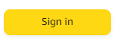
Steps to Reset Your Amazon Password
- In the Sign in page, select Forgot your password?
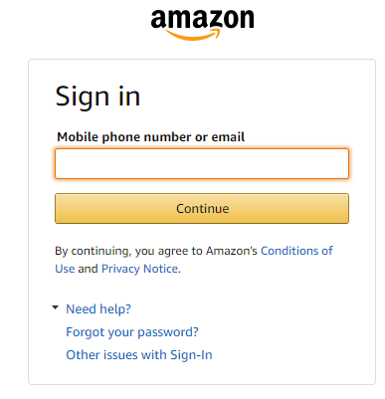

- On the Password assistance page, enter your SNC email address and select Continue.
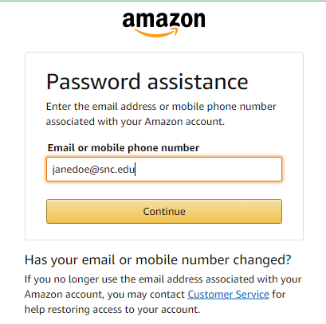
- Check your SNC email containing a One Time Password (OTP) and follow the prompts to enter your OTP and select Continue. You’ll be prompted to create a new password.
- Once you are logged into Amazon with your SNC email and the NEW password created, complete the Steps to Change Your Amazon Account Settings.

Steps to Change Your Amazon Account Settings
- Find your name at the top of the page and from the drop down menu, select Your Account.
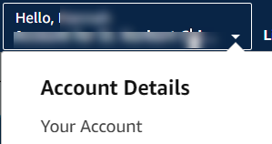

- On the profile page, select Login & security.
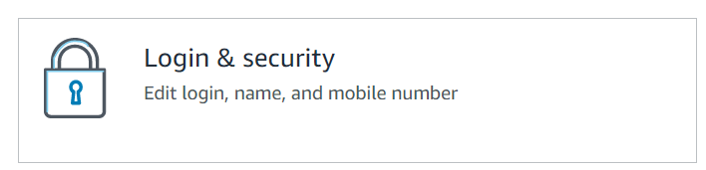

- Select Edit next to email.
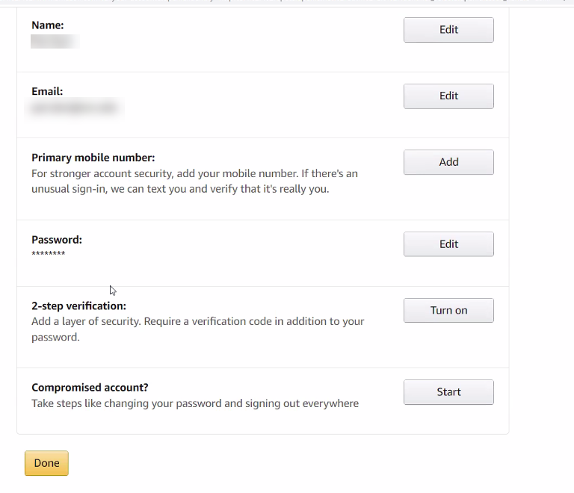

- Enter the new email address you want associated with your account, and select Continue.
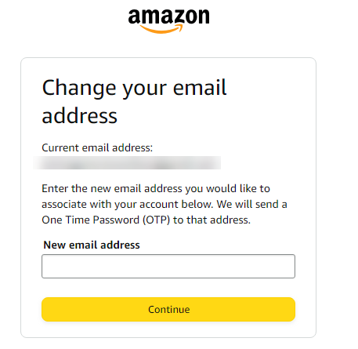

- You will receive an email with a One Time Password to the new email address you provided. Enter that password and select Continue.
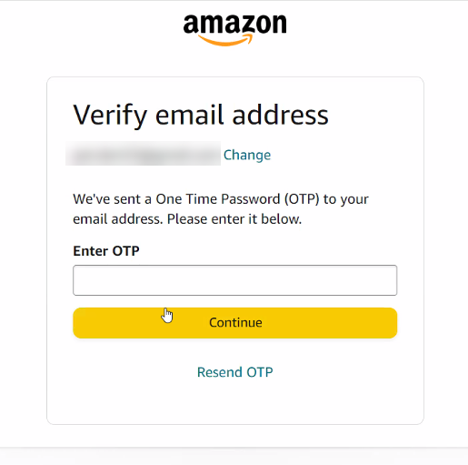
- Confirm the new email address is correct and enter your password. Select Save changes when complete.
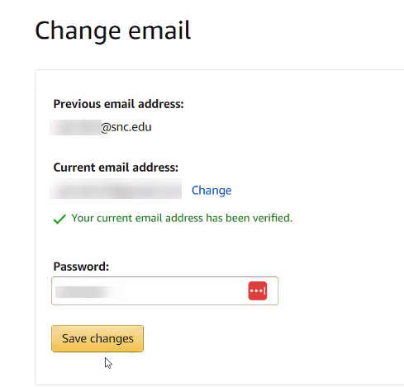

- Another email will be sent to the new email address associated with your account. You will need to confirm the new email address from this email.
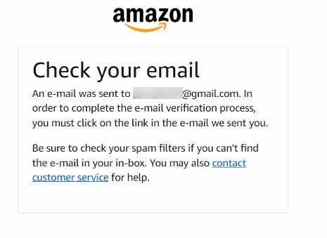
- Now, follow the steps in the SNC Job Aid - Create Requisition and Receipt – Connect to Supplier Website (Punchout to Amazon or Staples) to complete a Punchout Purchase in Amazon
- If you receive the following error message when logging into the punchout for the first time, follow the steps below.
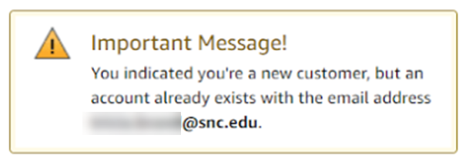
- Go to the Amazon homepage: http://www.amazon.com
- Select Account & Lists at the top of the page.
- Select Start here (Blue Start here below the yellow "SIGN IN").
- If you are using your same email, you'll be prompted with a message that says: "Email address already in use. You indicated you are a new customer, but an account already exists with the e-mail xxxx@domain.com.” Scroll down the same page and click in the option: "Create a new account with this email address".
- Select create an account anyways. Your previous account will be deactivated.
- You will receive an email with a link so you can verify the email address belongs to you and you have access to it.
- After you verify with the link sent to your email, fill in the information needed for the creation of the new account. Use a brand new password, at least 8 characters, with a capital letter and a number.
- Return to the Connect to Supplier Website task in Workday and continue with the steps in the SNC Job Aid - Create Requisition and Receipt – Connect to Supplier Website (Punchout to Amazon or Staples) to complete a Punchout Purchase in Amazon. If prompted to login, use the new password you created.
If you are still unable to get to the Amazon homepage through the punchout, contact Amazon Customer Service directly at 866-486-2360.

