Miscellaneous Payment Request

Overview
This job aid will outline how employees can initiate payments and reimbursements on behalf of a student. These payments can be reimbursements or other payments.
Security Role(s): Employee as Self

- Search “Create Miscellaneous Payment Request” and select the task.
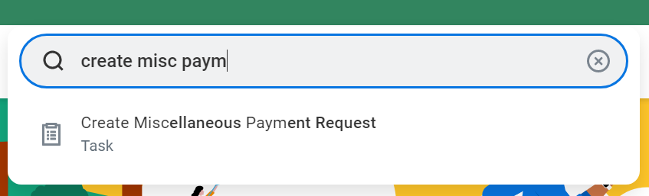

- Enter the required fields.
  - For Company, select St. Norbert College.
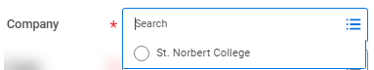
  - For Payee, enter the name of the student who will receive the payment.
  - Currency will auto populate based on the payee selected.
  - For Payment Type, enter the method that the payment will be distributed, usually Check or Direct Deposit. If you select a payment method that is unavailable for the payee, you will receive an error.
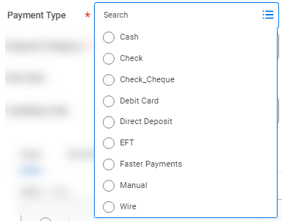

  - For Request Category, select the appropriate field.
    - Note: Only Accounting Services may initiate a Student Refund.
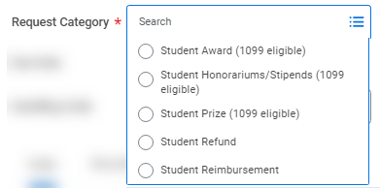

- Enter the line details.
  - Enter the Spend Category that is appropriate for the payment.
  - Enter the Quantity and Unit Cost.
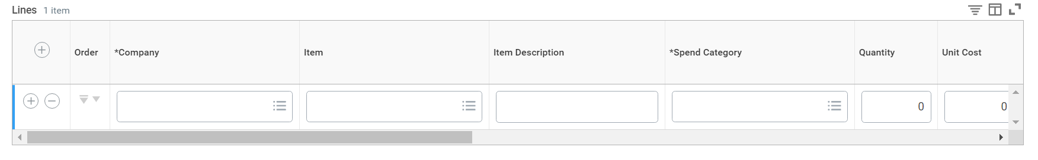
  - Enter the appropriate driver worktags. (Note: Additional Worktags will auto populate.)
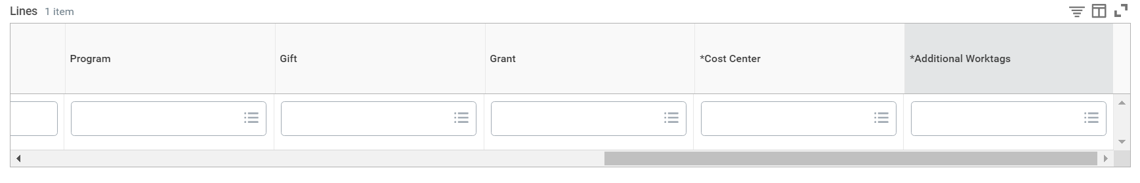

- Select the Attachments tab.
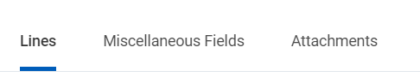

- You must attach the appropriate file depending on the payment type.
  - For Student Honorariums/Stipends (1099 eligible) or Student Prize (1099 eligible) or Student Award (1099 eligible), attach a document stating the reason for the honorarium/stipend/prize/award.
  - For Student Reimbursement, attach the appropriate receipts you are requesting be reimbursed.
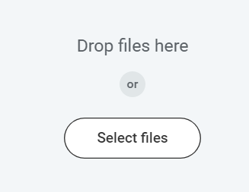

- Select Submit when complete.

