Mobile Expense Report

Overview
This job aid will outline how employees can perform the following functions in the Workday mobile app:
- Upload receipts and create an an expense report for a charge on a personal card
- Input quick expenses to go back and create an expense report later
- Submit full expense reports.
Security Role(s):

- Select View All on the Workday Mobile homepage.
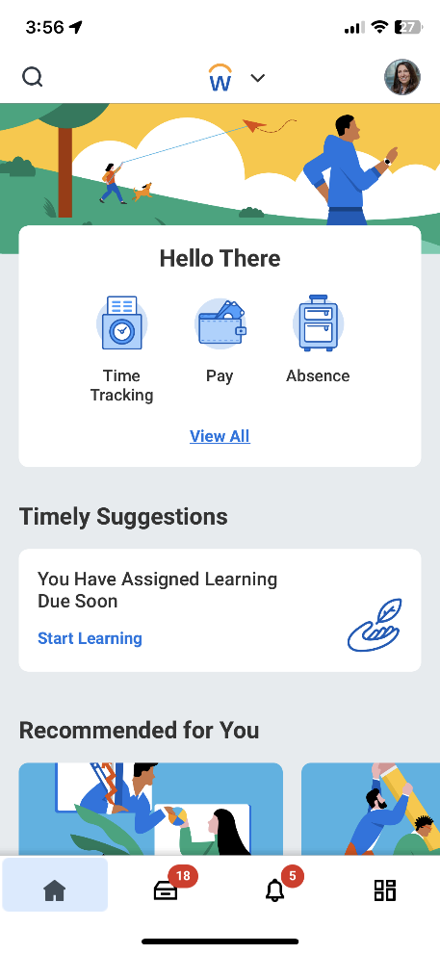

- Select Expenses App.
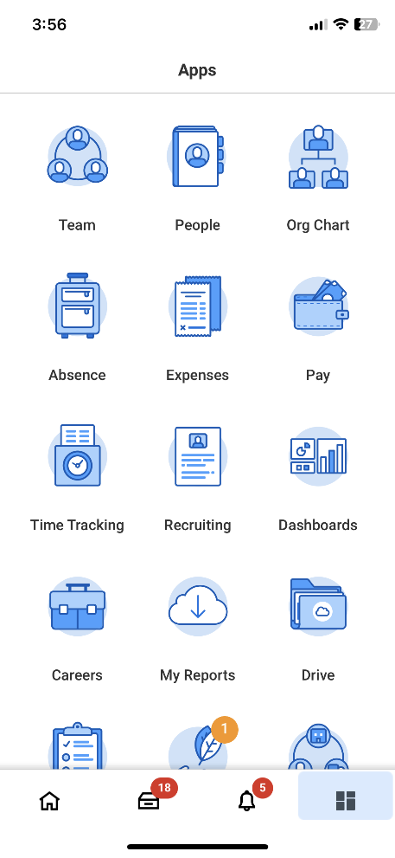

- On the Expenses landing page, there are three options.
  - Scan Receipt: Scan receipts directly through the app. Receipts can then be added to a report from the mobile app or your computer.
  - Enter Quick Expense: Add an individual expense without a report. Once ready to create a report through the app, select individual expenses to populate the report.
  - Create Expense Report: Create and submit an expense report in the app.
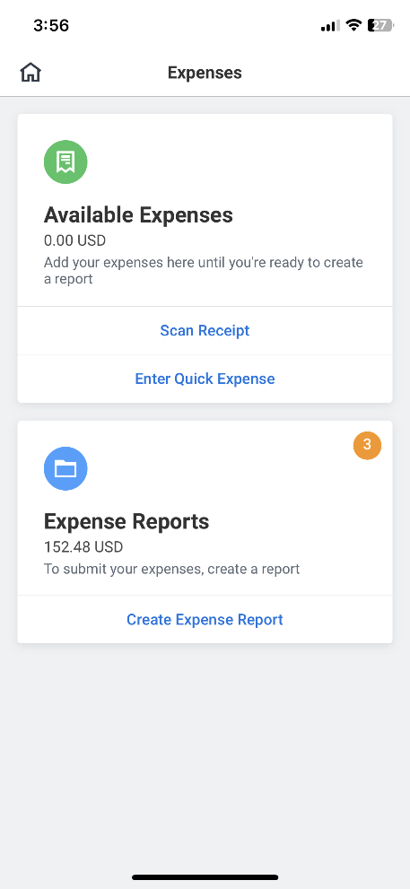

For Scan Receipt
- From the Expenses application, select Scan Receipt to take a picture of a receipt to create an expense report later.
  - You may need to allow access to your photo in order to scan a receipt.
  - Workday Mobile will scan the receipt to automatically populate information for the expense such as date and amount, as possible.

For Quick Expense
- If you select Enter Quick Expense, enter the details about the purchase that will need to be reimbursed.
  - This is not an expense report. You will be able to use these details to create an expense report.
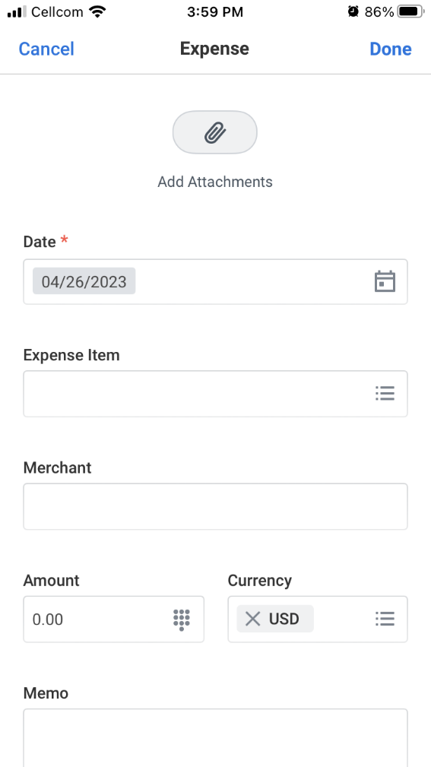
To Finish a Quick Expense or Scanned Receipt Expense Report
- Once ready to create a report, select the orange icon in the Available Expenses section from the application homepage​.
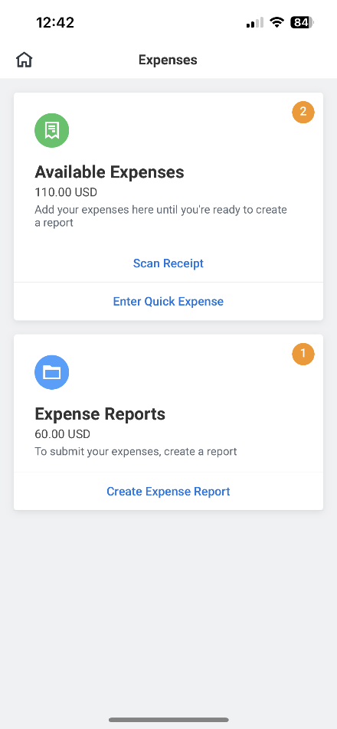

- Select the expense(s) or receipts to add to a report and select Add to Report​.
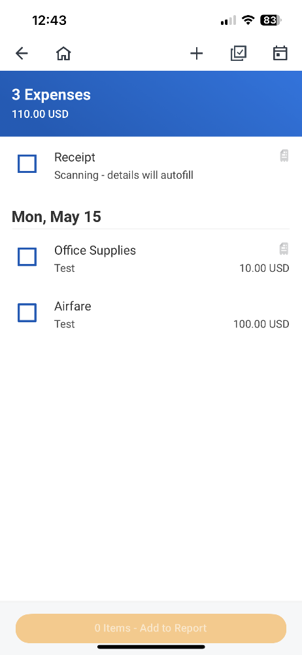
- Then complete the expense report details and submit.

Add Receipt to Drafted Expense Report
- You can add a receipt to an already drafted Expense Report by selecting the orange icon in the Expense Reports section from the application home page.
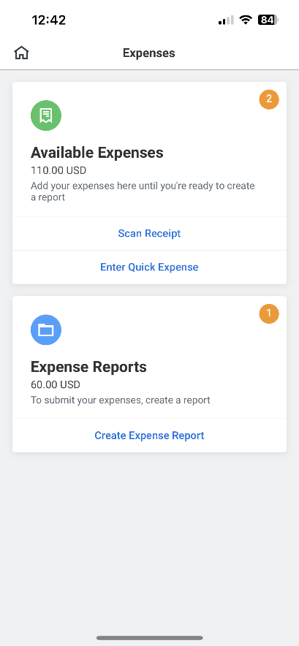

- Select the expense report and expense item to add the receipt to.
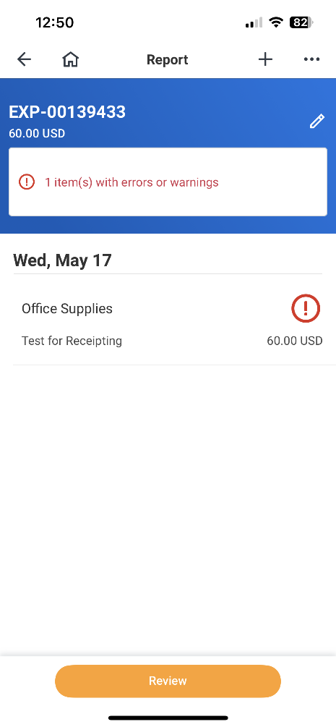
- Add an attachment to the expense report and select Take Photo to add to your expense report.
