St. Norbert College

Banner Finance Training Guide
(for version 7x)

Last Updated 1/26/07

Contents

 | Page
Organizational Budget Status Form (FGIBDST) . . . . . . . . . . . . . . . . . . | 3
Organization Budget Summary Form (FGIBSUM) . . . . . . . . . . . . . . . . | 6
Budget Status Current Period (FZRBDSC) . . . . . . . . . . . . . . . . . . . | 7
Save as Word document option . . . . . . . . . . . . . . . . . . . . . . . . | 13
Organization Detail Activity (FZRODTA) . . . . . . . . . . . . . . . . . . . . . | 15

Budget Forms – Organization Budget Status Form (FGIBDST) - Detail information for your organization.

- Select Organization Budget Status Form from the My Banner menu item on the main screen:
- Or you can enter FGIBDST in the Go To . . .box. 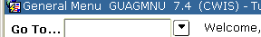
- Enter your Organization number in the Organization box. When you enter your Organization, the default Fund and Program will appear.
- In the Fund box enter either 100200 for Non-Personnel Expenses or 100202 for Student Wages.
- Delete the Program number.
- Do not enter anything in the Account box and all accounts will display. If you enter a number, accounts from that number forward will display.
- Click the Next Block icon..
- Fields displayed for each Account:
- Account: Banner Account Number
- Type: R = revenue, L = labor, E = expense (non-labor)
- Title: The descriptive title for the Account
- Adjusted Budget: The Adjusted Budget for the Account (Beginning + changes)
- YTD Activity: Year to Date actual amounts for the Account
- Commitments: Encumbrances for the Account
- Available Balance: The remaining budget for the Account (Available Balance = Adjusted Budget – YTD Activity – Commitments)

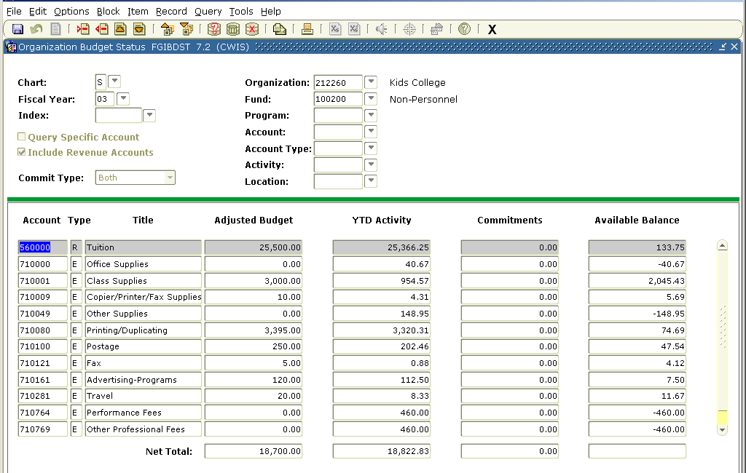
Note: Avail Bal column does not show a Net Total unless “Include Revenue Accounts” box was unchecked before displaying data

The Net Totals displayed may be confusing. The matrix below shows the equation based on various selections.

Revenue accounts selected in Account field | Include Revenue Accounts checkbox (checked?) | Notes | Net Total equation
Yes | Yes |  | Sum of revenue accounts – sum of expense accounts
Yes | No | Revenue account data will not display even if it exists. | sum of expense accounts
No | Yes | Revenue account data will not display even if it exists. The Net Total equation will use a revenue amount of zero. | 0 - sum of expense accounts

Options

- The Options menu item lists options for viewing the information. These additional options will be based on the information displayed on FGIBDST. You will not be able to change any of the selection criteria on the screens selected in the Options menu.
- Select Options, Budget Summary Information. This will display a summary for the Organization and Fund based on the originating FGIBDST. When you are done, click on the Exit icon 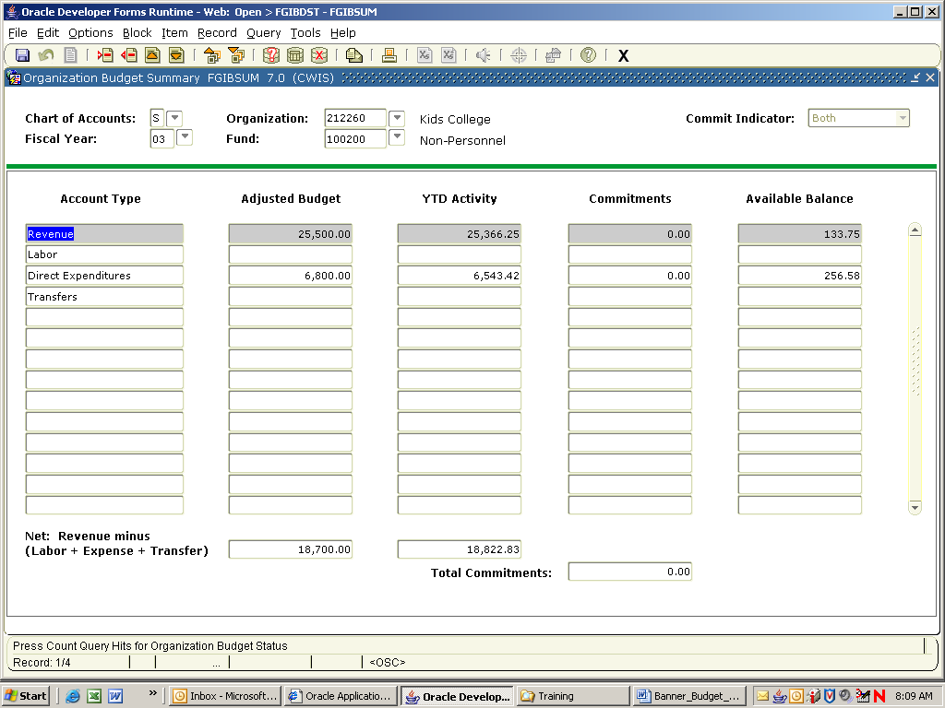 . This will return you to the originating FGIBDST screen.
Options, Budget Summary Information
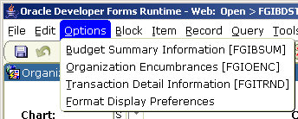
Exit icon

- Select Options, Transaction Detail Information. This will display the underlying transactions for the highlighted Account or cell. You may highlight a specific transaction and select Options, Query Document. This will display the originating document for the transaction. Common Document Types include:
- INNI: Payables Voucher
- JE16: Journal Voucher - affecting bank accounts
- FT01 Journal Voucher - not affecting bank accounts
- BD01: Permanent Adopted Budget
- BD02: Permanent Budget Adjustment
- BD04 Temporary Budget Adjustments

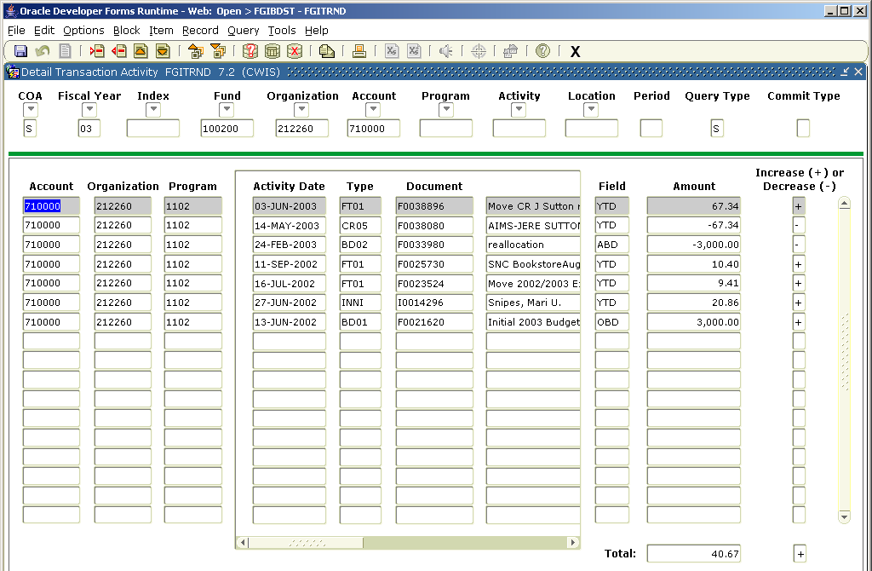
Transaction details for account 710000

Budget Forms – Organization Budget Summary Form (FGIBSUM) – Summary information for your Organization

- Select Organization Budget Summary Form from the My Banner menu item on the main screen:
- Or you can enter FGIBSUM in the Go To . . .box.
- Enter your Organization number in the Organization box.
- Click on Next Block. A summary screen will display for your Organization showing: Adjusted Budget, YTD Activity, Commitments, and Available Balance for:
- Revenue
- Labor
- Direct Expenditures
- Transfers
If the Fund is 100200 (Non-Personnel Fund) no Labor costs will display.
If the Fund is 100202 (Student Labor Fund) only SNC student Labor data will display.
If the Fund is blank all four of the categories will display.
- If you want to see more detailed information, select Options, Budget Status Information. This will return to the FGIBDST panel.

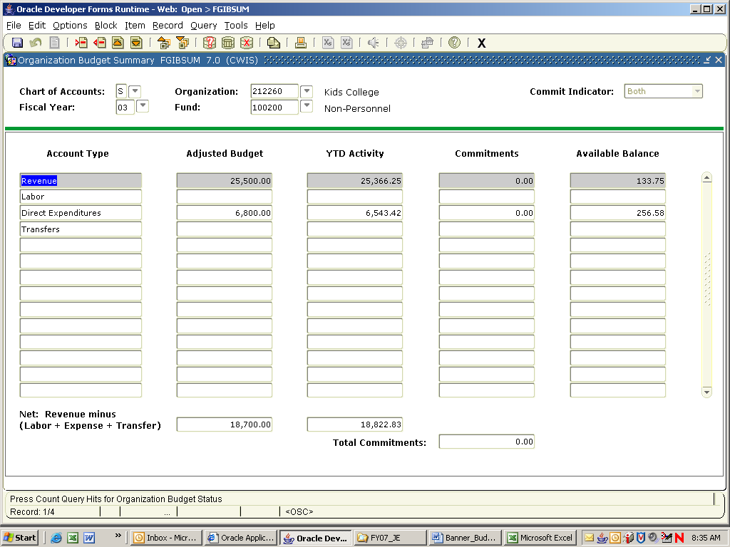

BANNER REPORT FZRBDSC – Budget Status (Current Period)

- Enter FZRBDSC in the Go To . . .box. (this is a customized report, not available in My Banner)

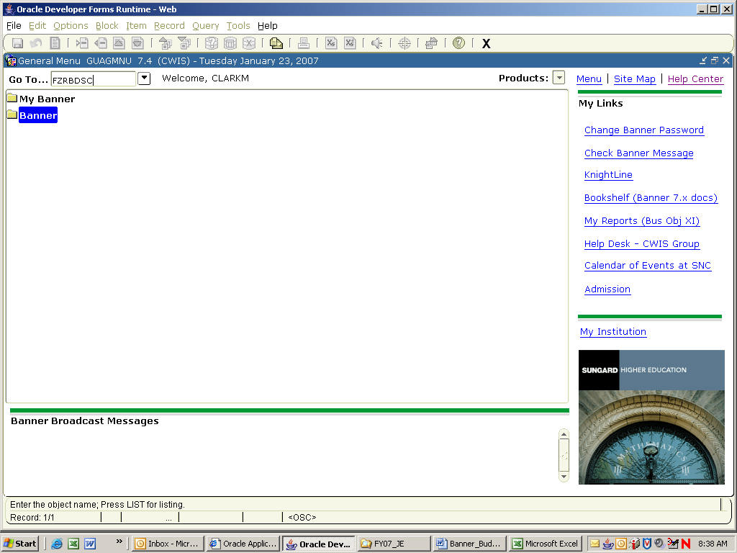

- The Process Submission Control Form will display.

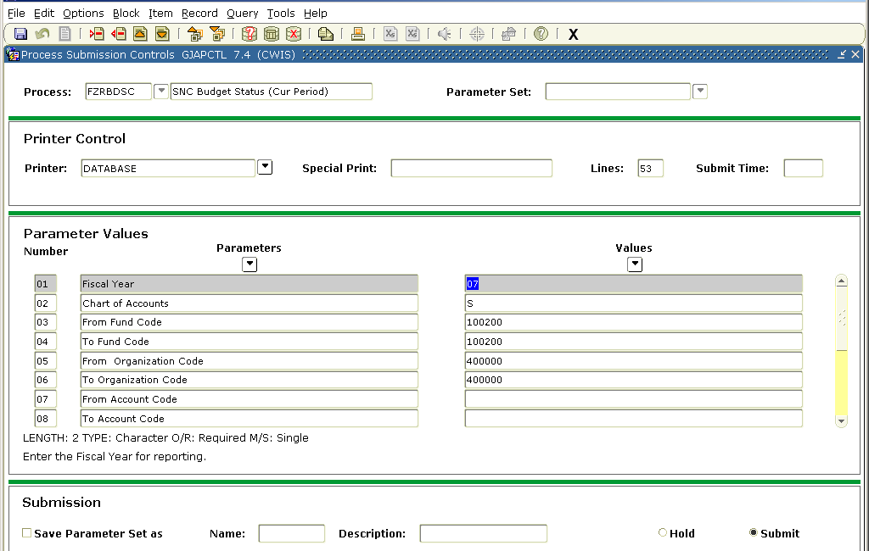
Parameter Values Block
Next Block icon

- Click on Next Block.
- Make sure the Printer box contains the word DATABASE.
- Click on Next Block. This will position you in the Parameter Values block.
- The following 13 parameters are used by FZRBDSC:

Parameter Values Block

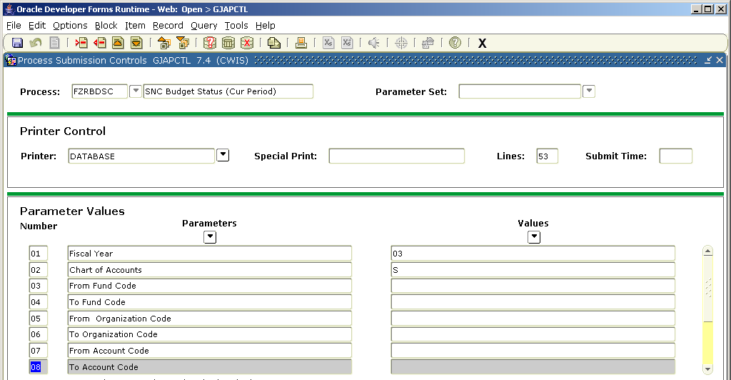
Next Block Icon
Key Block
Printer Control Block
Parameter Values Block
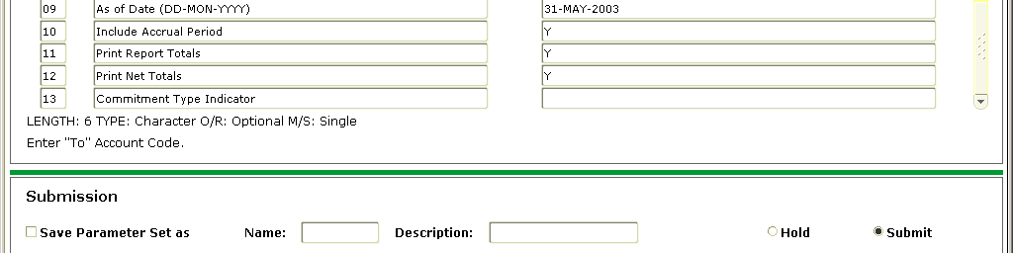
Submission Block

 | Parameters (questions) | Values (answers)
01 | Fiscal Year | Enter a 2 digit fiscal year
02 | Chart of Accounts | Enter “S” (value should always be set to “S”)
03 | FROM Fund Code | Enter From and To fund codes. If both are left blank, data for all fund codes accessible by the user will be returned
04 | TO Fund Code
05 | FROM Organization Code | Enter From and To organization codes. If both are left blank, data for all org codes accessible by the user will be returned
06 | TO Organization Code
07 | FROM Account Code | Enter From and To account codes. If both are left blank, data for all account codes accessible by the user will be returned
08 | TO Account Code
09 | As of Date (DD-MON-YYYY) | Enter a date (make sure date is within selected fiscal year)
10 | Include Accrual Period | Enter a “Y” for Yes or “N” for No. Recommended value is “Y”
11 | Print Report Totals | Enter a “Y” for Yes or “N” for No. Recommended value is “Y”
12 | Print Net Totals | Enter a “Y” for Yes or “N” for No. Recommended value is “Y”
13 | Commitment Type Indicator | Enter “U” for Uncommitted, “C” for Committed or leave blank for all types. Recommendation is to leave blank

- Run the job. Once all the Parameters are answered do the following to execute the job.

- Click on the Save Parameter Set As check box in the Submission block to put a check mark in the box. This will save the values that you entered in the Parameter Values block.
- Click the Save icon – the Save icon (blue diskette in upper left of tool bar) will execute the job. A pop-up message will appear saying “Saving current parameter values as user level defaults”, click OK.

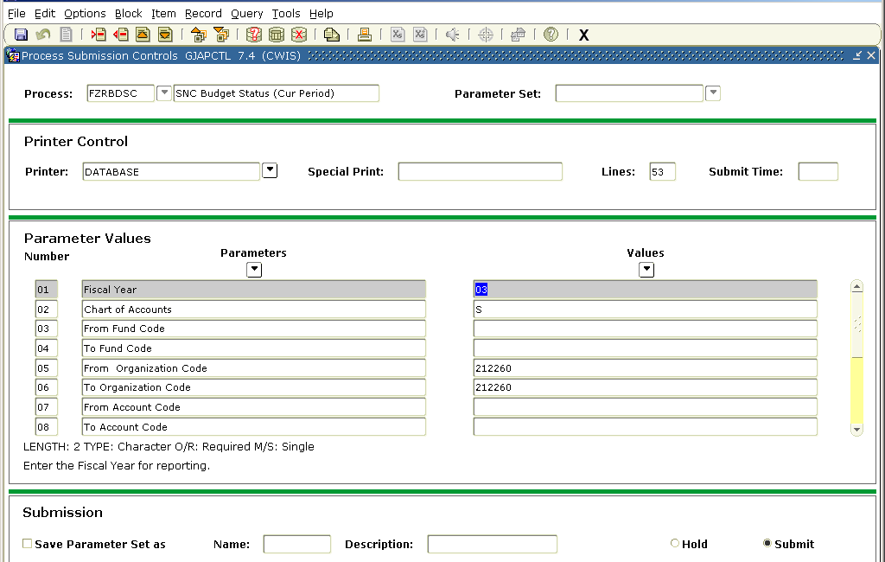
Submission Block
Save icon

- From the menu bar, click Options, Review Output. This will bring you to the Saved Output Review Form.

- Double click in the File Name box

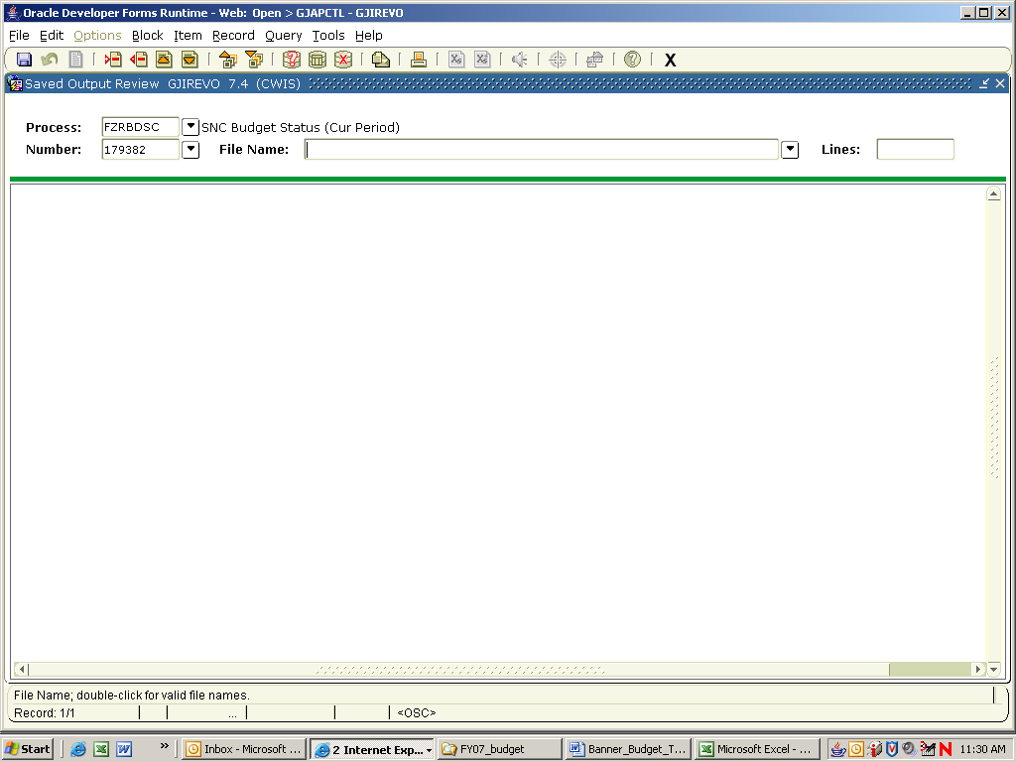
Double click in File Name box

- A list of available files will appear. There should be two types of files displayed with the following naming convention:

Report name_job number.lis – This is the actual report file
Report name_job number.log – This is a file with job information, usually indicates that the job ran successfully.

- Double click on the Output File Name that ends in .lis or click OK

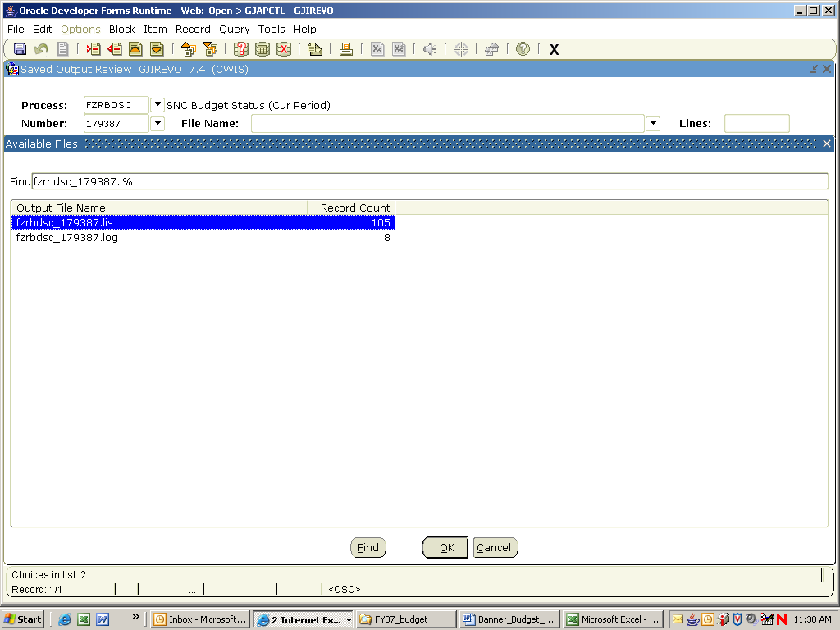

- The report will display.

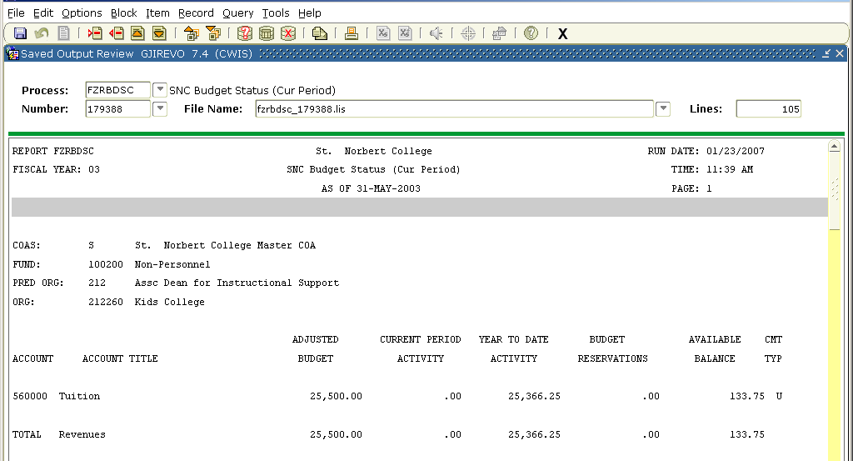

- It is recommended that the report be displayed in a browser for ease of saving or printing. To display the report in a browser select Options, Show Document. A pop-up window will appear, click Yes.

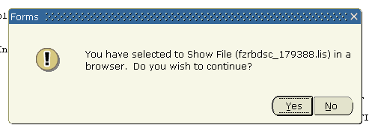

- The report will open in a browser window.

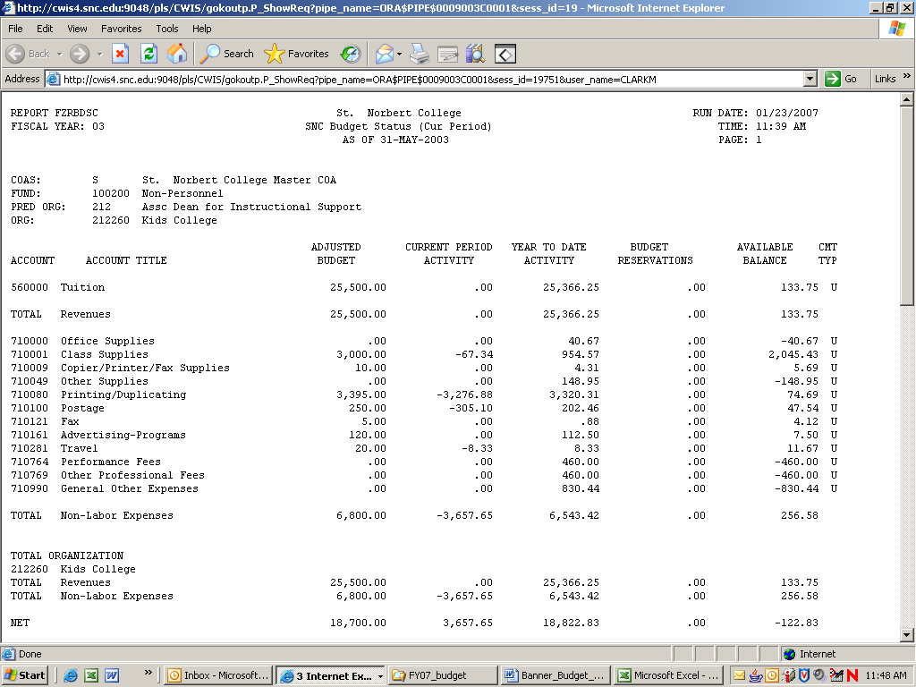

- To properly print the document, page and font settings must be adjusted. Page orientation must be set to “Landscape”. Recommended margin settings are .25. Select File, Page Setup from the menu bar. Make adjustments and click OK.

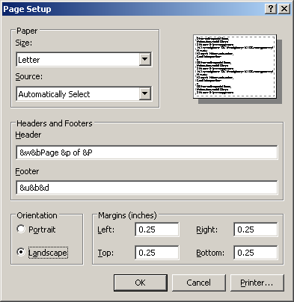
Page orientation should be set to Landscape
Margins should be set to .25

- Next, the font setting needs to be adjusted. From the browser menu bar, select View, Text Size and select Smaller or Smallest.

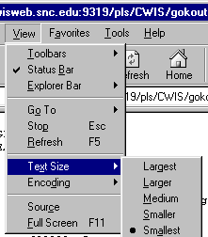
- From the menu bar, select File, Print Preview to see how the printed version will look. Click Print to print the report.

SAVE AS WORD DOCUMENT OPTION

- From the Menu bar select File, Save As. Choose a location in the Save in: box. Type a file name in the File name: box and make sure to include an extension of “.doc”. Click Save.

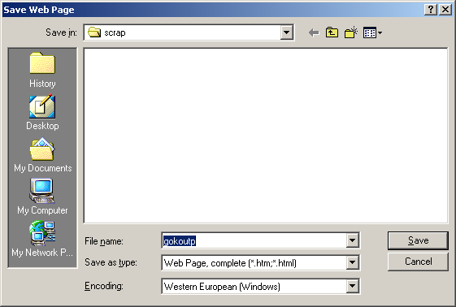
Choose a location in the Save in: box
Type a file name in the File name: box and make sure to include an extension of “.doc
Filename.doc

- Open the saved file from within Microsoft Word. Formatting will be misaligned.
- From the Menu bar select Edit, Select All.
- Change the font size to 8. Leave the font setting as Courier.
- From the Menu bar select File, Page Setup. Click on the Paper Size tab. Change the Orientation to Landscape.
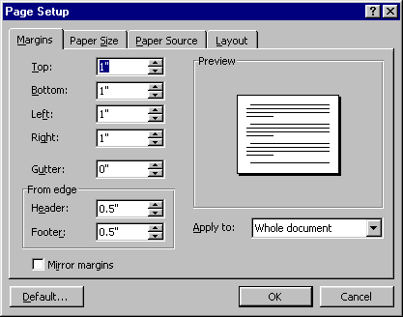
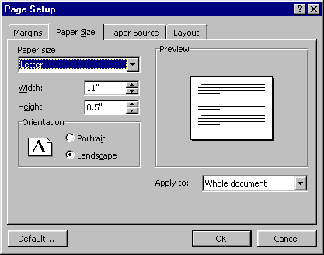
- Click on the Margins tab. Change all the margin settings. It is suggested to use a .25” setting.
Change all to .25

- The document should now be properly formatted for printing.

Budget Reports – Organization Detail Activity (FZRODTA)

- Enter FZRODTA in the Go To . . .box. (this is a customized report, not available in My Banner)

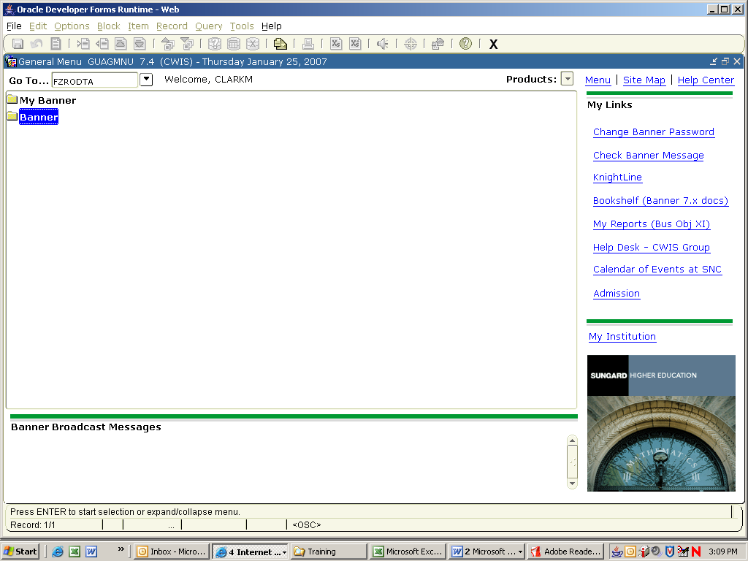

- The Process Submission Control Form will display.

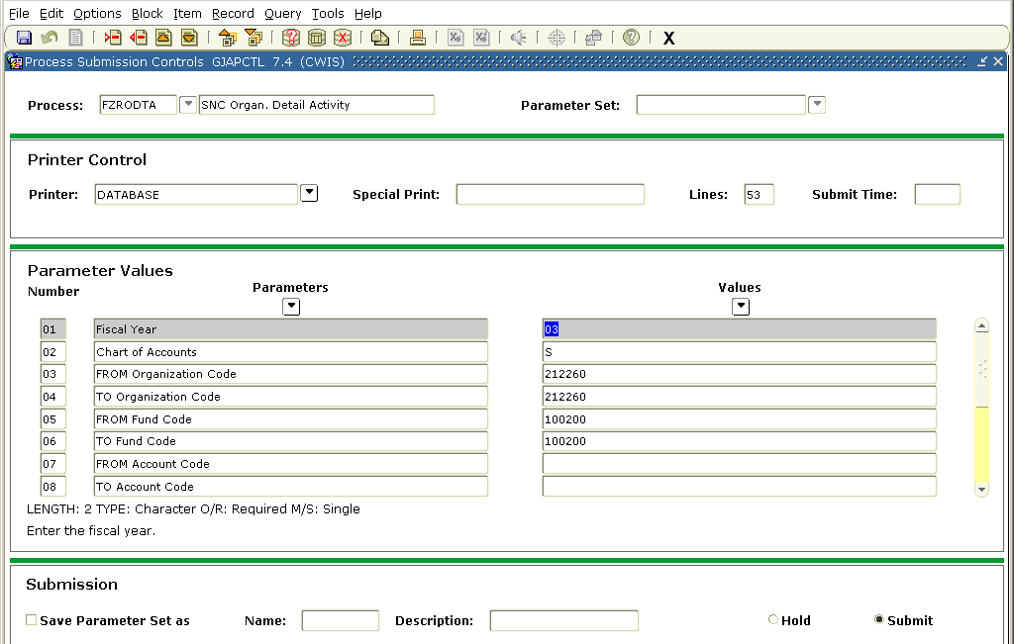
Parameter Values Block
Next Block icon

- Click on Next Block.
- Make sure the Printer box contains the word DATABASE.
- Click on Next Block. This will position you in the Parameter Values block.
- The following 13 parameters are used by FZRBDSC:

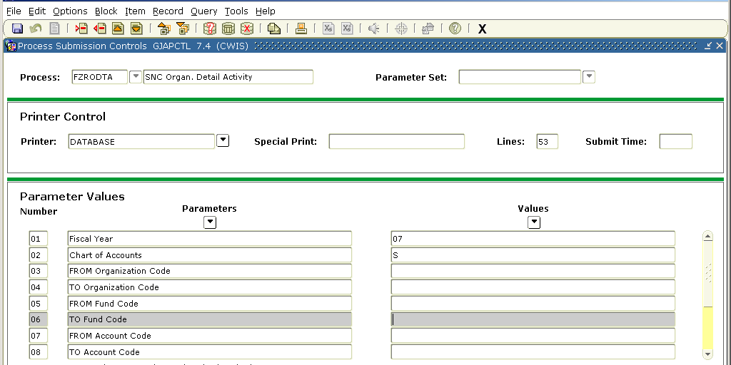
Next Block Icon
Key Block
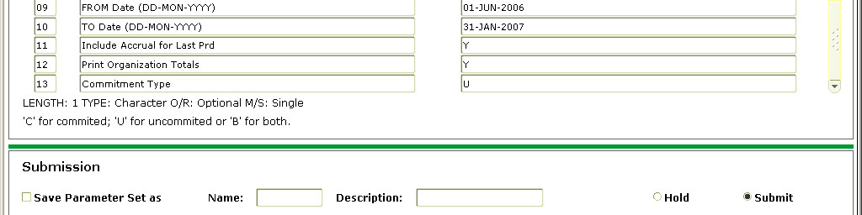
Submission Block

 | Parameters (questions) | Values (answers)
01 | Fiscal Year | Enter a 2 digit fiscal year
02 | Chart of Accounts | Enter “S”
03 | FROM Organization Code | Enter From and To organization codes. If both are left blank, data for all org codes accessible by the user will be returned
04 | TO Organization Code
05 | FROM Fund Code | Enter From and To fund codes. If both are left blank, data for all fund codes accessible by the user will be returned
06 | TO Fund Code
07 | FROM Account Code | Enter From and To account codes. If both are left blank, data for all account codes accessible by the user will be returned
08 | TO Account Code
09 | FROM Date (DD-MON-YYYY) | Enter a From date (make sure date is within selected fiscal year)
10 | TO Date (DD-MON-YYYY) | Enter a To date (make sure date is within selected fiscal year). Recommendation is to select a month-end date.
11 | Include Accrual for Last Prd | Enter a “Y” for Yes or “N” for No. Recommended value is “Y”
12 | Print Organization Totals | Enter a “Y” for Yes or “N” for No. Recommended value is “Y”
13 | Commitment Type | Enter “U” for Uncommitted, “C” for Committed or “B” for Both. Recommended value is “U”.

- Run the job. Once all the Parameters are answered do the following to execute the job.

- Click on the Save Parameter Set As check box in the Submission block to put a check mark in the box. This will save the values that you entered in the Parameter Values block.
- Click the Save icon – the Save icon (blue diskette in upper left of tool bar) will execute the job. A pop-up message will appear saying “Saving current parameter values as user level defaults”, click OK.

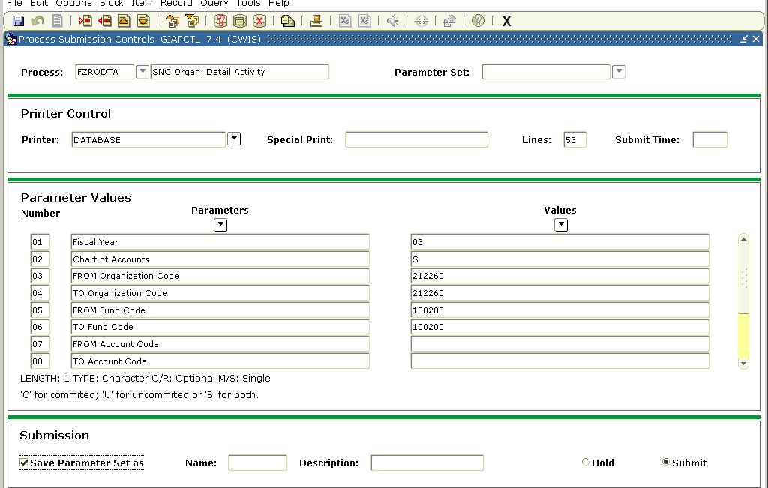
Submission Block
Save icon
Printer Control Block
Parameter Values Block

- From the menu bar, click Options, Review Output. This will bring you to the Saved Output Review Form.

- Double click in the File Name box

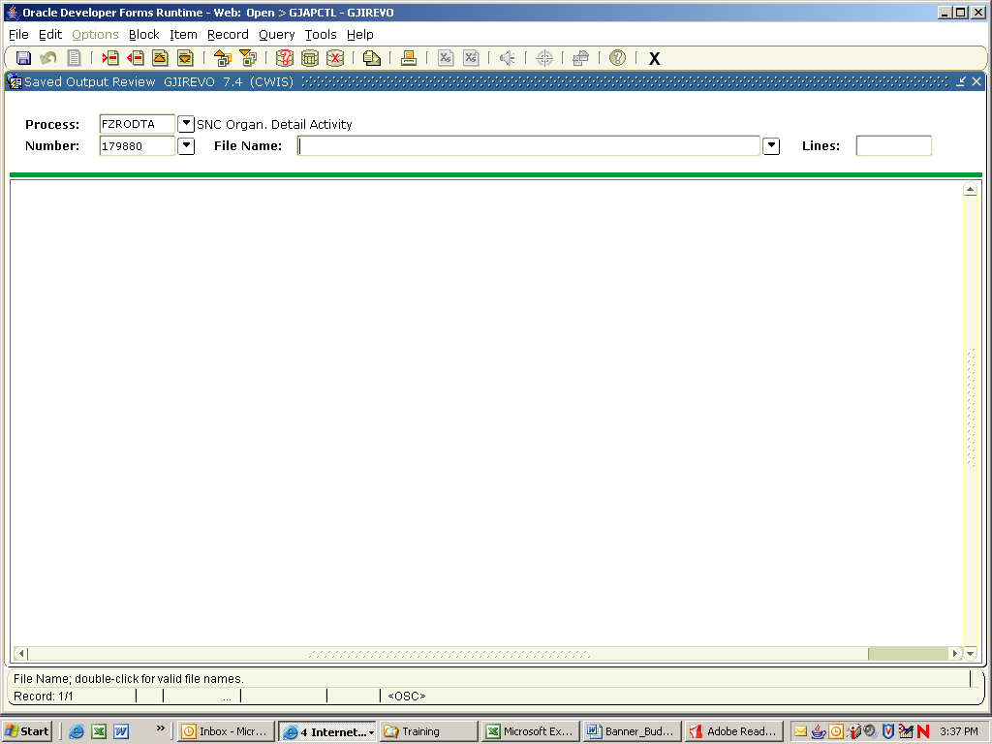
Double click in File Name box

- A list of available files will appear. There should be two types of files displayed with the following naming convention:

Report name_job number.lis – This is the actual report file
Report name_job number.log – This is a file with job information, usually indicates that the job ran successfully.

- Double click on the Output File Name that ends in .lis or click OK

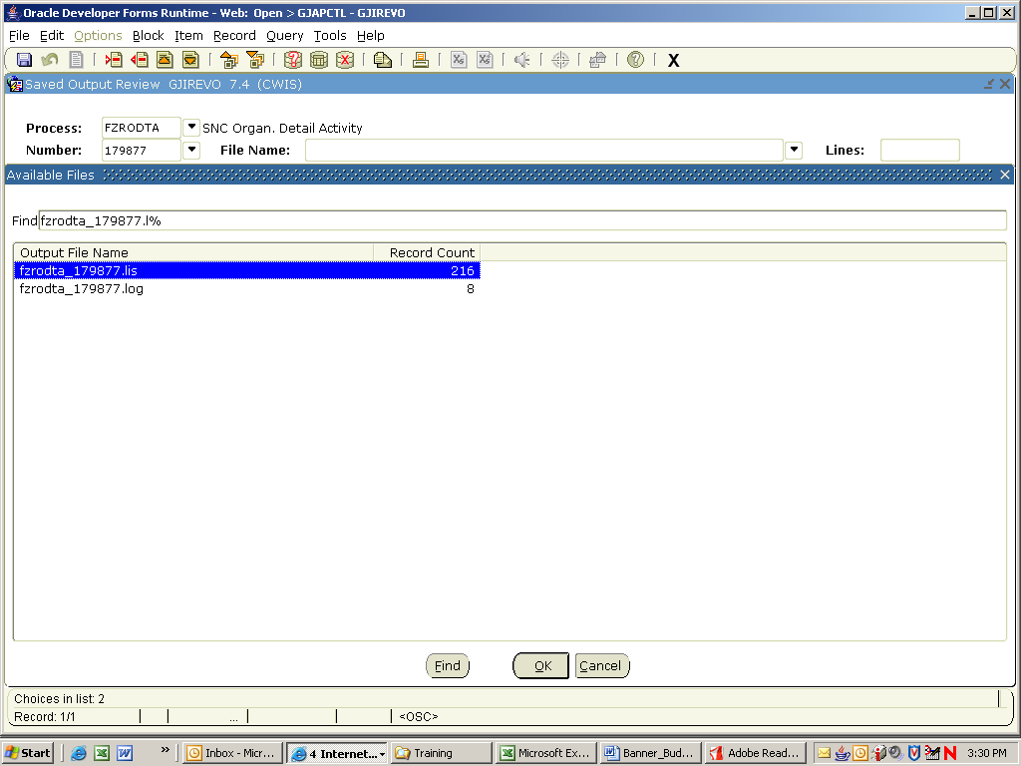

- The report will display.

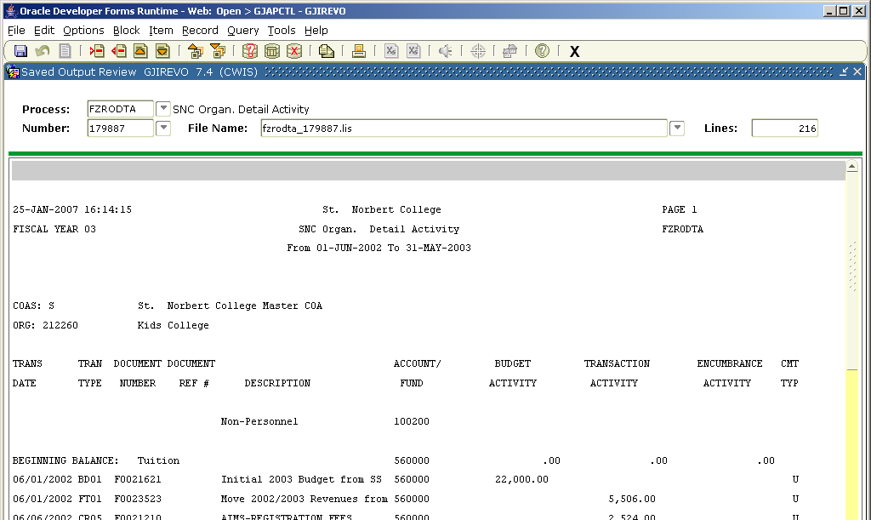
- It is recommended that the report be displayed in a browser for ease of saving or printing. To display the report in a browser select Options, Show Document. A pop-up window will appear, click Yes.

- The report will open in a browser window.

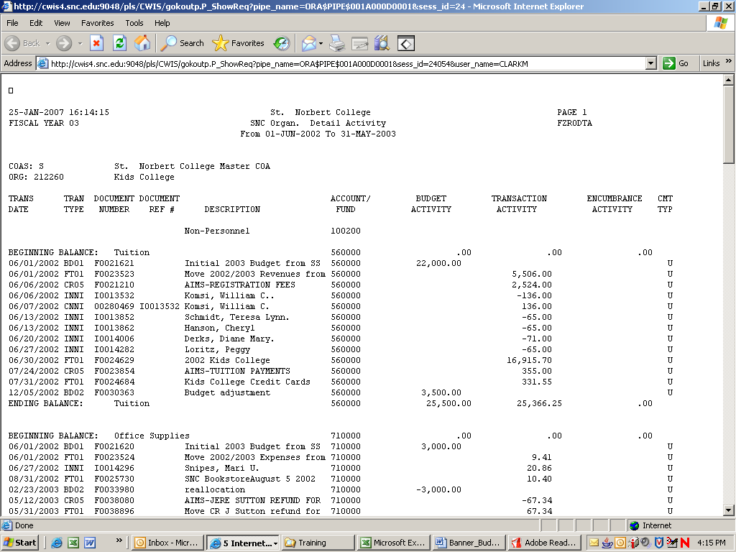

- To properly print the document, page and font settings must be adjusted. Page orientation must be set to “Landscape”. Recommended margin settings are .25. Select File, Page Setup from the menu bar. Make adjustments and click OK.

Page orientation should be set to Landscape
Margins should be set to .25

- Next, the font setting needs to be adjusted. From the browser menu bar, select View, Text Size and select Smaller or Smallest.

- From the menu bar, select File, Print Preview to see how the printed version will look. Click Print to print the report.

SAVE AS WORD DOCUMENT OPTION

- From the Menu bar select File, Save As. Choose a location in the Save in: box. Type a file name in the File name: box and make sure to include an extension of “.doc”. Click Save.

Choose a location in the Save in: box
Type a file name in the File name: box and make sure to include an extension of “.doc
Filename.doc

- Open the saved file from within Microsoft Word. Formatting will be misaligned.
- From the Menu bar select Edit, Select All.
- Change the font size to 8. Leave the font setting as Courier.
- From the Menu bar select File, Page Setup. Click on the Paper Size tab. Change the Orientation to Landscape.
- Click on the Margins tab. Change all the margin settings. It is suggested to use a .25” setting.
Change all to .25

- The document should now be properly formatted for printing.

