Encumbrance Information in Banner forms/reports
An encumbrance system is a management tool used to reflect commitments in the accounting system for better budget management and to prevent overspending. Encumbrances allow organizations to recognize future commitments of resources prior to an actual expenditure. When a regular or standing purchase order is completed and approved in Banner, an encumbrance is automatically created. As payments are made relating to a purchase order, encumbrances are liquidated or unencumbered. Payment amounts are added to the YTD Activity column and unencumbered amounts are subtracted from the Commitments column.
All of the standard financial forms may contain encumbrance data including FGIBDST, FZRBDSC and FZRODTA.
An example of encumbrance data in FGIBDST is shown below:

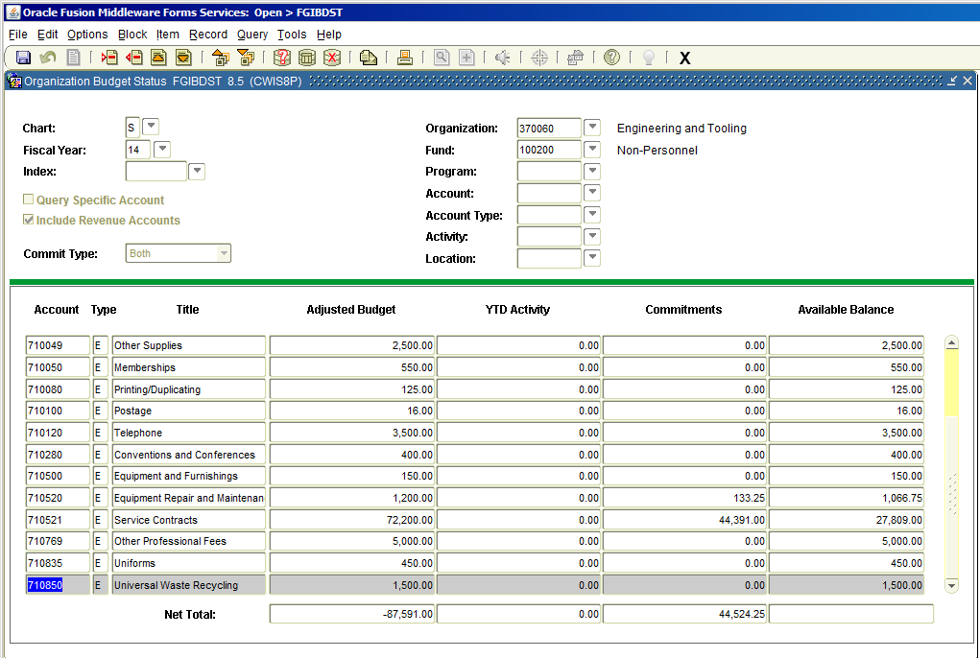

The available balance is the result of an equation:
Adjusted Budget – YTD Activity – Commitments = Available Balance

By including the commitment data in the available balance equation a budget manager can get a more comprehensive view of budget availability.

To view encumbrance detail transactions place the cursor in any Commitment cell and select Options, Transaction Detail Information from the Menu.

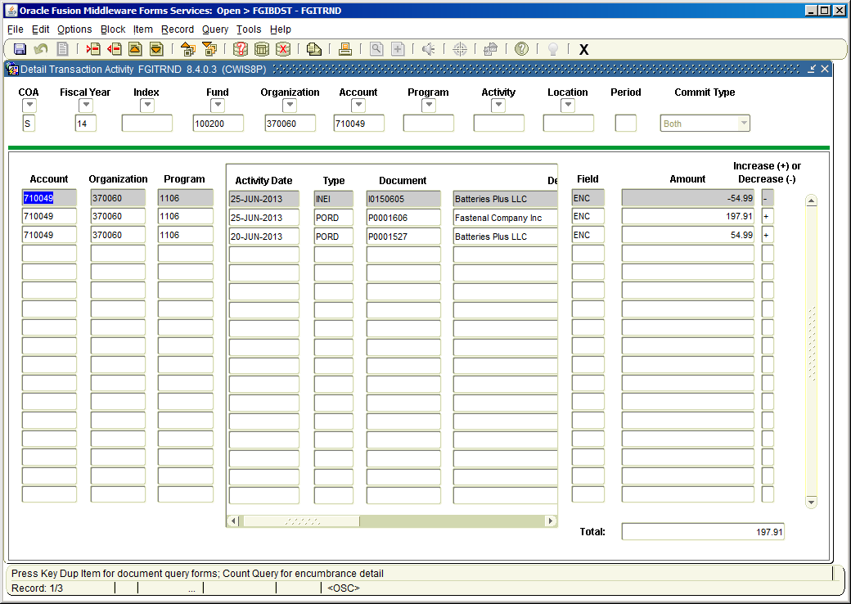
Encumbrance transaction details

