Finalizing Purchase Orders (Remove/Delete/Cancel/Close)

Buyers need to finalize every PO they generate. Typically this occurs when an invoice marked “final payment” is processed in Accounts Payable. A final payment indicator is then set which liquidates any remaining encumbrance and closes the PO. However, depending on a PO’s status it can be finalized by removing, deleting, cancelling or closing using various Banner forms. The Banner terms remove, delete, cancel or close are used based on the PO’s status in terms of being complete, approved, posted and having activity (payments, change orders . .. etc.) applied.

The table below summarizes how to finalize PO’s at various stages of their life cycle.

PO number created | Complete | Approved (and posted) | Activity (change order or payment) | Form | Notes | Page ref.
N | N | N | N | FPAPURR | If a PO is started but a PO number is not yet assigned, a buyer can simply exit the form. No PO records should exist.
Y | N | N | N | FPAPURR | If a PO number is generated but the complete button is not yet clicked, go to the Document Information tab and click Record, Remove twice. This will remove (delete) the PO data.
Y | Y | N | N | FOADOCU > FPAPURR | Once the PO is completed and forwarded to the approval process no changes can be made in FPAPURR. Disapprove the document in FOADOCU. This will send the PO back to an incomplete status where it can be changed or removed in FPAPURR.
Y | Y | Y | N | FPAPDEL | Use this form to permanently cancel PO's and blanket orders that have been completed, approved and posted (encumbered). A PO cannot be cancelled if it has any activity such as a change order or payment associated with it. Cancelling creates reversing entries to the original postings in the accounting ledgers. | 2
Y | Y | Y | N | FGAJVCD | This form is similar to FPAPDEL. It creates a JE using E032 to liquidate and close PO’s. It was used in a case where FPAPDEL had been used to cancel a PO but encumbrance amounts were not liquidated (actually doubled in error) | 9
Y | Y | Y | Y | FPAEOCD | FPAEOCD is used to close the remaining balance for a completed and approved PO that has had activity. | 5
Y | Y | Y | Y | FPPPOBC | FPPPOBC is used to close PO’s in mass. It can be helpful in closing PO’s under a specified dollar limit. FPPPOBC IS FOR FINANCE USE ONLY

The table below summarizes how to finalize change orders at various stages of their life cycle.

Change Order sequence number created | Complete | Approved (and posted) | Activity (payment) | Form | Notes | Page ref.
Y | N | N | N | FPACHAR | If a Change Order has not yet been completed, it can be removed in FPACHAR. | 9
Y | Y | Y | N | FPACDEL | Use FPACDEL to cancel change orders that have been completed, approved and posted. A change order can only be cancelled with FPACDEL if it does not have any activity against it, such as another later change order or invoices.
Y | Y | Y | Y | FPAEOCD | FPAEOCD is used to close the remaining balance for a completed, approved and posted PO that has had activity.

Remove/Delete: A PO or change order that is not complete will have no postings to the accounting records. Documents with an incomplete status can be removed (deleted).

Cancel or Close: A PO or change order that is complete, approved and posted will have created transactions in accounting records. Posted documents and related accounting transactions cannot be removed from Banner Finance, they can only be cancelled or closed which creates reversing accounting transactions in ledgers. A PO or change order that has had no activity (payments, invoices . . etc.) against it can be cancelled. A PO or change order that has had activity can be closed.

Monitoring of PO’s is very important as Incomplete or open PO’s can cause issues by remaining on exception lists and/or causing invalid budget availability data. Buyers should use the Incomplete Document List (FGRIDOC), Open Encumbrance Report (FGROPNE) or other forms to monitor their PO’s. The Incomplete Document List shows all types of Banner documents that have been created but not posted. It is an exception report. All documents should be cleared within a reasonable time, typically within a week. The Open Encumbrance Report shows open PO’s by user and should be closely monitored to insure that all PO’s are managed and eventually cancelled or closed.

Cancelling a PO

Banner form, FPAPDEL-Purchase/Blanket Order Cancel, can be used to cancel a PO that is completed, approved and posted (encumbered). Cancelling a document creates reversing entries negating the original postings to the accounting ledgers.

A PO cannot be cancelled if it has any activity such as a change order or payment associated with it. It is highly recommended to view the "Document History" (FOIDOCH) of the purchase order before you cancel it to make sure it does not have an invoice or check in process. If so, contact Accounts Payable.

In FPAPDEL enter the PO number to be cancelled then go to Next Block. Vendor and dollar values will populate.

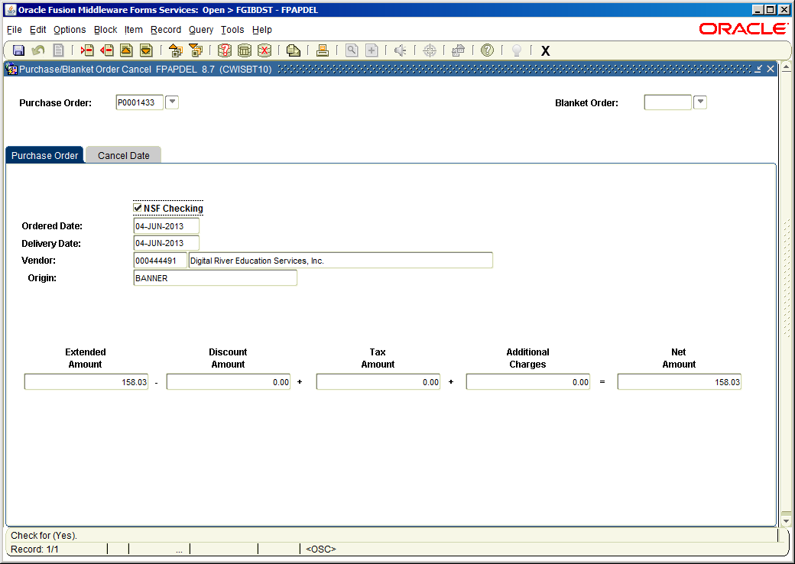

Click the Cancel Date tab. The Cancel Date field will default to the current date. Leave the date or change to a future date (not recommended). Leave the reason code blank, it’s not required and we are not using the codes. If you want to add an explanation, select Document Text from the Options Menu. After entering text, click the save icon and exit the form which will return you to the FPAPDEL form.

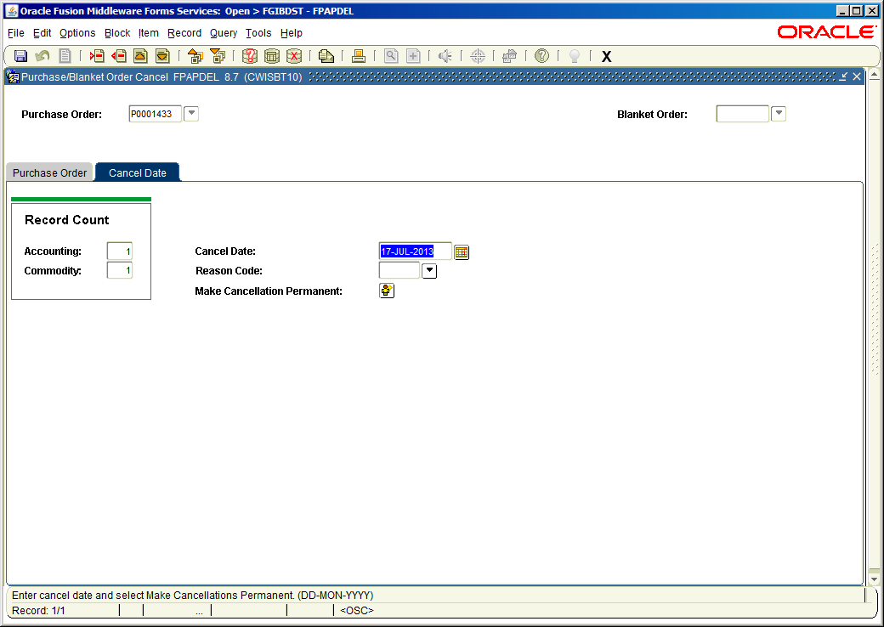

To complete the cancellation click the Make Cancellation Permanent button. Note that posting (FGRACTG) must occur for the cancellation record to be posted to accounting transaction records.

To confirm the cancellation go to FOIDOCH and enter PO in the Type field and the PO number in the Document Code field. Click Next Block. The PO document should have a status of X-Cancelled.

The image below shows the FOAPAL transaction record associated with the PO before cancellation:

The image below shows the FOAPAL transaction records associated with the PO after cancellation:

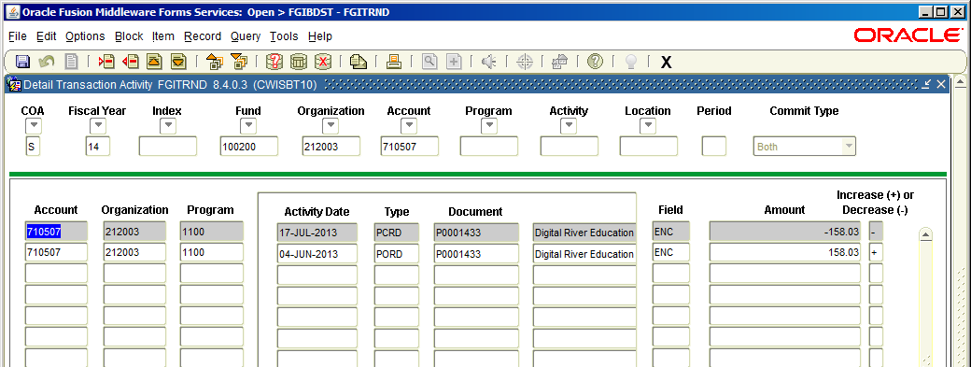

Closing a PO

Banner form, FPAEOCD-Open/Close, is used to close the remaining balance for a completed and approved PO that has had activity. Associated change orders must be deleted before deleting a PO.

For example, a PO was encumbered for $195.17 but only $143.93 was paid on the PO and no more payments will be made. The $51.24 balance needs to be unencumbered and the PO needs to be marked as closed.

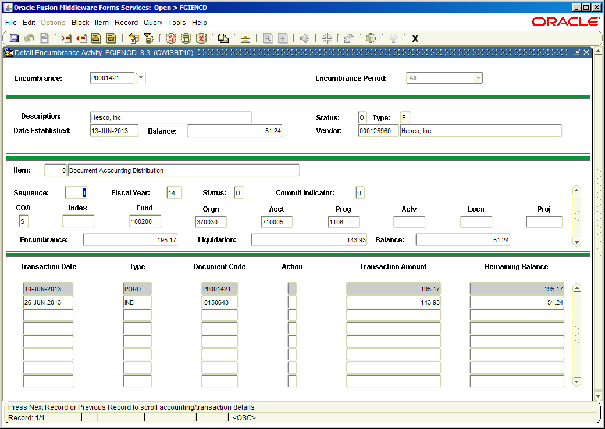
Example: PO that is completed, approved, posted and has activity. PO has a remaining encumbered balance of $51.24.

In FPAEOCD enter NEXT to generate a document number.

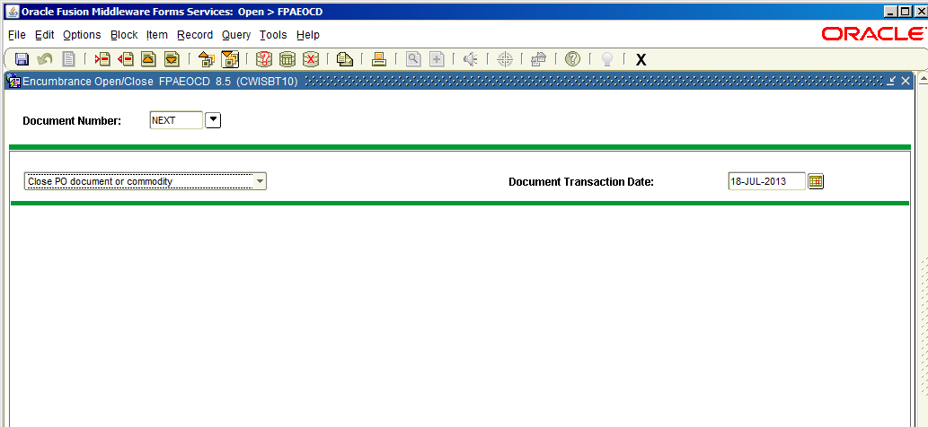

Select Next Block and enter the PO number. Place a check mark in the boxes for Close All Items and Change Accounting.
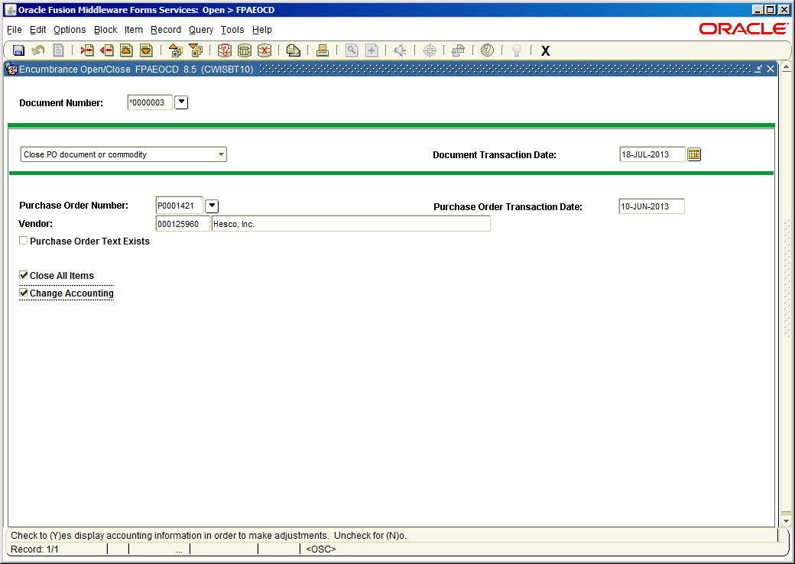

Select Next Block twice. In the Accounting Information Block, enter the amount to be unencumbered (as a positive number) in the Adjust Encumbrance By column.

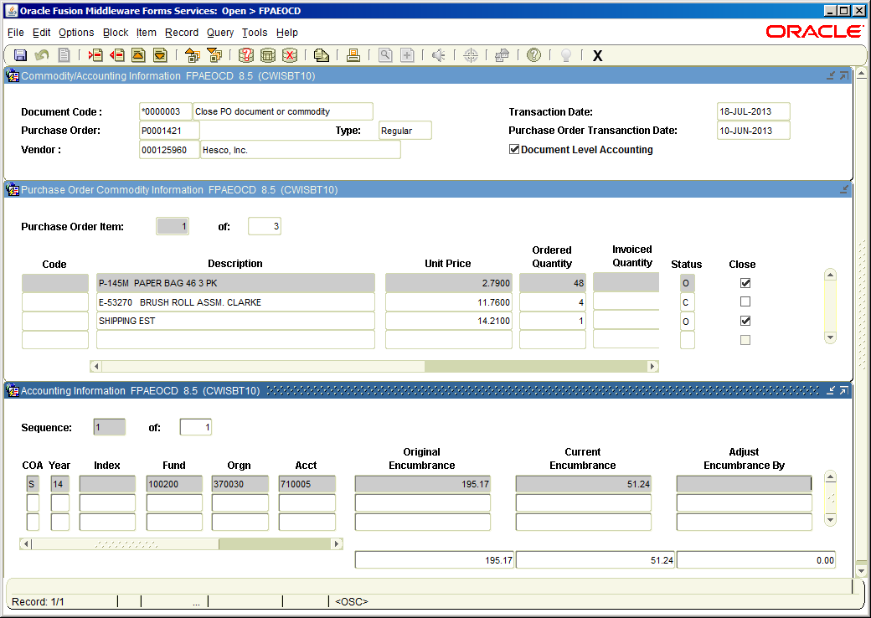

Click Complete from the Options menu. The auto hint line will indicate that the document has been forwarded to the posting process. Encumbrance transactions generated will need to be posted using FGRACTG.

View the PO status and closing transaction in FGIENCD. The close transaction document will start with an asterisk.
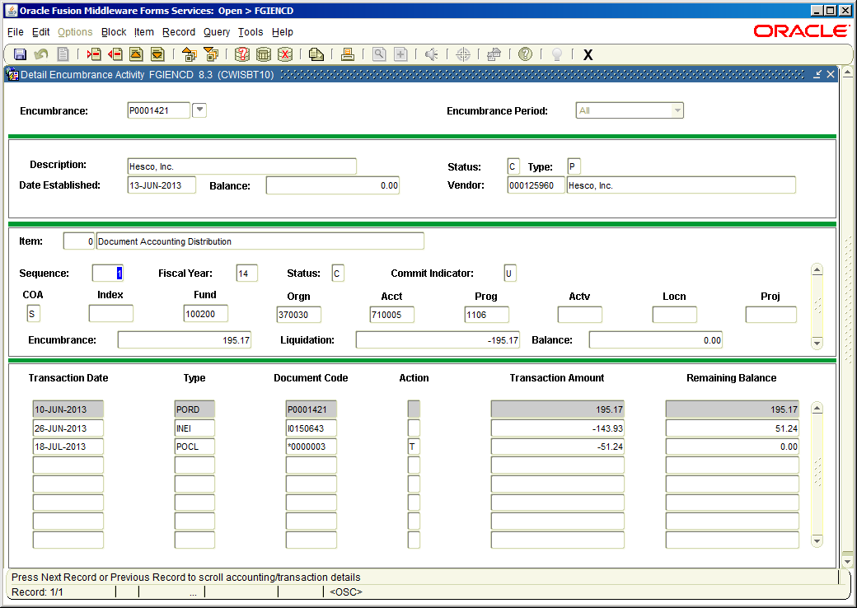

Closing and Liquidating a PO through a JE with rule code E032

In cases where a PO tied to a blanket order is cancelled with FPAPDEL the encumbrance amount is doubled rather than reversed. As of 8/6/15 this is a known Banner defect. To close and unencumber use FGAJVCD.

In the example below P0002846 is closed and liquidated in the amount of $126,000.00.
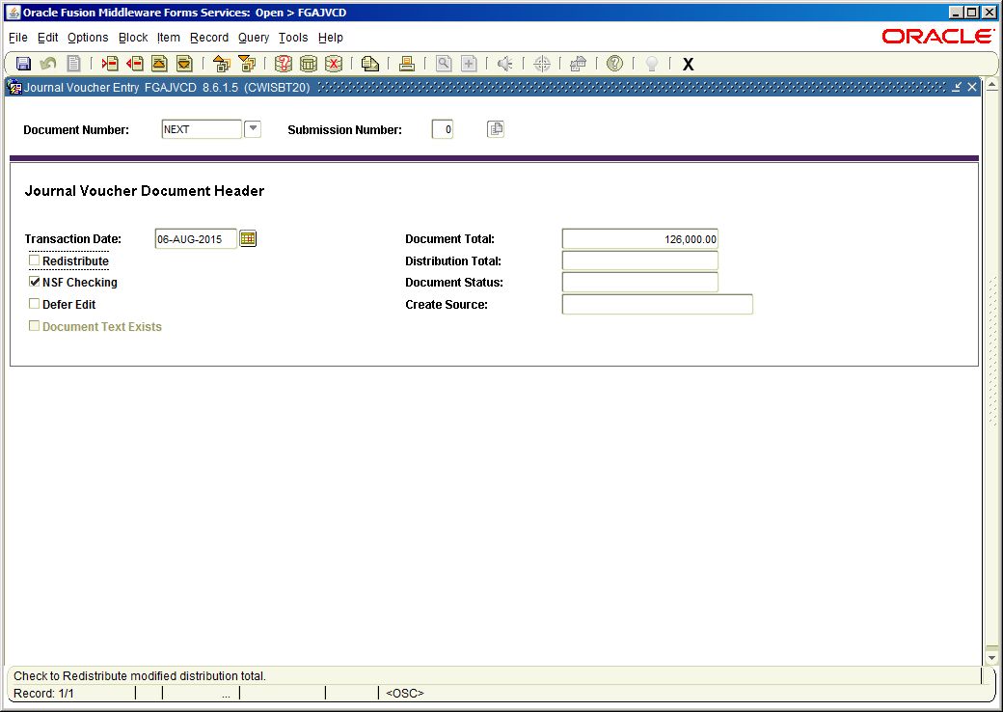

The FOAPAL code and amount must match the encumbrance amount. Verify on FGIENCD. The Debit/Credit field should use a Plus amount even though unencumbering. The item number should be zero and the sequence should match FGIENCD. For a complete cancel and liquidation select “Total” in the Action field. Send the document to the posting process and post through the normal process of FURFEED, FGRTRNI, FGRTRNR and FGRACTG. Verify the liquidation and close on FGIBDST and FGIENCD.

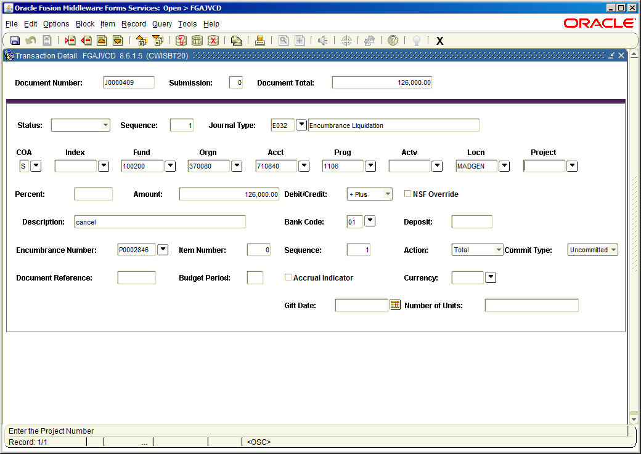

Removing Incomplete Change Orders

If a Change Order has not yet been completed, it can be removed in FPACHAR.

- Access the Change Order Form (FPACHAR) and enter the PO number and change sequence number that is incomplete.
- Perform a Next Block. The cursor will be in the Order Date field.
- Select Record, Remove from the menu. The auto hint line will display “Press ‘DELETE RECORD’ again to delete this record”.
- Select Record, Remove again. The auto hint line will display “All commodity and accounting records will be deleted”.
- Click on the OK button. A dialog box will confirm the deletion. Click OK again.
- You will be taken back to the beginning of FPACHAR with the auto hint line displaying “order/change sequence is invalid . . .”. This is not a problem, just close out of the form.

