FINANCIAL REPORTING SYSTEM OVERVIEW

The college’s accounting system uses a Chart of Accounts (COA) to provide the structure for collecting and retrieving financial data used by various interested parties. In Banner, the COA defines the accounting distribution used on all financial transactions in the Finance module.
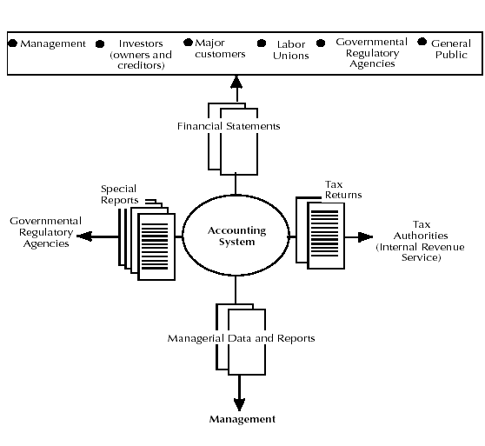
Chart of Accounts System

F -Fund
O -Organization
A -Account
P -Program
A -Activity
L -Location

Banner Chart of Accounts System – FOAPAL

The Banner chart of accounts system is known by the acronym FOAPAL which stands for Fund, Organization, Account, Program, Activity and Location.

The following table briefly describes the FOAPAL elements.

 | Element | Definition | Structure
F | Fund | A self balancing set of accounts. Used to identify financial transactions related to a specific activity or objective. For example, individual endowments or grants may have their own fund codes. Funds are also used to segregate certain types of data (like payroll data) so that individual access rights can be restricted by fund code. For financial statement purposes funds may be grouped into categories like Unrestricted, Temporarily Restricted and Restricted. | 6 digits
O | Organization | Represents a department or unit of budgetary responsibility within the institution. A single department (organization) could have many funds associated with it. Examples include grants, gifts or payroll activity. | 6 digits
A | Account | Identifies the specific type of transaction within the accounting categories of Asset, Liability, Equity, Revenue and Expense. Common expense categories include items like supplies, travel, hospitality . .etc. | 6 digits
P | Program | Program codes are used to group financial data into categories for financial statement presentation. Categories include Instruction, Research, Student Services, Auxiliary Enterprises . . etc. | 4 digits
A | Activity | An optional code used to further identify activities or transactions. This code is not currently being used. | 6 digits
L | Location | An optional code used to associate a physical location with a financial transaction. Primarily used to track fixed assets but also used for other situations such as segregating data by individual residence halls. | 6 digits

FOAPAL Example:

Fund Org Account Program
100200 310000 710000 1105
Non-Personnel
Business Office
Office Supplies
Institutional Support

Hierarchies And Ledgers

SNC COA and FOAPAL: This section is intended to help you understand the SNC chart of accounts (COA). Banner allows an institution to have multiple charts of accounts. In order to distinguish a chart, each chart is assigned a Chart Code. SNC only has one chart and its chart code is S. In the production database CWIS, S will be the only valid chart.

The Banner system uses six elements for accounting purposes. These elements are known by the acronym FOAPAL.

 | Banner Standard Definition | SNC Notes | Ledger
Fund  (Required) | A six character hierarchical code that identifies a self balancing set of accounts. Identifies ownership. | Fund is related to the FASB classifications of:  - Permanently Restricted  - Temporally Restricted  - Unrestricted  Fund includes the following major categories:  - Loans  - Endowments  - Annuities  - Gifts  - Grants  - Scholarships  - Programs  - Bank | Balance Sheet  General Ledger
Organization  (Required) | A six character hierarchical code that identifies a unit of budgetary responsibility. | Organization relates to a Budget Unit or Payroll Classification. Departments are classified so that information will roll up to the responsible VP.  An Organization can be associated with more than one Fund. | Operating Ledger
Account  (Required) | A six character hierarchical code that identifies objects, such as assets, liabilities, fund balance, revenues, expenditures, transfers. | Account identifies the specific category of accounting classification. This includes revenues, expenses, transfers, assets, liabilities, and fund balances.  An Account can be used in association with any Fund, Organization, Program, Activity, or Location. | Balance Sheet  General Ledger
Program  (Required) | A four character code that identifies function, such as instruction, research, or institutional administration. Program codes are used to group financial data into categories for financial statement presentation. | Program identifies operating and non-operating activities for:  Revenues & Expenses  Education and General Expenses including:  - Instruction  - Research  - Public Service  - Academic Support  - Student Services  - Institutional Support  - Operation & Maintenance of Plant  Auxiliary Enterprises  Interest on Indebtedness  Depreciation Expense  Releases from Restriction  A Program can be used in association with any Fund, Organization, Activity, or Location. | Operating Ledger
Activity  (Optional) | A six character, non-hierarchical code that can be used to further define an object. | Activity can be used to further identify the object of a revenue or expense. It is generally used to identify a specific project, program, course, or activity. In association with the other components of the FOAPAL, it provides very detailed distribution and reporting. | Operating Ledger
Location  (Optional) | A six character hierarchical code that identifies physical locations. | Location identifies where fixed assets are located. It can also be used to identify revenues and expenses generated by a building or room. | Operating Ledger

Ledgers

The General Ledger (G/L) and Operating Ledger (OPAL) are the ledgers most commonly referred to and for which most reporting is done.

General Ledger (G/L):
- Incorporates data for assets, liabilities, fund balances, control accounts, budget and encumbrance control.
- Requires Fund and Account
- Transactions include Beginning Balances and Current Activity.

Operating Ledger (OPAL):
- Incorporates data for the nominal accounts including revenue, expense and transfers.
- Requires Fund, Organization, Account, and Program.
- Optional elements are Activity and Location.
- Transactions include original budgets, budget adjustments, encumbrances, and YTD actuals.

Other Ledgers that are used within Banner are:

Encumbrance Ledger:
- Incorporates PO’s, requisitions, labor and general encumbrances.

Grant Ledger:
- Incorporates activities including revenue, labor, and expenses associated with specific grants.
- Allows grant year to be different than fiscal year.

Budget Availability Ledger:
- Incorporates budget, encumbrance, reservation, and expenses.
- Is used to check budget availability in PO’s, JE’s, etc.

Hierarchy

The hierarchical structure of the FOAPAL elements (excluding Activity) provides for roll-up reporting. For example, the account 71000 Supplies has multiple detail accounts under it, ranging from 710000 through 710049. Each of these detail accounts can be reported or a summary report which sums the detail accounts into account 71000 could be generated.

Data Entry

In order to use a FOAPAL element in the accounting distribution of a transaction, the element must be marked for Data Entry. When you do a search, the query screen will show a No or Yes in the Data Entry field. You must choose an account with Y in Data Entry. Roll-up accounts are not available for data entry.

Credit/Debit

When entering a General Ledger transaction, use D or C.

When entering an Operating Ledger transaction, use a plus (+) or minus (-).

Normal Balance

Every account is assigned a Normal Balance of either Credit or Debit.
Account Begins With | Account Type Description
1 | Assets
10 | Cash and Cash Equivalents
11 | Investments
12 | Accounts Receivable-Student
13 | Accounts Receivable-Other
14 | Notes Receivable
15 | Pledges Receivable
17 | Inventories
18 | Deferred Charges
22 | Assets Held by Trustees
23 | Assets Held by the Premont Fathers
26 | Fixed Assets
29 | Other Assets
2 | Liabilities
30 | Accounts Payable
31 | Annuities and Interest Payable
32 | Accrued Payroll
33 | Faculty Contracts Payable
34 | Interest Payable
35 | Funds Held in Custody for Others
36 | Student Deposits Held in Trust
37 | Deferred Revenue
38 | Accrued Postretirement Benefit Cost
39 | Long-Term Debt
40 | Capital Lease
43 | Due to/Due from
3 | Control Accounts
45 | Control Account
4 | Net Assets
47 | Net Assets
5 | Revenues
50 | Revenues
6 | Labor
60 | Labor
7 | Expenses
70 | Expenses
8 | Transfers
80 | Transfers In
81 | Transfers Out

