St. Norbert College

Financial Procedures Guide
(2021)

CONTENTS

CONTENTS 2
THE BIG FINANCIAL PICTURE 4
College Financial Overview 4
Administrative Software System Overview 4
Fiscal Year 5
Accrual Basis of Accounting 6
Types of Accounts 6
Financial Statements 7
Statement of Financial Position (a.k.a. Balance Sheet) 7
Statement of Activities (a.k.a. Income Statement) 7
Statement of Cash Flows 7
COLLEGE ADMINISTRATIVE SYSTEMS 7
Access to Financial Information 7
Banner Chart of Accounts System - FOAPAL 8
Basic Banner Financial Forms and Reports 10
Business Objects Reports 14
COLLEGE BUDGET MANAGEMENT 17
Budget Basics 17
Budget Management Overview 18
Budget Manager Responsibilities 18
Requesting Transfers, Adjustments and Corrections 19
Budget Development 20
Understanding and Managing Agency Funds 20
Understanding Endowments 21
Endowment Asset Pooling 21
Endowment Spending Policy 22
Managing Endowment Activity 23
Fiscal Year-End 23
CASH MANAGEMENT 24
Deposit of Receipts 24
Policy: Deposit of Receipts 24
Petty Cash 25
Change Funds 26
Check Cashing 26
PURCHASING AND CASH DISBURSEMENTS 26
Decentralized purchasing and receiving 27
Purchasing related policies and guidelines 27
Recommended suppliers 28
Interdepartmental sales and purchases 29
Cash disbursements through Accounts Payable 29
Purchasing Cards (P-cards) 30
Travel and Expense Reimbursements 32

THE BIG FINANCIAL PICTURE

College Financial Overview
College operations are organized into operational units that execute strategic and operational plans in support of the college’s mission, vision and objectives. Operational units collect and utilize financial resources which are recorded as transactions in the college’s financial accounting system. The financial records are essential for providing necessary information to various stakeholders such as auditors, banks, taxing authorities, lenders and internal management.
• Management • Trustees • Lenders • Auditors • Regulatory Agencies

Administrative Software System Overview
The college uses Ellucian’s Banner software for the following administrative modules: student, financial aid, and finance. Although modules are integrated, a great deal of cooperation and collaboration between operational units is necessary to support efficient flows of data. The college uses Workday for Payroll, Adaptive Planning and HR and Advancement uses Raiser’s Edge.

The finance module is the central repository for all financial transactions. All other modules and any non-Banner systems that generate financial transactions must integrate with the finance module.

The image below shows the flow of data:
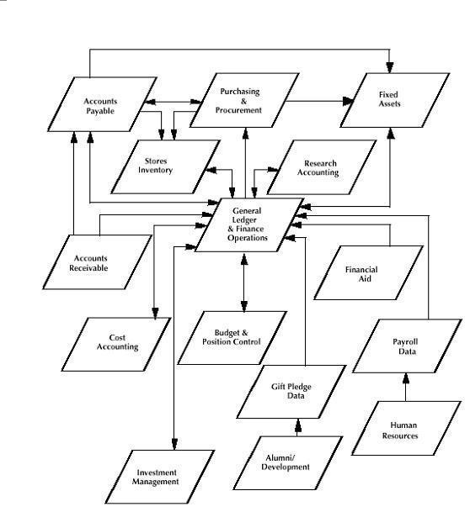

Fiscal Year
The college’s fiscal year runs from June 1 through May 31. This 12 month period is used for budgeting, accounting and financial statement purposes. All financial transactions in the automated financial systems of the college have a designated transaction date which determines the fiscal year in which they will be included. The fiscal year is divided into 12 monthly periods or fiscal months. In the case of a June 1 through May 31 fiscal year, the fiscal months are numbered as follows:

June: 1 | July: 2 | August: 3 | September: 4 | October: 5 | November: 6
December: 7 | January: 8 | February: 9 | March: 10 | April: 11 | May: 12
Accrual: 14

Period 14 is the accrual period which is available for year-end closing entries. At SNC the accrual period is rarely used, however, when running reports based on periods, using period 14 is recommended to insure inclusion of all possible transactions for a year.

Although most college operations are based on the fiscal year (June 1 – May 31), certain benefit related operations run on a calendar year. This would include the Medical Benefit, Dental and Flexible Spending plans.

Accrual Basis of Accounting
The college uses the accrual basis of accounting rather than the cash basis. Under the accrual method of accounting revenues are recorded when earned, and expenses are recorded when incurred which is different than cash basis accounting where revenues and expenses are recorded when cash is received or disbursed. Although accrual and deferral entries could be computed monthly, the college generally only applies adjusting accrual and deferral entries as part of the year end closing process.

In practical terms, for year-end expenses, the timing of the delivery of goods or services generally determines the fiscal year in which they will be recognized regardless of the actual cash disbursement date. For example, if goods were ordered 2 weeks before the end of a fiscal year but were delivered 2 weeks after the end of the fiscal year, the associated expenses would be charged to the fiscal year in which the goods were delivered regardless of when the actual cash disbursement was made.

Similarly, revenue is recognized when earned not necessarily when the actual receipt of funds occurs. For example, if a student were to prepay tuition a year in advance, the college would not recognize the revenue until the fiscal year in which the educational services would be provided (earned). Until then, the funds would be recorded as a liability.

Types of Accounts
Financial transactions are accounted for in five major account types; assets, liabilities, equity, revenues and expenses. A basic understanding of the account types is helpful in interpreting financial information.

Account Type | Informal Description
Asset | Things of value owned by the organization.
Liability | Amounts owed to external parties.
Equity (also called net worth or net assets) | The difference between assets and liabilities, theoretically the amount that would be received upon liquidation of the business.
Revenue | Amounts earned from external sources.
Expense | Amounts paid to external sources for goods or services.

Financial transactions are recorded as either debits or credits to accounts thereby increasing or decreasing account balances.

Account Type | Debit | Credit | Normal Account Balance | Example Debit | Example Credit
Asset | Increase | Decrease | Debit | 100 + | 100 -
Liability | Decrease | Increase | Credit | 100 - | 100 +
Equity | Decrease | Increase | Credit | 100 - | 100 +
Revenue | Decrease | Increase | Credit | 100 - | 100 +
Expense | Increase | Decrease | Debit | 100 + | 100 -

Financial Statements
The college prepares financial statements on a monthly basis for assessing its financial status and results of operations. Three main statements are produced as described below:

Statement of Financial Position (a.k.a. Balance Sheet)
The primary purpose of the Statement of Financial Position is to provide relevant information about the college’s assets, liabilities and net assets and their relationships to each other at a moment in time. The information contained in the Statement of Financial Position provides help in assessing the following:
- The college’s ability to provide services.
- The college’s liquidity, financial flexibility, ability to meet obligations and needs for external financing.

Statement of Activities (a.k.a. Income Statement)
The primary purpose of the Statement of Activities report is to provide relevant information about revenues and expenses during a specific period of time. The information contained in the Statement of Activities provides help in assessing the following:
- The college’s performance during the period.
- The college’s service effort and ability to continue providing the service.
- How the college’s management has discharged its stewardship responsibilities and other aspects of performance.

Statement of Cash Flows
The primary purpose of the Statement of Cash Flows is to provide relevant information about the cash receipts and cash payments of the College during the period. The information contained in the Statement of Cash Flows provides help in assessing the following:
- The college’s ability to generate positive future net cash flows.
- The college’s ability to meet obligations and its needs for external financing.
- The College’s differences between net income and associated cash receipts and payments.
- The effects of the college’s financial position of cash and noncash investing and financing transactions during the period.

The average budget manager is generally not concerned with the financial statements of the college but, rather, is more concerned with individual transactions and departmental accounts and results. Both the College’s financial statements, which represent aggregate views of the underlying financial transactions, and the financial transactions themselves must comply with various laws, regulations and accounting principles. Budget managers involved in generating financial transactions should be aware that accounting principles, laws or regulations may apply and govern the coding, timing or other transaction characteristics.

COLLEGE ADMINISTRATIVE SYSTEMS

Access to Financial Information
Each division of the college determines which staff members have financial oversight over specific divisional operational units. Access to financial information through the Banner Finance module or Business Objects, a third party reporting tool, is accomplished through supervisory authorization of fund and organization codes and training that emphasizes understanding financial information and generating reports.

Steps for access to Business Objects finance reports for a new user are listed below:

- User’s supervisor to complete a Finance Access Request Form and forward to Business & Finance department. The form formally authorizes access to specific fund and org codes.
- Once a completed form is received in Business & Finance, a project request is submitted to Information Technology Services (ITS) to create necessary accounts, assign security classes and generate a password.
- When ITS notifies Business & Finance of completion, fund and org code rights specified in the Finance Access Request Form will be set-up.
- Business & Finance staff will then offer to meet with the new user to explain how to access, run and interpret reports. The users’ password will be delivered at the meeting. This is typical. If the user declines, the users’ department or division will be responsible for training and the password will be emailed. This is not typical. Meetings are generally scheduled for one hour and involve the following:
  - Accessing and running financial reports is demonstrated
  - Detailed, step-by-step handouts are provided
  - Question are encouraged
  - After the meeting a follow-up email is sent with links to electronic versions of meeting handouts and links to more financial information and documentation. Banner training is offered if needed (as opposed to Business Objects). Assistance with questions or running reports is offered.

Banner does not allow access limitations on set combinations of fund and organization codes, therefore, a user will have access to data for any combination of fund and organization codes for which authorization is granted. The accounting services department web site contains specific information on finance access and training.

It is important for supervisors and administrators to periodically consider security rights in relation to current staff duties. As users’ duties change, access needs should be reevaluated and added or removed as appropriate. This is particularly important for staff changing positions within the college. Both adding and removing of access rights is not done automatically and must be explicitly authorized. The Finance Access Request Form can be used for both adding and removing rights.

Banner Chart of Accounts System - FOAPAL
The chart of accounts is a coding system for recording, tracking, classifying and reporting financial (budget and actual) transactions. It provides the structure for collecting, storing and retrieving financial data. The Banner chart of accounts system is known by the acronym FOAPAL which stands for Fund, Organization, Account, Program, Activity and Location.

The following table briefly describes each FOAPAL element.

 | Element | Definition | Structure
F | Fund | A self- balancing set of accounts. Used to identify financial transactions related to a specific activity or objective. For example, individual endowments or grants may have their own fund codes. Fund codes are also used to segregate certain types of data (like personnel data) so that individual access rights can be restricted. For financial statement purposes funds may be grouped into broad categories like Unrestricted, Temporarily Restricted and Permanently Restricted. | 6 digits
O | Organization | Represents a department or unit of budgetary responsibility within the institution. A single department (organization) could have many funds associated with it. For example, the Chemistry org code could have grant, payroll and student wage funds associated with it. | 6 digits
A | Account | Identifies the specific type of transaction within the accounting categories of Asset, Liability, Equity, Revenue and Expense. Expense codes represent items like supplies, travel, equipment . . .etc. | 6 digits
P | Program | Program codes are used to group financial data into categories for financial statement presentation. Categories include Instruction, Research, Student Services, Auxiliary Enterprises . . etc. | 4 digits
A | Activity | An optional code used to further identify activities or transactions. | 6 digits
L | Location | An optional code used to associate a physical location with a financial transaction. Primarily used to track fixed assets but also used for other situations such as segregating data by individual residence halls. | 6 digits

FOAPAL Example:

Fund Org Account Program (Activity and Location not used in example)
100200 310000 710000 1105
Non-Personnel
Business Office
Office Supplies
Institutional Support

Financial transactions relating to balance sheet accounts (assets, liabilities or equity) require a minimum of a fund and an account to be processed in Banner. Transactions relating to the income statement (revenues and expenses) require a minimum of a fund, organization, account and program. In addition, Banner assigns transactions to one of its two ledgers or recording systems (General or Operating) based on the account type. Individual account codes are grouped into ranges which are associated with account types for quick and systematic categorization.

Account Type | Account Code range | Normal  Account Balance | Debit | Credit | Required FOAPAL elements | Ledger
Asset | 100000 - 299999 | Debit | Increase | Decrease | Fund, Account (FA) | General
Liability | 300000 - 440000 | Credit | Decrease | Increase | Fund, Account (FA) | General
Equity | 470000 - 479999 | Credit | Decrease | Increase | Fund, Account (FA) | General
Revenue | 500000 - 599999 | Credit | Decrease | Increase | Fund, Org, Account, Prog (FOAP) | Operating
Expense | 600000 - 899999 | Debit | Increase | Decrease | Fund, Org, Account, Prog (FOAP) | Operating

The relationship between financial transaction entries and end-user financial reports is shown below:

transaction detail and history
asset, liability or net asset transactions
(account code range 100000 – 479999)
(requires Fund and Account)
revenue or expense transactions
(account code range 500000 – 899999)
(requires Fund, Org, Account and Program
General Ledger
Operating Ledger
balance sheet
management reports
income statement
management reports

Basic Banner Financial Forms and Reports
Banner software is delivered with a standard set of financial forms and reports. The various forms and reports allow users to obtain data in varying levels of detail based on selection parameters (key values). A form will return data within a Banner window while a report is run from a process and will display data outside of the Banner application, usually in a browser window. Common end-user forms and reports are briefly described below:

- FGIBDST – Organization Budget Status Form
- FZRBDSC – Budget Status (Current Period) Report
- FGIBSUM – Organization Budget Summary Form
- FZRODTA – Organization Detail Activity Report

FGIBDST – Organization Budget Status Form
This form allows users to query the status of accounts based on selected key values. It displays information in a typical financial format with columns for Adjusted Budget, YTD Activity, Commitments and Available Balance.

FZRBDSC – Budget Status (Current Period) Report
This form allows users to query the status of accounts based on selected parameters. It provides the same information as FGIBDST but in a report format and for time periods other than year-to-date.

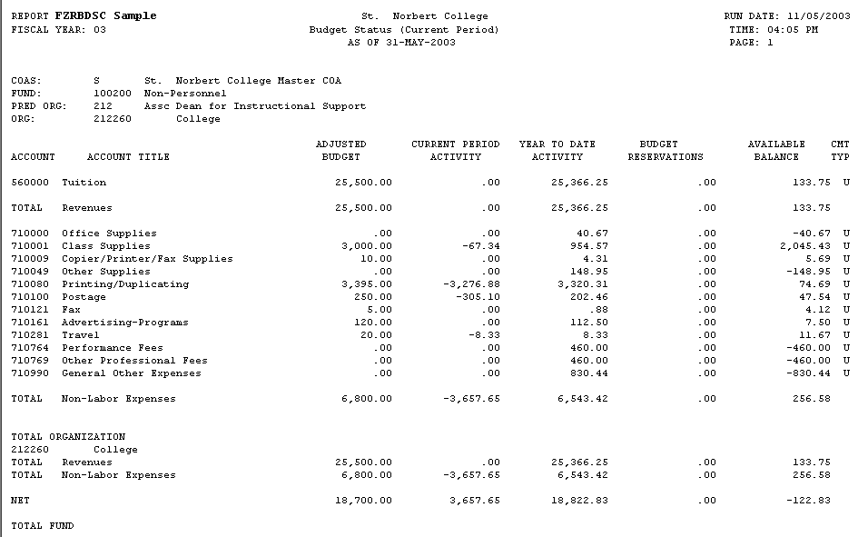

FGIBSUM – Organization Budget Summary Form
This form provides a view of an organization’s status summarized by major category (Revenue, Labor, Expenditures and Transfers). The information is a summarized version of data available in FGIBDST.

FZRODTA – Organization Detail Activity Report
The Organization Detail Activity Report displays individual line-item transactions (budget, actuals and encumbrance) for accounts within specified fund and organization codes. The report can be useful for viewing and tracking the status of individual transactions. The information is a detailed version of data available in FZRBDSC.

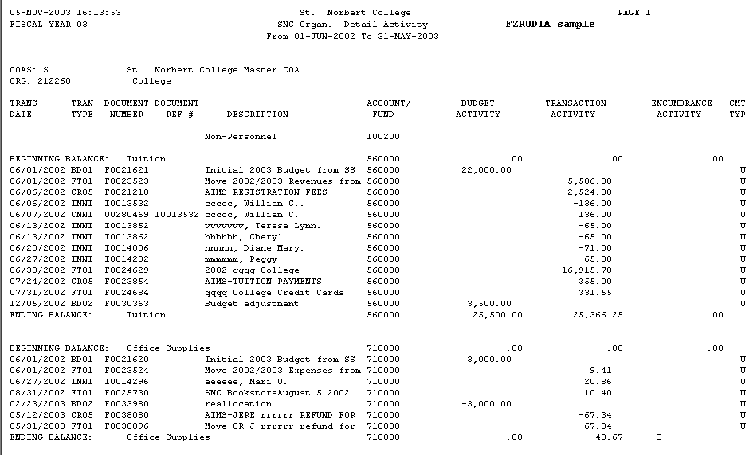

Business Objects Reports
Business Objects is a reporting tool that allows users to run customized reports based on data within the college’s administrative system (Banner) database. Advantages of Business Objects over Banner include ease of use, better output options and the ability for reports to be scheduled at future specified times and emailed to selected recipients.

Business Objects can be accessed from a link on the main Campus Wide Information System web page (https://www.snc.edu/cwis/).

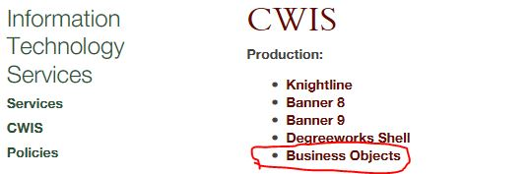

Click the Business Objects link and login using a network username and ID. Some reports have been developed and deployed for special departmental data needs and some are general and available to all Business Objects users with finance rights. Several of the general financial reports are described below:

- FIN – Budget Status by Orgs (summarized line item financial data for selected org(s))
- FIN – Budget Status by Orgs-Funds (summarized line item financial data for selected org(s) and funds)
- FIN – Comparative Bud Status by Org 2 FYR (two years of comparative year financial data by selected org)
- FIN – Transactions by org and fund (Detailed transaction level data by selected org and fund codes)

For general reports, a users’ access is limited to supervisory authorized fund and organization codes. The general finance reports are located in the following Business Objects directory structure: Public Folders > Finance Public > General Reports.

FIN – Budget Status by Orgs
This report is similar to Banner’s FZRBDSC. It provides subtotals for Revenues, Non-Student Labor, Student Labor, and Non-Labor Expenses. It also displays a breakdown of the Adjusted Current Budget in terms of Temporary Budget and Permanent Budget.

sample
sample
FIN – Budget Status by Orgs-Funds
The report format is the same as Fin-Budget_Status_by_Orgs but allows the user to select specific funds. This can be helpful in isolating data for grants, endowments or other purposes relating to specific funds.

FIN – Comparative Bud Status by Org 2 FYR
This report shows comparative financial data for two years.

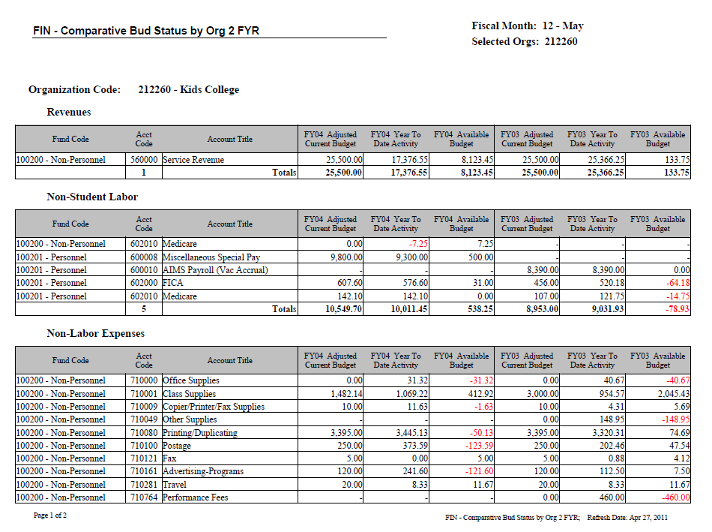
sample

FIN – Transactions by org and fund
Detail transaction level data is displayed for each account.

sample

COLLEGE ACCOUNTING MANAGEMENT

Requesting Transfers, Adjustments and Corrections
Accounting adjustments in the form of transfers or corrections are common and necessary in the course of normal business operations. The first step in requesting an adjustment is to determine whether a budget or journal entry is needed. This choice may seem obvious to those with a financial background but non-financial managers have a tendency to classify all adjustments as budget not recognizing the distinction between budget and actuals. The criteria for requesting a journal entry is described below.

A Journal Entry is used to adjust actual revenue or expenses earned or expended. Journal entries are also used to adjust balance sheet accounts including assets, liabilities and fund balances. A common use of a journal entry is to make coding adjustments where, for example, a particular fund, organization or account incurred expenses that need to be recorded in a different fund, organization or account.

The image below shows where journal entry adjustments will impact financial data in a typical Banner report like FGIBDST – Organization Budget Status.

A journal entry will change data in this column

The recommended procedure for submitting a journal entry is to use a Journal Entry Request Form available on-line from the Accounting Services Department webpage. Emailing a completed form to the appropriate Accounting Services department contact is the most efficient method for submitting entries. The form provides a standardized structure for collecting data elements required by the Banner system. Emailing the file affords Accounting Services staff the option of cutting and pasting data into Banner input forms whereas any data submitted as a hardcopy must be completely rekeyed. The on-line form includes sample journal entries, Accounting Services department contacts and a frequently asked question section. Using the on-line form, which is a Microsoft Excel file, has the advantage of subjecting data to certain rudimentary validation checks meant to minimize errors or omissions. For example, a warning would display if a 5 digit organization code were entered rather than the required 6 digits as specified in Banner’s coding structure.

Understanding and Managing Agency Funds
Agency funds are held in a custodial capacity by the college for faculty, staff, student organizations or others closely aligned with the college’s mission. Agency funds are held in trust for others so do not involve measurement of college revenues and expenses. Accordingly, financial activity, both inflows and outflows, is usually recorded in a single assigned liability account. A running balance similar to a checking account is maintained. The standard Banner financial reports available to budget managers apply to income statement accounts (revenue and expense) only so cannot be used to view Agency Fund activity. Normally, in the case of Agency Funds, customized Business Objects reports must be created to allow budget managers to view specific Agency Fund account activity.

An example of a college Agency activity is Discoveries International. This student led organization sells products and generates payments for goods and services. All of Discoveries International’s financial transactions are recorded in the college’s financial system as liability entries. A credit balance in the Discoveries International’s liability account represents funds held in trust by the college while a debit balance represents amounts owed to the college.

Any transfers, adjustments or corrections involving Agency accounts must be processed as journal entries. Also, financial transactions relating to balance sheet accounts (assets, liabilities or net assets) require only a Fund and an Account to be processed in Banner whereas transactions relating to the income statement (revenues and expenses) require a minimum of a Fund, Organization, Account and Program.

Understanding Endowments
An endowment is a financial arrangement that can be used to provide long-term or even permanent funding to the college. Endowments are a critical component of the college’s fund raising efforts and significantly contribute to ongoing college financial resources. Typically endowments are targeted for particular organizational needs such as student scholarships, endowed faculty chairs or supporting academic programs. The terms “scholarship endowment” and “program endowment” are used to distinguish an endowment’s purpose as relating to either student scholarships or support of other college purposes.

There are three primary categories of endowments: with donor restriction endowments, with donor time restriction endowments and without donor restriction endowments.

- With donor restriction endowments are funds where the principle or corpus is held in perpetuity and invested. Only the return on investment may be used as a funding source.
- With donor time restriction endowments endowments are similar to donor restriction endowments except that all or part of the principle may be used after a stated period of time or upon the occurrence of a certain event.
- Without donor restriction endowments are funds from which either the investment return or some portion of the principal may be used as needed.

When donors agree to fund an endowment they enter into a legal agreement that spells out any special conditions or donor stipulations. Although uniformity in donor agreements is simpler for the administration of funds, many varieties of agreements are in effect to accommodate specific donor stipulations and to broaden the pool of potential donors.

Endowment Asset Pooling
Endowment assets are invested in either a pooled or non-pooled method. Pooled assets are managed similar to a mutual fund whereby individual endowments are accounted for separately yet funds are commingled for investing and accounting efficiencies. Non-pooled assets are invested according to donor stipulations which may involve specific types of financial instruments. Each participating pooled endowment is assigned a number of units in the pool at the time the endowment is established. The process of calculating units in the pool per endowment is called unitization. The number of units is adjusted monthly to include endowment additions.

Unitization Example based on a single endowment
Pool Market Value | 10,000,000
Units | 100,000
Market Value per Unit (pool market value / units) | 100

If a new $15,000 endowment were added to the pool the number of additional units would be 150 ($15,000 endowment / $100 market value per unit).

Unitization Example with added endowment
Pool Market Value | 10,015,000
Units | 100,150
Market Value per Unit (pool market value / units) | 100

The market value of the endowment is the original donation plus additions plus investment earnings and appreciation, less distributions and fees. Monthly market value is determined by summing the value of all investment vehicles included in the pool. New pooled unit valuations are made by dividing the total market value by the number of units.

Example Market value and pooled unit valuations
 | Units | Price Per Share | Market Value
Starting Pool Market Value |  |  | 10,000,000
Units | 100,000
Market Value per Unit (pool market value / units) |  | 100
Gifts | 150 |  | 15,000
Add: Net Income (interest plus dividends minus fees) |  |  | 70,000
Add: Earnings and appreciation (realized and unrealized gains and losses) |  |  | 200,000
Less: Distributions | -500 |  | -50,000
Ending Pool Market Value |  |  | 10,235,000
Ending Market Value per Unit and Shares | 99,650 | 103

Endowment Spending Policy
When a donor makes a gift to establish an endowment, two funds are created; a restricted fund representing the fund’s principle (gifts and reinvested income) and a spendable fund which records budgeted distributions and actual expenditures in accordance with the endowment agreement. The budgeted distribution or amount available to spend is based on the college’s endowment spending policy.

Each year, the board of trustees, exercising their fiduciary responsibilities, establishes the spending rate for the next fiscal year. The spending rate determines each fiscal year’s allocation of spendable funds. Spending rates are typically determined from a formula based on historical market values which reduces volatility in payout rates.

As an example, let’s say a spending policy uses an average market value of 12 quarters which amounts to an average unit value of $75. Let’s also presume the institution has established a spending rate of 4.5% of the 12 quarter average market value. An endowment with 150 units would generate an annual spending amount of $506.25 (150 units x $75 (avg 12 qtr unit value) x 4.5%).

Managing Endowment Activity
Each college endowment is assigned a unique Banner fund code to enable tracking of endowment activity. There are several hundred endowment fund codes in the Banner system. When assigning expenses to endowments, budget managers must be careful to use the endowment’s spendable fund code as part of the fund-organization-account combination required to post expenses in Banner. Each endowment fund’s particular Banner fund code is the key to tracking its financial transactions. Budgeted spending allocations are generally coded to account 710995-Endowment Spending although they may at times be spread to other accounts like salary and fringe accounts. Actual expenses are charged to appropriate expense accounts such as Travel or Supplies.

Below is an example of financial data relating to an endowment that was allocated $5,000 in spendable funds.

Organization: 123456 – College Operations
Fund: 129999 – Endowment 1
Account | Account Title | Budget | Year-to-date (actuals) | Available Balance (Variance)
Expense
700000 | Office Supplies |  | 1,500 | -1,500
710100 | Postage |  | 600 | -600
710281 | Travel |  | 0 | 0
710995 | Endowment Spending | 5,000 |  | 5,000
Net Total |  | 5,000 | 2,100 | 2,900

For expenses to be correctly charged to the endowment, the fund code of 129999 and org code of 123456 must be used along with the appropriate account for the particular category of expense (travel, supplies, postage . . . etc.). In the example above, $5,000 was the designated spendable amount and $2,100 has been expensed to date. For budget management purposes, it is important that the net total year-to-date does not exceed the net total budget.

Fiscal Year-End
The close of each fiscal year involves preparation of financial statements in accordance with generally accepted accounting principles. Year-end financial statements are audited by independent external auditors who issue an opinion as to their fairness and conformity with accounting principles. The desired result of an audit is an unqualified audit opinion. Anything else could adversely affect the college’s accreditation, credit rating, recruiting and reputation.

The audit includes an examination of evidence supporting amounts and disclosures in the financial statements as well as assessing accounting principles used. Auditors conduct the bulk of their work on site during several weeks following the May 31 end of each fiscal year. In order to close the year and prepare financial statements in a timely manner, budget managers must expedite any paperwork involving receipts and disbursements relating to the year being closed. Delays can extend the audit timeline resulting in extra staff work and likely add to audit costs.

The college uses the accrual basis of accounting requiring various year-end accounting adjustments including accruals and deferrals. To assist with timely preparation of year-end entries, cut-off dates will be publicized for certain types of transactions. For example, the Accounts Payable function will have cut-off dates for payment of vendors and payment of staff travel reimbursements. After the cut off dates, transactions will no longer be posted to the year being closed.

In the case of vendor payments, expenses are generally charged to the fiscal year in which goods or services are received regardless of when the actual cash disbursement is made. Budget managers should take care when ordering goods or services near year-end to insure that delivery occurs within the fiscal year that expenses are intended to be charged. In no case is it appropriate to charge an expense to a fiscal year solely because budget is available. The facts and circumstances of the transaction and correct accounting treatment take precedence over budget availability.

Special accounting consideration must be given to transactions that relate to more than one fiscal year such as service agreements, annual or multi-year contracts or license agreements. Due to the variety and complexity of year end expense situations, judgment and discretion must be used on the part of accounting services staff and auditors in terms of apportioning expenses to fiscal years. For transactions that don’t fit neatly or cleanly into a particular fiscal year, the accounting principles of consistency and materiality may be considered as well as efficiency and historical precedence.

CASH MANAGEMENT

Deposit of Receipts
Cash represents one of the college’s most sensitive assets. In order to insure appropriate accounting and safeguarding, necessary controls must be in place. The following deposit of receipts policy supports appropriate cash controls:

Policy: Deposit of Receipts

In consideration of sound business practices and internal financial controls, St. Norbert College requires that all receipts (cash, checks, money orders or other financial instruments) be transmitted to the Bursar Office on a timely basis. This policy helps the College optimize cash flow, maximize short-term investment income, safeguard assets and reduce administrative burdens associated with stale-dated checks and cancelled credit cards.

It is preferred that all receipts of the college be hand-delivered to the Bursar Office daily, but never later than within five business days of receipt. Any College funds held by a department should be stored in a secure, locked area. If a department does not have a secure locked area, transmittals should be made to the Bursar Office daily. Unless special arrangements have been made, any department or employee accumulating $1,000 or more should make a transmittal to the Bursar Office within the day.

For audit, documentation and accountability purposes, it is required that any physical transfer of funds to the Bursar Office be accompanied by a Deposit Transmittal Form or other written documentation indicating the following:

- Transmittal date
- Transmitting department
- Breakdown of cash, coin, checks . . . etc., including a grand total
- Source and/or purpose of funds
- Banner system coding (fund, organization and account) to which deposit is to be applied
- Signature of person responsible for deposit

All deposits should be hand delivered to a Bursar Office employee who will provide a receipt for transmitted funds. Deposits should not be routed through internal mail or placed on the Bursar Office counter. Obtaining a receipt is very important to protect both depositors and the Bursar Office.

Deposit transmittal forms can be accessed from the forms link on the Accounting Services Department web page.

Petty Cash
Petty cash funds have been established at various locations on campus for the purpose of reimbursing individuals for small, incidental business related expenses. The recommended maximum reimbursement amount is $30. For administrative efficiency, petty cash is the preferred method of reimbursement of expenses under $10. Each petty cash fund is assigned to a custodian who has responsibility for appropriate administration and safeguarding of the fund.

Petty cash funds are to be maintained on an imprest basis meaning that the sum of cash on hand plus receipts or other documentation of disbursements must equal the total authorized fund amount. Written documentation including original receipts should be maintained for each petty cash payout. At a minimum the documentation should include the name of the individual receiving cash, the business purpose and/or itemized list of purchases for which petty cash is being requested, amount, date and banner coding for charging the expense. For audit purposes, original receipts or a written explanation of why there is not an original receipt should be maintained for each payout.

Custodians are responsible for restricting access and safeguarding funds. For internal control purposes, accounting services department staff may make periodic unannounced audits of petty cash to verify balances and supporting documentation.

Establishment of petty cash funds or changes in amounts must be approved by the Controller. To insure appropriate control and accountability, the Controller should be notified whenever a change of custodian occurs.

Petty cash funds have been established at the following campus locations:
- Admissions
- Mulva Fitness Center-Athletics
- Sensenbrenner-lower
- Bemis 304
- Boyle Hall 333
- Facilities Service Center 103
- Mail Center
- Main Hall 107
- Mulva Library 111

Change Funds
Change funds are essentially cash advances from general college funds to custodial departments for the purpose of making change. The amount of a change fund remains constant and does not require periodic reimbursement. Change funds may not be used to make petty cash disbursements or other cash advances. Custodians are responsible for restricting access and safeguarding funds. For internal control purposes, accounting services department staff may make periodic unannounced counts of change funds to insure proper accountability is being maintained.

Establishment of change funds or changes in amounts must be approved by the Controller. To insure appropriate control and accountability, the Controller should be notified whenever a change of custodian occurs.

Change funds have been established in the following campus locations:
- Mulva Fitness Center
- Todd Wehr 128
- Cofrin 328
- PAC
- Kress Inn
- Mail Center
- Todd Wehr 124

Check Cashing
As a convenience to students and staff, certain types of checks may be cashed on campus.

Procedures/rules for students
- Student ID is required for all check transactions.
- Payroll checks will not be cashed on Campus.
- Personal checks (one party only) may be cashed up to $25. There is a 25 cent fee.
- Parent-to-student checks may be cashed up to $50. Proof of same name or address required.
- A $30 service charge applies to all returned checks.

Procedures/rules for employees (non-student)
- $50 limit per day
- Personal checking account only (no two-party checks).
- A $30 service charge applies to all returned checks.

Checks can be cashed at the Bursar Office (Todd Wehr 127).

PURCHASING AND CASH DISBURSEMENTS

The overarching goal of campus purchasing activity is to maximize the value of goods and services while providing honest, ethical and responsible stewardship of financial resources. Once purchases have been made, appropriate procedures must be followed to verify the receipt of goods or services, make timely payment to vendors and establish appropriate documentation for audit and accountability purposes.

There are several available methods of paying for college related expenses. Petty cash and travel and expense reimbursements are available to reimburse staff for out-of-pocket business related expenses. Direct payment to vendors can be made through the Accounts Payable system or college purchasing cards may be used to pay certain types of expenses where appropriate.

Decentralized purchasing and receiving
The college does not have a purchasing director or a central purchasing office or system. Instead, the college uses a decentralized purchasing system which bestows considerable flexibility on departments and budget managers in making purchasing decisions. Although the benefits of centralized purchasing such as standardized procedures and coordinated group purchases are not always realized, decentralized purchasing allows for quicker purchases with less red tape and without the costs associated with centralized purchasing.

The college also does not employ a centralized receiving system. Budget managers and departments making purchases have the responsibility of verifying the receipt of goods and services and resolving discrepancies with vendors.

Purchasing related policies and guidelines
Although budget managers and departments have considerable flexibility in making purchasing decisions policies and guidelines are in place for specific types of purchases which must be considered where appropriate.

Contracts for goods or services policy
Purpose: The purpose of this policy is to ensure that all contracts or agreements that legally obligate the College for payment or that require a commitment for action or non-action from the College are reviewed and executed by an appropriate authority.

Scope: The term contracts as used in the policy means all contracts, leases, agreements, memos of understanding, vendor terms and conditions, letter agreements or other written instruments that may legally obligate the College to pay money, take action (e.g., provide certain services) or refrain from taking action (e.g., non-competes or exclusive deals). Included in this policy are gift instruments such as endowment agreements, annuity agreements, and other such arrangements where the College has a specific obligation related to the gift. All contracts or agreements that legally obligate the College for payments in excess of $2,000 or require a commitment from the College for a period of more than one year must be in writing. This policy does not include employment contracts and letters, which will be processed through Human Resources.

General Procedure:
1. All contracts, regardless of financial obligation or length of commitment, should be reviewed by the initiating College employee for the following:
- · The nature and scope of the obligation placed upon the College
- · Appropriate indemnification of the College
- · Any limitations on vendor responsibility for defective products
- · Any hidden termination costs
- · Any language indicating one-sided responsibility for lawsuits
- · Unintended transfers of copyright ownership
- · Any other contract language that may place unintended financial or other obligations on the College
All contracts requiring a certificate of insurance listing the requester as an additional insured must be forwarded to the Director of Insurance and Property Management for approval prior to signing the contract.

A summary of this review must be retained by the initiating College employee. In addition, this summary must be attached to all contracts submitted to Vice Presidents for approval. (See steps 3 and 4 below.) The Vice President responsible for approval (or the Vice President for Business and Finance or the President in the cases of contracts of $10,000 or more) will determine if additional legal review by the College’s attorney is necessary.

2. All contracts that legally obligate the College for payments of less than $5,000 or that require a commitment for action or non-action from the College for a period of less than one year may be signed by the appropriate department director, discipline coordinator, associate vice president or associate dean.

3. All contracts that legally obligate the College for payment in excess of $5,000 but less than $10,000, or that require a commitment for action or non-action from the College for a period of more than one year must be submitted in writing to the Vice President of the area for approval and signature. The Vice President of the area may assign or delegate responsibility for the review and signature of these contracts.

4. All contracts that legally obligate the College for payment of $10,000 or more must be submitted first to the Vice President of the area for review and comment, and then to the President or the Vice President for Business and Finance for approval and signature.

5. A file copy of all contracts approved by a Vice President will be maintained in the Vice President’s office.

6. Executed contracts will be returned to the initiating College employee.

Guidelines for Classification of Workers
Due to serious tax consequences for both the payee and the college, it is very important to correctly classify a payee as either an employee or independent contractor. For guidance, see Guidelines for Classification of Workers in the Human Resources section of the College Policies webpage: http://www.snc.edu/businessfinance/policies.html .

Recommended suppliers
The college has, through its affiliation with the Wisconsin Association of Independent Colleges and Universities (WAICU), secured discounted pricing for certain goods and services with specific suppliers. Budget managers are encouraged to utilize the WAICU discount programs.

WAICU Office Supplies Program: The college participates in the WAICU Office Supplies Program which offers the opportunity to receive reduced prices on products and to realize increased efficiencies relating to office supplies management. Through a competitive process, Staples Business Advantage was selected as WAICU’s business partner to provide this program. Staples offers attractive prices, savings incentives and an array of on-line and customer services that will benefit St. Norbert College. Contact the Digital Print Center with questions about the WAICU Office Supplies Program.

WAICU Travel Solutions Program: This WAICU program uses a preferred vendor to provide discounted travel services. More information is available at http://www.snc.edu/hr/documents.html?d=/EAP_LTC_WAICU_Benefits .

Interdepartmental sales and purchases
For accounting and financial statement purposes, revenue is defined as any transaction which results in an increase in the current financial resources (i.e., net assets) of the college as a whole. While sales to external parties generate revenue, interdepartmental sales do not add any new dollars to the college, they just increase the net assets of the selling department and decrease net assets of the purchasing department.
Since interdepartmental sales and purchases do not increase the college’s overall financial resources they are not recorded as revenue to the selling department.

When interdepartmental sales and purchases occur, an expense is recorded in the purchasing department and a contra-expense (negative expense) is recorded in a departmental charges account (710260 – 710266). A negative expense has the same accounting effect as revenue.

Since transactions are internal there is no need to use a requisition to generate a check as would normally occur with an external vendor. There are banking costs associated with issuing and depositing checks that are not necessary in cases of internal sales and purchases. A journal entry can be initiated to record the necessary accounting entries. For example, if one department purchased event tickets from another department a journal entry could be made debiting the appropriate expense account of the purchasing department and crediting the appropriate departmental charges account of the selling department.

Cash disbursements through Accounts Payable
The primary purpose of the Accounts Payable (A/P) department is to pay the college’s financial obligations in a timely manner. A standard Requisition Form is used to document and authorize payments and is available from the Accounting Services department website. Using the form increases efficiency by providing a uniform structure for collecting data elements required by automated systems. Payments can be processed faster and with fewer errors or omissions. Payment requests received without all of the necessary authorizations, coding, documentation or other payment requirements will cause delays and may result in errors or miscommunications.

Standard accounting procedures require appropriate authorization and documentation in support of payments. Documentation should be in such form as to justify an expense to an inquiry by an auditor or tax authority. Usually a supplier’s invoice is considered acceptable supporting documentation. The requesting budget manager or department has primary responsibility to insure that appropriate authorization and supporting documentation is included with any payment requests. A Vendor Information Form along with a completed W-9 must be submitted before a new vendor can be paid. The form is available from the Accounting Services Department website.

Payments are issued on a weekly, Thursday, payment cycle. Payment requests (complete and authorized) must be received in Accounts Payable by 4:00 p.m. on the previous Tuesday to be included in a Thursday payment cycle. Variations in the payment schedule may occur in the case of holidays or other special timing situations such as year-end cutoff deadlines.

Purchasing Cards (P-cards)
Employees with a demonstrated business need may be eligible to receive a college issued P-card. These cards function similar to standard credit cards but may allow the college to receive a rebate under certain conditions. The college’s P-card policy including application procedures, usage guidelines and other information is listed below:

Purchasing Card (P-Card) Policy
General Policy
Employees with a demonstrated business need may be eligible to receive a College issued p-card. Cards may be issued if one or more of the following criteria apply:
- Employee is engaged in frequent business related travel
- Employee is engaged in frequent off-campus business
- Employee makes frequent purchases of low-dollar value items

P-Card Application Procedure
Requests for College p-cards should be made on a Purchasing Card Agreement form available from the Accounting Services Department website.
- Cards should only be issued in cases where a legitimate business need exists
- Approval by the appropriate divisional Vice President is required

Guidelines for Card Use
P-cards are to be used for official College business only. Prohibited purchases include:
- Cash advances (ATM machines)
- Non-business (personal) goods or services
- Capitalizable items (generally, items with a life greater than one year and a cost $5,000 or greater)

The card will be rejected if used for a prohibited purchase. If a card is rejected and it is not for a prohibited purchase please call the Accounting Services Department at 920-403-3961.

Dollar Limits
Each cardholder will have a per-purchase and monthly limit. The per-purchase limit will be $4,999.. The monthly limit amount will be requested on the Purchasing Card Agreement form and approved by the cardholder’s supervisor and the Accounting Services Department. Once set, the card will reject purchases for amounts greater than the limits. A temporary increase in the credit limits can be arranged, where appropriate, by contacting the Accounting Services Department at 920-403-3961. A permanent increase can be requested using the P-Card Credit Limit Change form found on the Accounting Services website. Under no circumstances should a transaction be split into two separate receipts to bypass the single transaction limit.

Sales Tax
St. Norbert College is exempt from Wisconsin state sales tax. The tax exempt number is printed on the bottom of the p-card. This number should be provided by the cardholder to the supplier as evidence of the college’s tax exempt status. Sales tax should not be charged on any purchases.

Documentation Requirements
The cardholder must reconcile p-card purchases online using PaymentNet (www.paymentnet.jpmorgan.com)
- It is the cardholder’s responsibility to obtain original receipts from the merchant or supplier each time the card is used and upload them into PaymentNet. If a receipt cannot be provided, a signed Missing Receipt Form must be uploaded in its place.
- Any disputed items must be noted. The cardholder is responsible for dispute resolution.
- A legitimate business purpose and the proper account coding must also be provided for each transaction. In the case of entertainment/hospitality expenses, the names and titles of those being entertained must be included. Entertainment that involves a meal and/or drinks require a credit card receipt that breaks out the expenses by individual meal. The unspecified total receipt is not sufficient.
- Monthly credit card statements are available online and also sent by mail. P-card purchases must be reconciled within 30 days of the statement they appear on.

Transaction Approval/Authorization
Cardholder: The cardholder must mark the transaction “Reviewed” in PaymentNet once all the necessary information has been entered. This sends the transaction to the cardholder’s supervisor for approval.
Approver: Approvers have primary responsibility for ensuring that p-card transactions are reconciled in accordance with SNC policies. This includes reviewing accompanying documentation for completeness in support of charges. Missing, incomplete or inadequate documentation should be resolved with cardholders prior to marking the transaction “Approved” in PaymentNet.
- The Approver must have authorization to approve transactions for the budget(s) being charged
- The Approver cannot be the cardholder
- Whenever possible, the Approver should be the cardholder’s direct supervisor
- The Approver should not report to the cardholder

Audit
P-card accounts are subject to periodic internal control reviews and audits designed to protect the interests of St. Norbert College. The cardholder may be asked to produce the card to validate its existence and produce statements and receipts to verify appropriate use.

Merchants That Do Not Accept the Card
Not all suppliers accept P-Cards. If this happens, choose an option below:
- Make sure the supplier understands that the purchasing card is treated (processed) the same as any personal charge card
- Choose another supplier
- Complete the transaction using an alternative purchasing procedures such as completing a requisition and forwarding it to Accounts Payable for payment

Disputed Items
In the case of a disputed charge, first contact the supplier and try to reach an agreement. Most disputes can be resolved between the cardholder and the supplier directly. If you are unable to reach an agreement with the supplier please contact JP Morgan Chase customer service at 1-800-316-6056 within 60 days of the statement date.

Lost or Stolen Cards
If a card is lost or stolen, the cardholder must immediately call the card issuer at 1-800-316-6056 and the Accounting Services Department at 920-403-3961. Prompt notification will reduce exposure to unauthorized charges.

Cancellation of Cards
If a credit card is to be cancelled, it should be turned in to the Accounting Services Department. Supervisory staff should make sure credit cards are returned upon staff termination.

Charge card Policy Misuse
Misuse of charge cards or other failure to adhere to credit card policies may result in card revocation and/or appropriate disciplinary measures. The two most common issues relating to credit cards are non-business purchases and failure to promptly and correctly file MasterCard Payment Approval forms. Cardholders should keep in mind the following:
- Cards are to be used for business purposes only
- It is illegal to use a College credit card for personal purchases to avoid payment of sales taxes
- P-card transactions must be reconciled and approved in PaymentNet within 30 days of the statement they appear on. A reminder email will be sent to the cardholder after 30 days. Failure to reconcile expenses within 60 days will result in a reminder being issued to the cardholder, their supervisor, and the divisional Vice President. If expenses are not reconciled within 90 days of the statement date, credit card privileges will be revoked.

Reinstatement process
If a cardholder has had their credit card privileges revoked, there will be a one-year waiting period. After that time the cardholder’s supervisor may request reinstatement subject to Vice President approval.

Travel and Expense Reimbursements
Employees may be reimbursed for reasonable and necessary business expenses. In keeping with IRS accountable plan rules, proper documentation must be provided in support of expense reimbursements. The college’s travel and expense reimbursement policy is listed below:

General Policy
St. Norbert College will reimburse employees for reasonable and necessary expenses incurred in conjunction with job related responsibilities.

Reimbursement requests are not to be submitted for items provided free of charge, not personally paid for by the requestor, reimbursed by another source, or which will be paid or reimbursed by another source. Any reimbursement which is received by the requestor from another source for items reimbursed by the College shall be returned to the College.

IRS Requirements
Reimbursement procedures must comply with IRS Accountable Plan rules in order for travel advances and reimbursements to be considered non-taxable income to employees. St. Norbert College does not have a per diem policy. Without proper documentation, advances and reimbursements must be reported as income on an employee’s W-2 form. Accountable Plans must meet the following requirements:
- Advances and reimbursements must be made for business related expenses only
- Requestors must provide written substantiation of expenses within a reasonable time. St Norbert College requires reimbursement requests to be made within 30 days of the associated expense.
- Employees must return any advance amounts in excess of properly substantiated expenses within a reasonable time after incurring expenses. St Norbert College requires return of excess advance amounts within 30 days of associated expenses.

Meal Reimbursement Guidelines
Meal expenses, including gratuities, will be reimbursed at actual costs up to established maximums as listed below:

Breakfast: $10.00 | Lunch: $15.00 | Dinner: $30.00

In cities with populations exceeding 1 million the maximum dinner allowance is $50. Business meals are defined as meals taken with students or colleagues where specific college related business discussions take place or meals are due to college related travel. Exceptions to maximums may be allowed with the approval of the employee’s supervisor.

Gratuity
The College will reimburse routine and customer gratuities of up to 20% of the total bill for catering, meals, and other travel services.

Documentation Requirements
Reimbursement requests should be submitted on the standard Travel Reimbursement/Advance Request form. Using the form insures collection of necessary documentation in a standard and consistent format.
- Original receipts must be included for any item exceeding $10.
- Lodging receipts must be itemized. Credit card receipts, statements or cancelled checks are not sufficient to satisfy itemization requirements.
- Reimbursement requests for entertainment or hospitality expenses must include a description of the business purpose and names/titles of those being entertained. Entertainment that involves a meal and/or drinks require a credit card receipt that breaks out the expenses by individual meal. The unspecified total receipt is not sufficient.
- If receipts cannot be provided (such as taxi or parking meter charges), or were misplaced, a written explanation should be provided (receipts are only required for items over $10).

Approval/Authorization
Requestor: Requestor’s signature is required to certify that reimbursement requests are true, correct and in compliance with the policies of the College.
- Requestor must sign and date form
- Use of a signature stamp or signing another person’s name is not allowed

Approver: Approvers have primary responsibility for ensuring that reimbursement requests are submitted in accordance with College policies. This includes reviewing accompanying documentation for completeness in support of reimbursement requests. Missing, incomplete or inadequate documentation should be resolved with requestors prior to submission of expenses for payment.
- The Approver must have authorization to sign for the account(s) being charged
- The Approver cannot be the requestor
- Whenever possible, the Approver should be the requestor’s direct supervisor
- The Approver should not report to the requestor

Non-allowable Expenses
Expenses submitted for reimbursement should be reasonable, necessary and business related. The following list of non-allowable expenses is not intended to be all-inclusive:
- Expenses not related to College business
- Travel costs of spouses or family members (unless spouses or family members are employees on official college business)
- Personal entertainment
- Traffic citations, parking tickets and other fines
- Kennel fees
- Excess cost of circuitous or side trips for personal reasons
- Childcare costs
- Extra costs for additional person(s) in room
- Lost/stolen cash or personal property

Travel Advance
General
Travel advances may be requested to cover reasonable out-of-pocket expenses relating to official College travel. Advances should not be requested for lodging, conference fees or other substantial costs that can reasonably be prepaid or invoiced. Where feasible, direct payment to vendors is encouraged. A travel advance will be recorded as a receivable in the requestor’s department until cleared with a Travel Reimbursement/Advance Request form documenting appropriate expense accounts.
Advance Request Requirements
- Advances should be requested at least 7 days prior to travel
- An employee may have only one travel advance outstanding at any given time
- Travel advances are to be requested on a Travel Reimbursement/Advance Request form. Check the Advance Request box and print “TRAVEL ADVANCE” in the description row. Complete the rest of the form.
Expense Reimbursement Requests Associated with Travel Advances
- Travel advances must be indicated and deducted from total travel costs on a Travel Reimbursement/Advance Request form.
Expenses > Advance | Expenses < Advance | Expense = Advance
Amount due employee | Amount due College from employee | No amounts due.
Receivable cleared, expenses charged to appropriate accounts and payment made to employee. | Receivable cleared, expenses charged to appropriate accounts and employee to return excess advance funds. | Receivable cleared and expenses charged to appropriate accounts.
- Any unused travel advance funds along with a completed Travel Reimbursement/Advance Request form must be received in the Accounting Services office within 30 days of the associated travel.

Travel and Expense Reimbursement Policy Changes
Changes to the travel and expense reimbursement policy must be approved by the Vice President of Business and Finance.

