Create Requisition and Receipt – Connect to Supplier Website
(Punchout to Amazon or Staples)

Overview
This job aid will outline how employees create a Requisition within Workday to request the purchase of goods and/or services from Amazon or Staples. This job aid also includes steps to Create Receipt once the order has been received. A receipt is needed to ensure the supplier is paid and the purchase is reflected on your SNC budget.

Note: If you are purchasing a good or service from another supplier, please see the Create Supplier Invoice Request job aid or the Create Requisition and Receipt - Non-Catalog job aid (for goods and services greater than $5,000). See this folder for additional Workday Finance reference materials including Worktag mappings and categories.

Security Role(s): Employee as Self

- From the Workday Landing Page, select Menu.
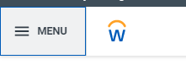
- Select the Purchases application.
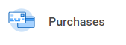
  - Note: When completing this process for the first time and the Purchases application does not display, select Add Apps then search for Purchases and select the + icon. Then select Back to Menu.
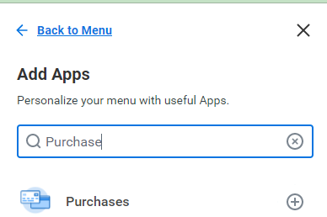

- Under the Actions section, select Connect to Supplier Website.
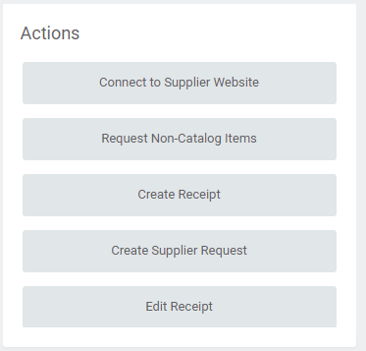

- On the Connect to Supplier Website page, all the fields will pre-populate based on your Workday account details. Worktags will pre-populate based on your Workday account details. The Cost Center and Additional Worktags will auto-populate with your default Cost Center.
- If you need to charge to a different account, add the appropriate Driver Worktag – Program, Gift, Grant, or Cost Center, which will populate other required Worktags in the Additional Worktags field.
- Do not adjust Additional Worktags.
- Select OK to take you to the next page.

- On the Connect to Supplier Website page, find the Supplier (Amazon or Staples) and select Connect in the far right of the screen, to connect to that Supplier Website.
  - Note: Connection to the CDW site is restricted to ITS employees only. Please contact the ITS department for any CDW purchase needs.
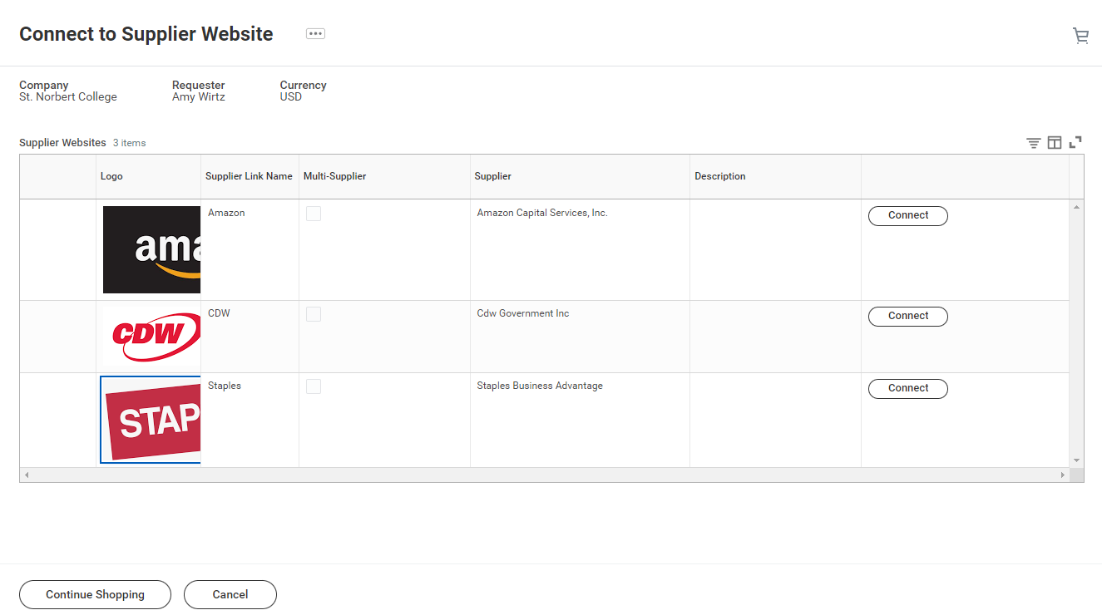

- A small window may display while you are connected to the Supplier Website.

- Once connected to the supplier website, complete the Steps for Amazon or Steps for Staples below.

Steps for Amazon
- If this is your first time connecting to Amazon from Workday, you will be directed to one of the following pages within Amazon. These pages should not display after your initial connection.
  - If you are directed to the Welcome to Amazon Business page, enter your full name and select Start shopping. 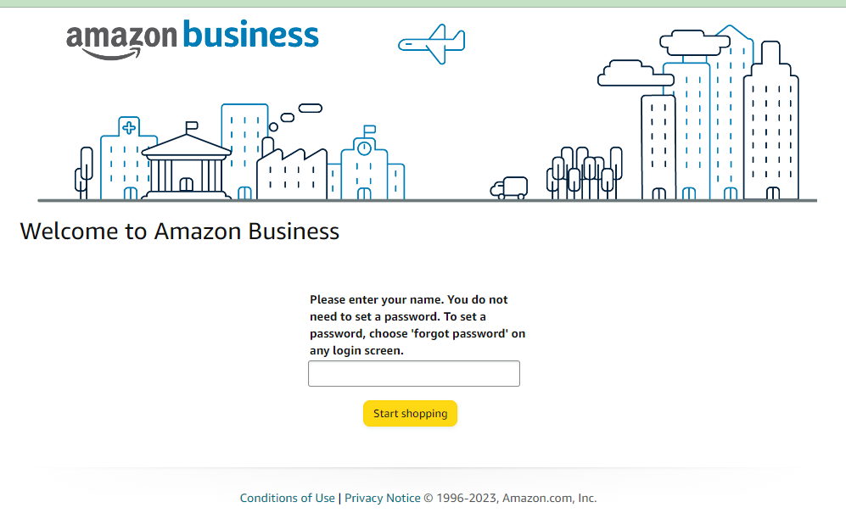

  - If the Sign in to join Amazon Business page displays with your SNC email address, you will need to complete the steps in the Amazon Personal Account - Change Account Settings job aid first.
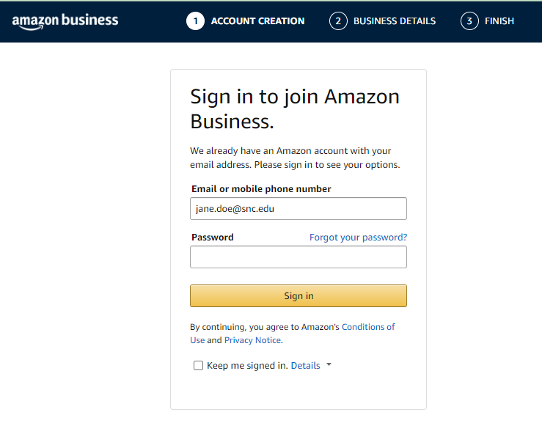

- Once on the Amazon Business home page, find your item and select Add to Cart. Repeat for additional items.
  - Note: SNC’s Amazon Business Prime account includes free two-day shipping on over 100 million items. Free One-Day or Free Same-Day Delivery may also be available for eligible orders.
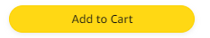

- Once you are ready, select Go to Cart to review your Cart. Adjust any item details as needed (Quantity, Delete).
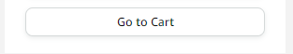

- Once you are ready, select Go to Cart to review your Cart. Adjust any item details as needed (Quantity, Delete) then select Proceed to checkout.
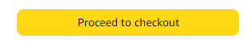
- On the Checkout page, for 3- Choose a Shipping address:
  - In the Deliver To: field, enter the recipient’s full name.
  - Select Use this address.
- Note: All orders are set to a default shipping address for the SNC mail center. Suppliers will not deliver directly to individual offices.

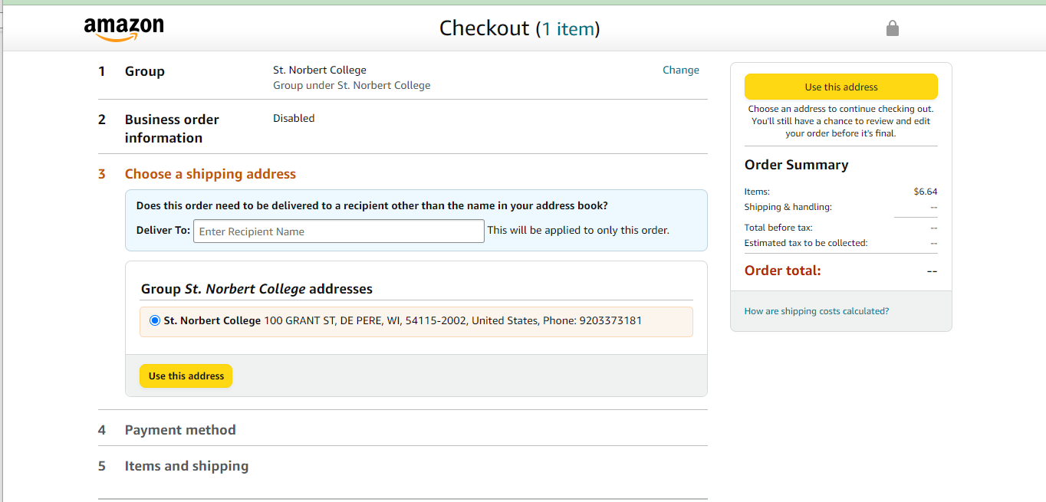

- On the checkout page, for 4- Choose a payment method, select Use this payment method.
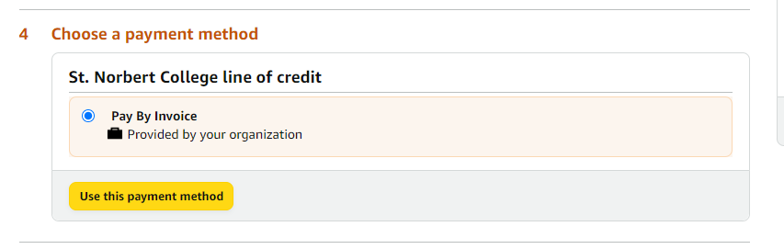

- On the checkout page, for 5- Review items and shipping, select Qty to update or delete the item count. You can also Choose your Prime delivery option.
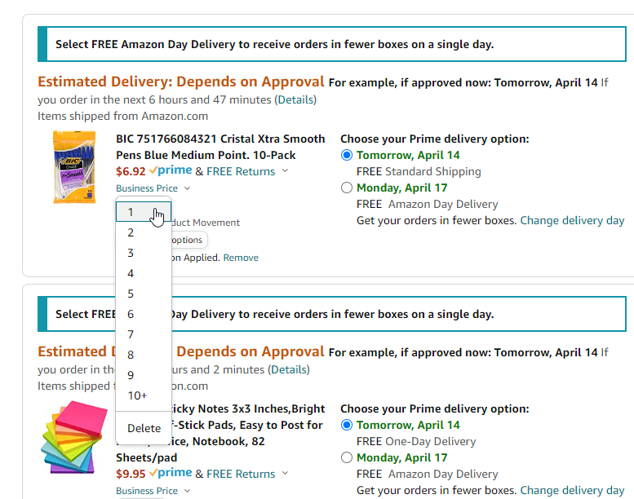

- Once all your cart details are correct, select Submit order for approval to copy your cart details into Workday. You may see a waiting screen momentarily. Once you are back in Workday, continue with the Steps for Workday Checkout below.

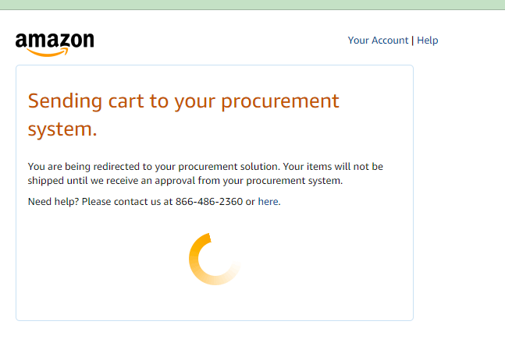

Steps for Staples Checkout
- Enter the Delivery ZIP Code and select Continue.
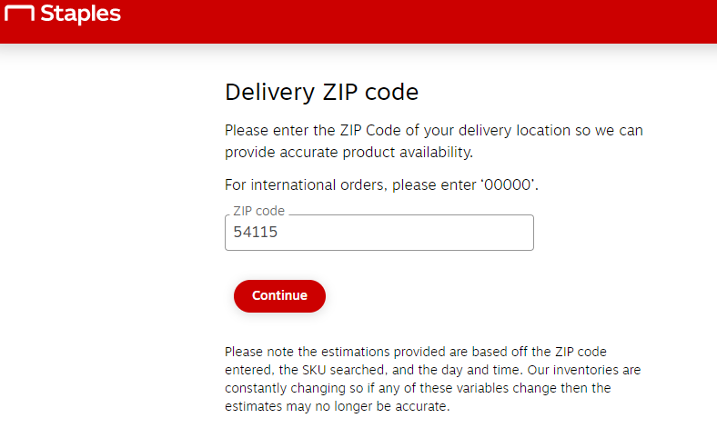

- Find your item and select Add.
  - Note: Select On Contract items from Staples when possible.

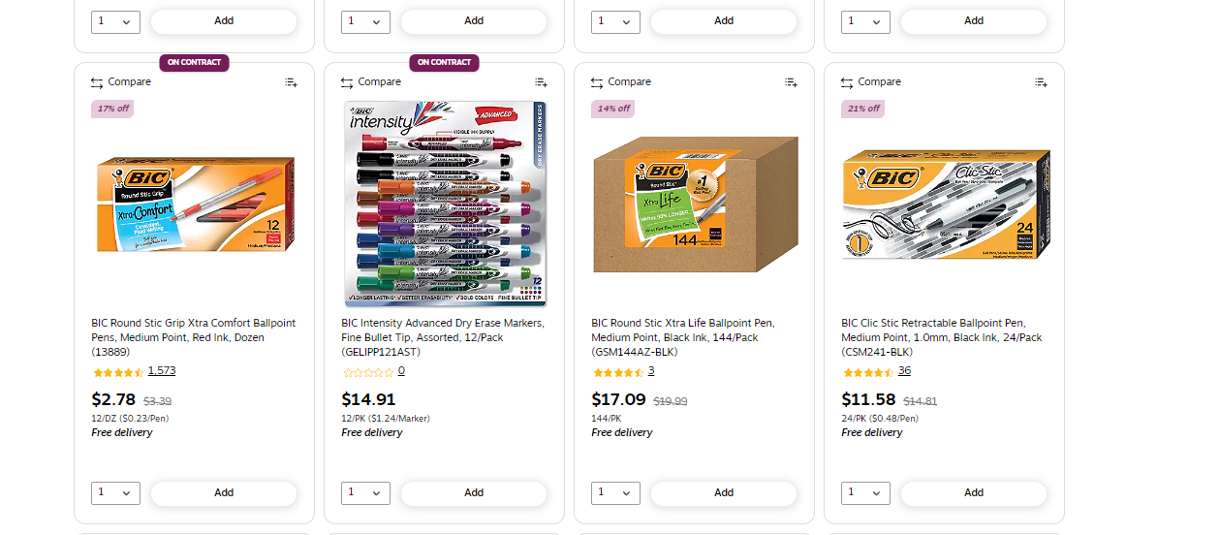
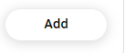

- Select Continue shopping to continue adding items to your Staples cart. Otherwise, select Review & Checkout.
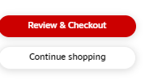

- On the Review and Checkout page, update the Quantity or Remove any item as needed.
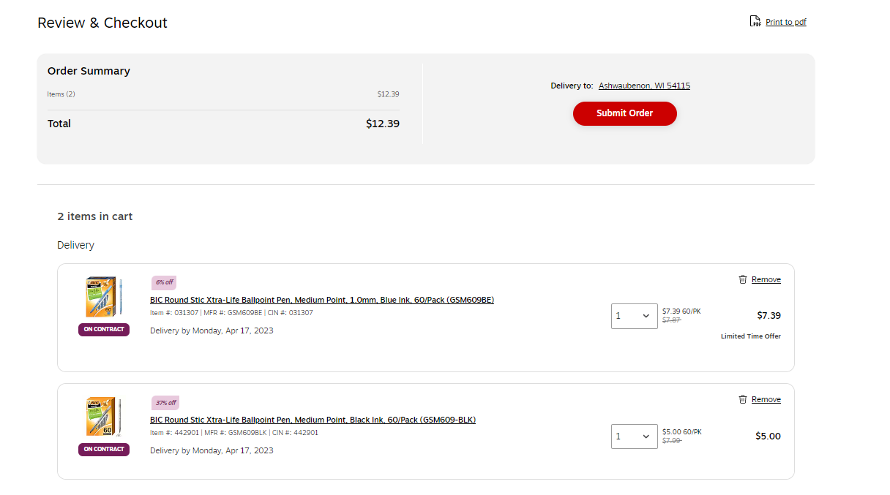
- Once all your cart details are correct, select Submit Order. This copies your cart details into Workday. Continue with the Steps for Workday Checkout below.

Steps for Workday Checkout
- Once your cart details are copied from the Supplier Website into Workday, you are taken to the View Cart page. At the bottom of this page, select Checkout.
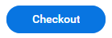
- On the Checkout page, review all the details that have been pre-populated. Select Submit. This then routes the Requisition for approvals.
- Note: If you receive an Error message that a Spend Category was not included for any of your items, enter or search for the appropriate Spend Category. Then select Submit.
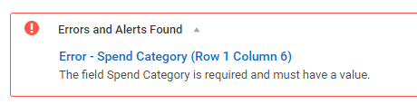
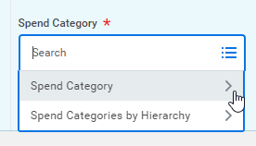

- You will receive emails to your SNC email address directly from the Supplier:
  - For Amazon: You will receive two emails:
    - The first email is sent once the order has been placed (this occurs immediately and automatically after the final approver has approved the transaction).
    - The second email is sent when your order has been shipped; the email will include tracking information.
  - For Staples: You will receive one email with your order confirmation. A shipping confirmation will not be sent from Staples. However, you can repeat the steps above to connect to Staples to open order history and view the order status.

- Once you receive your order from the Supplier, follow the Steps for Receipt in Workday below.

Steps for Receipt in Workday - A Workday receipt is needed to ensure the supplier is paid and that the purchase is reflected on your SNC budget. You are encouraged to complete these steps in Workday once all of your items have been received (i.e. If your order shipped in multiple packages, complete this process once all packages are received).

- From the Workday Landing Page, select View All Apps.
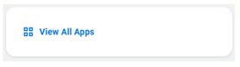
- Select the Purchases application.
- Under the Actions section, select Create Receipt.
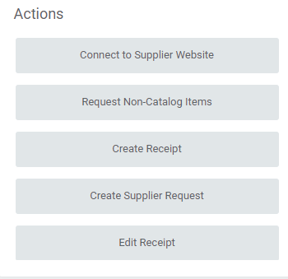

- The Create Receipt window will pop-up. In this window, you will need to complete the steps to select the Purchase Order that relates to the order of goods/services that you have received.
  - Document Number: Select Most Recent Documents in the menu and select the correct Purchase Order.
    - Note: This menu will display all Issued Purchase Orders where you are the Requester. If multiple Purchase Orders display, select the … Related Actions button and view the details (line items, amounts, date, etc.) to find the correct Purchase Order.
  - Fully Receive: OK to leave the field unchecked in this window. More details on this in the steps below.
  - Select OK.
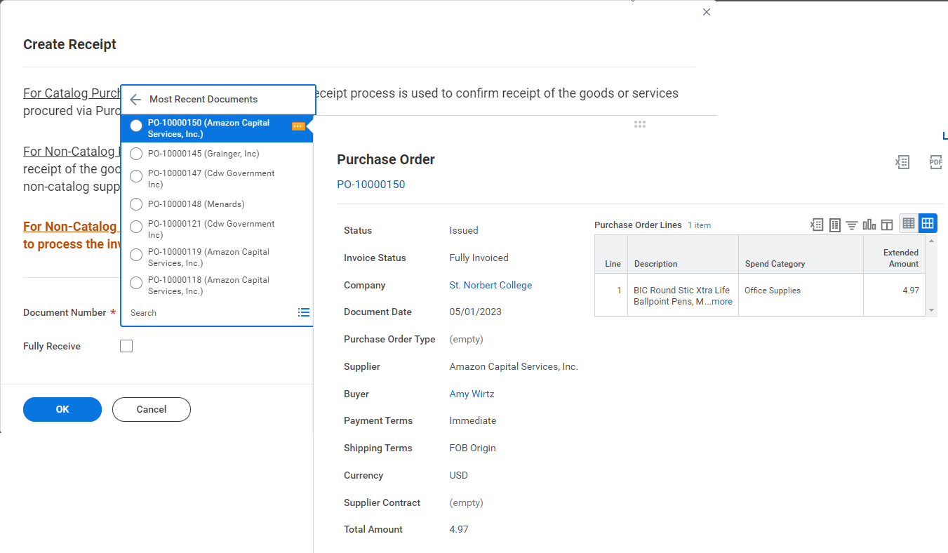

- On the Create Receipt page, each purchased Good will display on the Lines tab. Complete the following steps for each line item:
  - Quantity to Receive : Enter the amount received.
  - Fully Receive: Select the checkbox if you received the full quantity that was ordered.
    - Example: If you ordered 4 bulletin boards and received all, enter 4 and select the the Fully Receive checkbox.
    - Example: If you ordered 4 bulletin boards and only received 3, enter 3 and do not select the the Fully Receive checkbox.
  - Memo: Optional. If you did not select the Fully Receive checkbox above, enter the details here (e.g. missing or incorrect items)
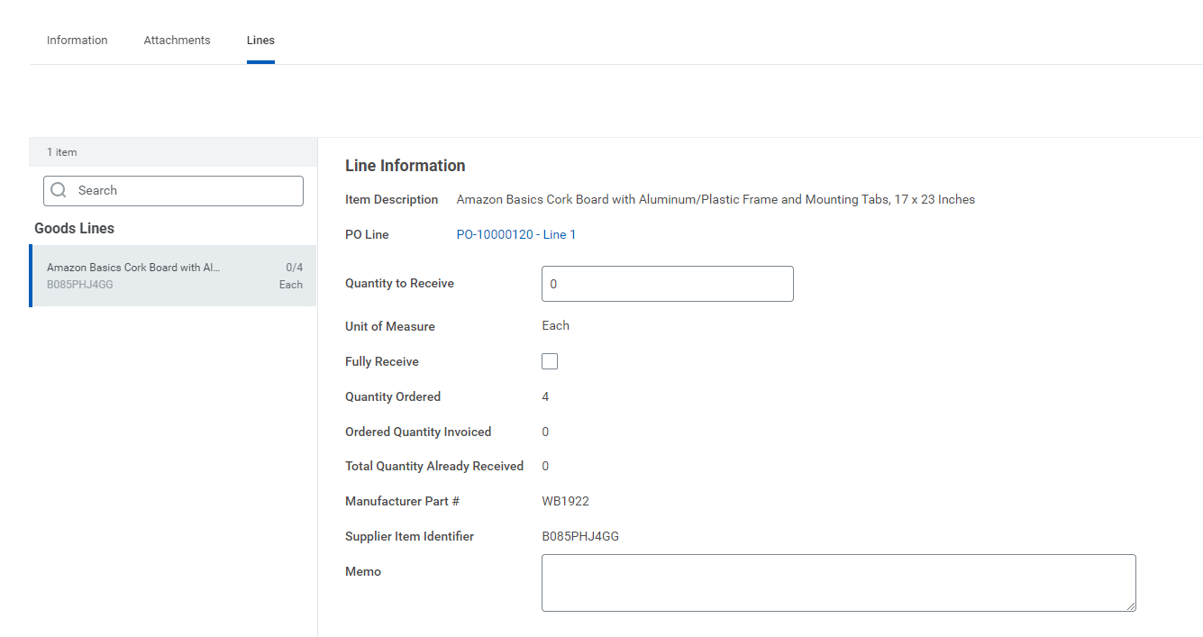

- Select Submit. This step informs the Accounting Department that you have received the item(s). The supplier is paid once your entire Purchase Order is in a Fully Received status.
  - Note: If you receive errors that prevent you from submitting the process, you must address the error messages first. Select Submit once all errors above have been addressed.
