Create Supplier Invoice Request

Overview
This job aid will outline how employees initiate a request in Workday to pay a supplier invoice for most goods or services under $5,000. Before you start this process in Workday, please be sure to obtain a copy of the supplier invoice as many of the details on that document will need to be entered into Workday. Contact Accounting Services if you cannot obtain an invoice from the supplier. See this folder for additional Workday Finance reference materials including Worktag mappings and categories.

Note: If you are purchasing a good or service from Amazon or Staples, see the Create Requisition and Receipt – Connect to Supplier Website (Punchout) job aid.

Security Role(s): Employee as Self

- From the Workday Landing Page, search for and select the Create Supplier Invoice Request task.
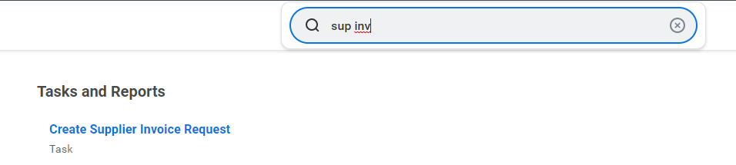

- On the Connect to Supplier Website page, you will notice two sections at the top of the page with several fields beneath them – Primary Information and Additional Information.
- In the Primary Information section, ensure all fields marked with a (red asterisk ) are populated
  - Invoice Date: If today’s date populates in this field, replace the date with the actual Invoice Date printed on your supplier invoice.
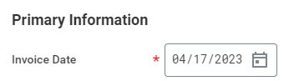
  - Company: Defaults to St. Norbert College. Do not update.
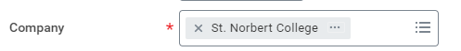
  - Supplier: Enter or use the menu to search for the Supplier.
Note: If the Supplier does not display in this menu, select Cancel at the bottom of the page and complete the steps in the Create Supplier Request job aid, first.

  - Currency: Defaults to USD once the Supplier is selected. Do not update.
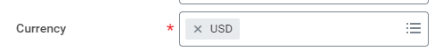
  - Control Amount: Optional. Enter an amount if you know what the total invoice is and you want to ensure that the computed Total Invoice Amount matches your expectation. Otherwise, OK to leave blank.
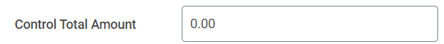
  - Supplier’s Invoice Number: Enter the reference number on the invoice document you received from the Supplier.

- In the Additional Information section, certain fields may prepopulate based on the Supplier selected. Do not update any data in this section.
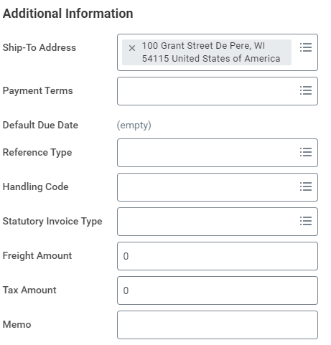

- In the Lines tab, populate details from the Supplier Invoice into the following Workday fields:

  - Item Description: Enter the Item Name

  - Spend Category: Enter or search for the appropriate Spend Category.
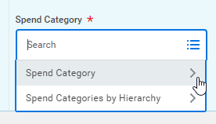

  - Quantity, Unit of Measure, Unit Cost: Enter and select what is most relevant. Workday will utilize information from these fields to pre-populate the Extended Amount field.
- For example: If you enter 10 Cases (Quantity, Unit of Measure) at 10 Unit Cost, then Workday will auto-calculate the the Extended Amount = 100.
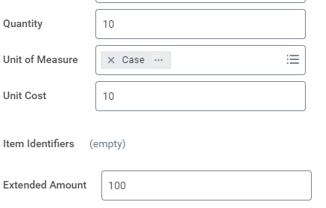

- Note: If unsure of the correct details to populate, for Unit of Measure, select Each and enter the Quantity and Unit Cost accordingly to populate the Extended Amount.
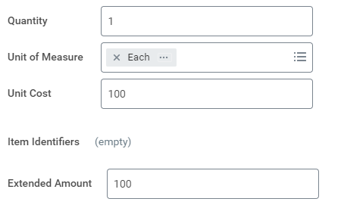

  - Enter or select the appropriate driver worktag, either Cost Center, Program, Gift, or Grant.
    - Note: For this process, a driver and additional worktags do not auto-populate based on your Workday account details.
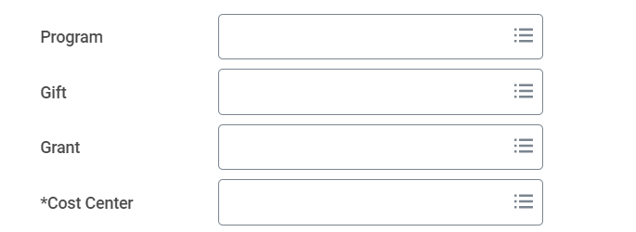
  - Additional Worktags will auto-populate based on the driver Worktag. Do not adjust the Additional Worktags.
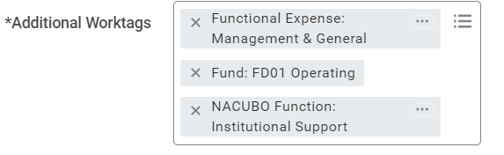
  - Memo: Enter the business purpose for the purchase.
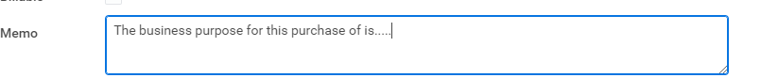

  - If you have additional line items to add from the invoice, scroll up until you see the Lines tab and select the +Add Icon. Then repeat the above steps to enter details for the additional line(s).
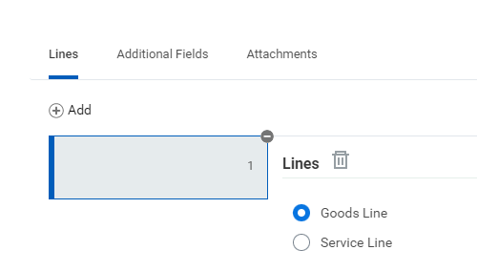

- In the Attachments tab, attach a copy of the supplier invoice.

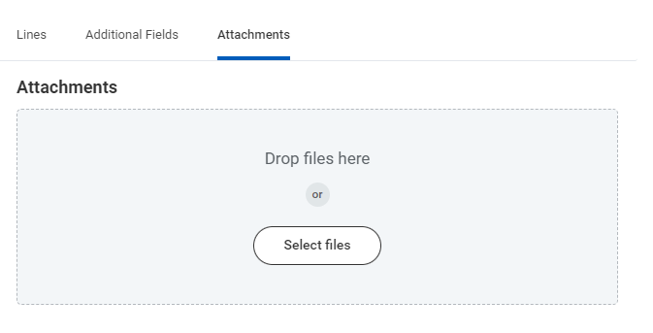

- Select Submit. This request then routes to your Manager and the Cost Center Manager for approval. Once all approvals are complete, the process will be routed to Accounting Services for payment.
- Note: If you receive errors that prevent you from submitting the process, you must address the error messages first. Select Submit once all errors above have been addressed.

