Create Supplier Request

Overview
A Supplier is any provider that sells goods or services to SNC (previously known as “vendor” in Banner).
This job aid will outline how to request that a new Supplier be added to Workday.

The most common use cases to complete this process are if you are entering a Non-Catalog Requisition or Supplier Invoice Request in Workday and the Supplier is not available to select in the menu.

Security Role(s): Employee as Self

- From the Workday Landing Page, select Menu.
- Select the Purchases application.
- Under the Actions section, select Create Supplier Request.
  - Note: If you do not initially see the task, select More.
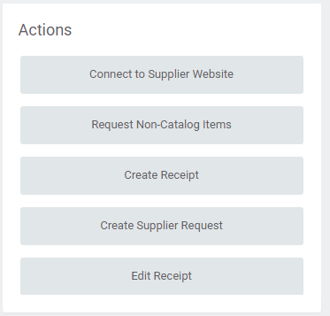

- In the Create Supplier Request window, enter the following information:
  - Supplier Name: Enter the full name of the supplier (no acronyms or abbreviations).
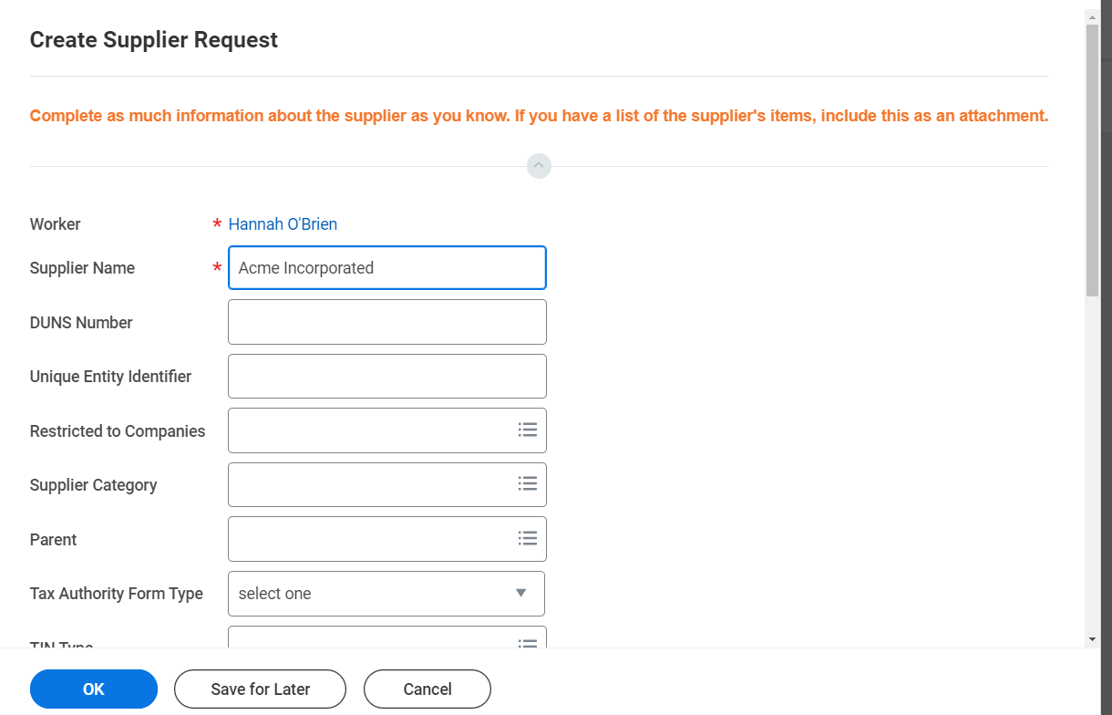

  - For all other fields, enter as much information about the supplier as you know.
  - Select the Attachments tab and upload a W-9 and any supporting information you may have about the Supplier.
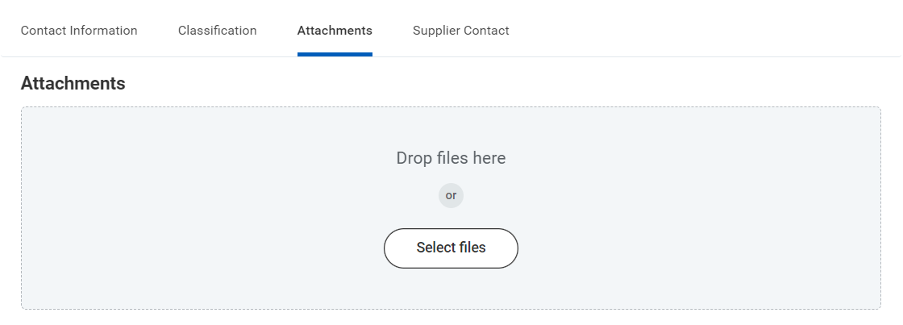

- Select OK. This then routes the request to the Accounting Services Department for review and processing. This may take a few days. Once the request is completed, you will receive a Workday notification and can then select the new Supplier in Workday for any Purchases transactions.

