Amazon Business Institutional Account Administrator– Deregister Account

Overview
This job aid is for Administrators of an existing SNC Institutional account with Amazon. With the rollout of Workday Financials any employee can initiate purchases using SNC’s primary Amazon Business Account via the Connect to Supplier Website functionality.

As part of the Workday Financials rollout, all existing SNC Institutional accounts with Amazon should be de-registered via the steps outlined in this job aid. Note: Only Administrators of the existing Institutional accounts can complete these steps. Individual staff members nor SNC’s Accounting Services Department have the ability to complete these steps.

Security Role(s): Administrators of Institutional Amazon accounts created prior to the rollout of Workday Financials

- Navigate to www.business.Amazon.com, enter your credentials and and select Sign in.
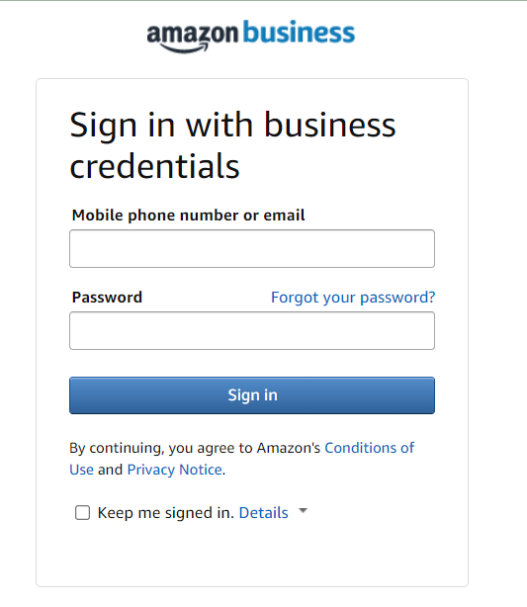
- Hover over Hello in the top right corner and select Business Settings from the drop down.
- On the next page, in the Members section, select People.
- Next to each person’s name, select Actions and Remove from group, to remove all end users from the account.
- Once you as the Administrator are the last person on the account, use the following link to deregister the account: https://amazon.com/gp/b2b/manage/deregister
- On this page, select Close Your Amazon Account.
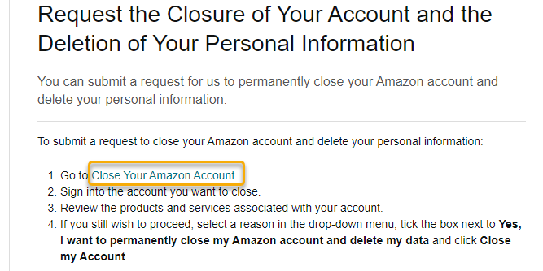

- On the Close your account page, select Continue.
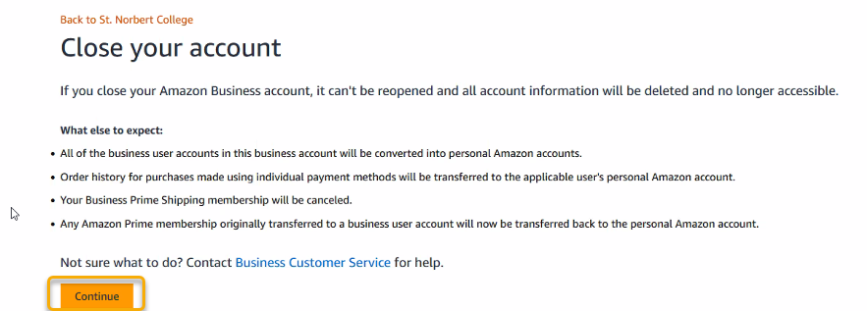
- In the next screen, enter your username and password again and select Sign In.
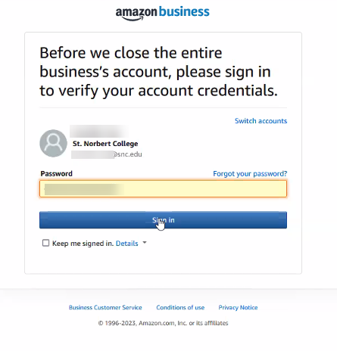
- In the Reason for closing page, select Joining another business account and select Continue.
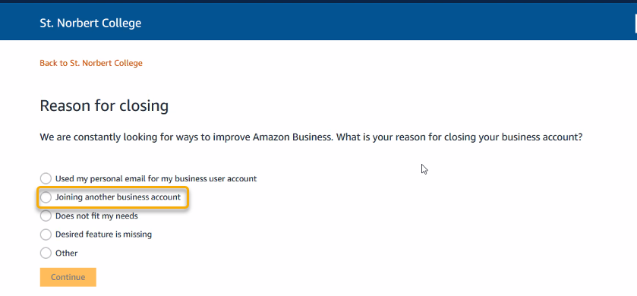
- Select Yes, close this account.
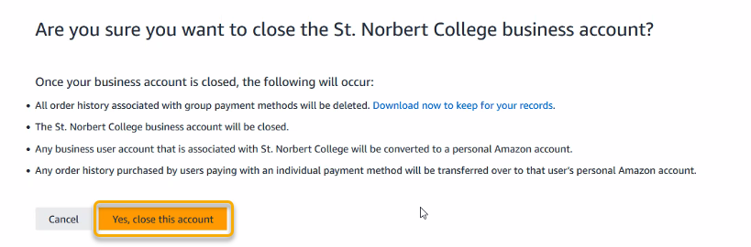
- You have successfully closed the business account once you see this screen and can close your browser.
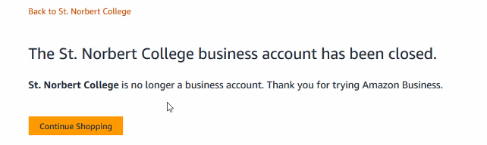
- Now, follow the SNC Job Aid - Create Requisition and Receipt – Connect to Supplier Website (Punchout to Amazon or Staples) up to the Steps for Amazon portion.
- After entering your name, you will need to merge your accounts. Select St. Norbert College’s business shopping only and select Next.
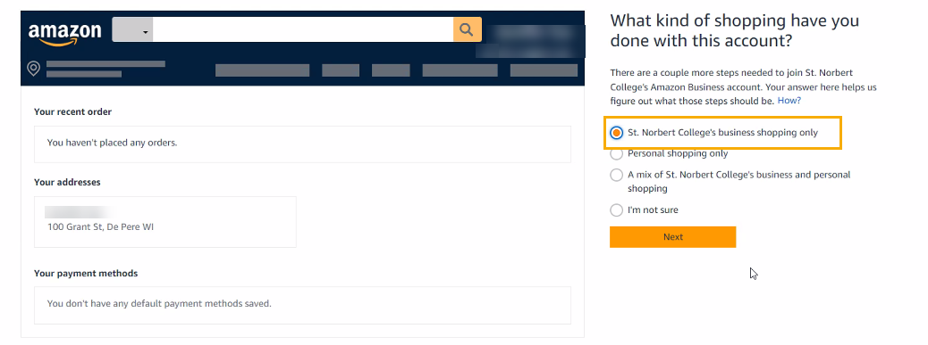
- Select Yes, add to my organization’s shared account and select Next.
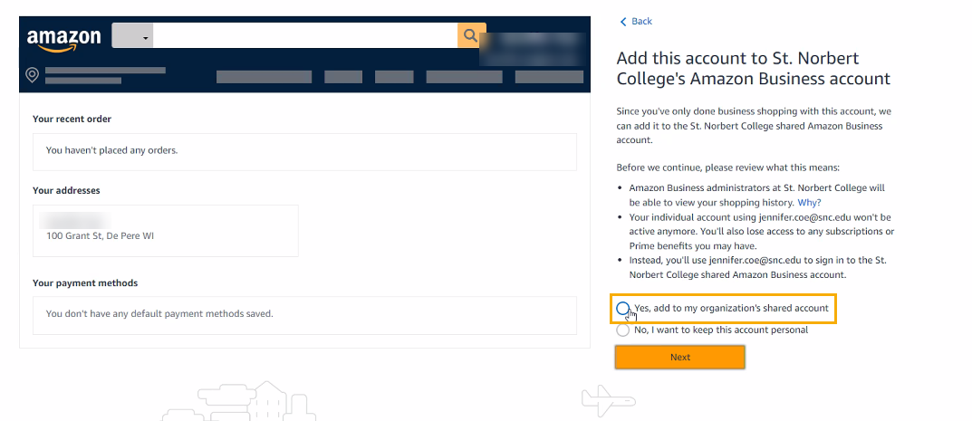
- Select Start using Amazon Business
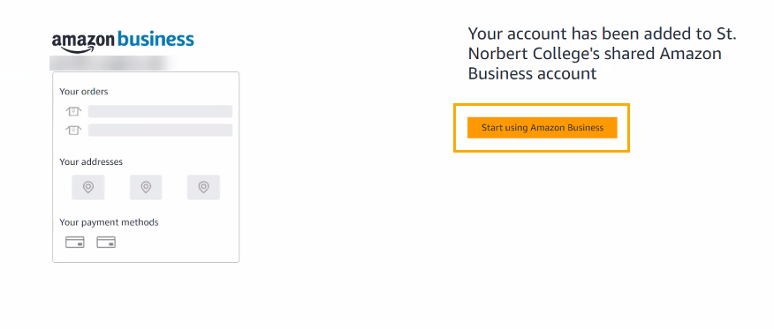
- Return to the SNC Job Aid - Create Requisition and Receipt – Connect to Supplier Website (Punchout to Amazon or Staples) and continue from the Steps for Amazon portion.

