Create Expense Report – SNC Expense Card Reconciliation
Overview
This job aid will outline how employees create and review their own expense report in Workday for a charge on an SNC Expense Card. If you are creating an expense report for a charge on your personal credit card, please see the job aid: Create Expense Report – Personal Reimbursement. The unique steps for completing an Expense Report for an SNC Expense Card Reconciliation are prefixed on page 3 below with [FOR SNC EXPENSE CARD].
See this folder for additional Workday Finance reference materials including Worktag mappings and categories.
Security Role(s): Employee as Self, Delegate
- From the Workday Landing Page, select Menu.
- Select the Expenses application.
  - Note: When completing this process for the first time and the Expenses application does not display, select Add Apps then search for Expenses and select the + icon. Then select Back to Menu.
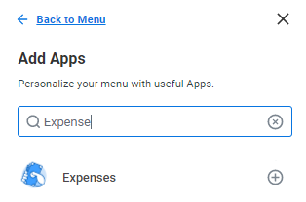

- Under the Actions section, select Create Expense Report.
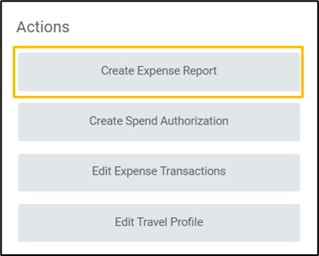

- On the Create Expense Report page, in the Expense Report Information section:
  - Expense Report For: Your name will automatically populate.
  - Creation Options: You may create a new expense report or copy from a previous expense report. When copying from a previous expense report, expense lines from those transactions will automatically populate.
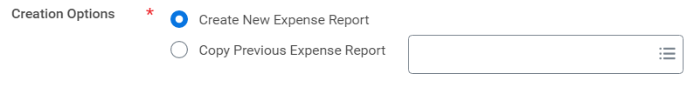
  - Memo: Enter the business purpose for the expense, which states why the expense was needed.
  - Company: Do not update. Prepopulates to St. Norbert College
  - Expense Report Date: Do not update. Defaults to today’s date, which is the date you are creating the expense report.
- Worktags will pre-populate based on your Workday account details. The Cost Center and Additional Worktags will auto-populate with your default Cost Center.
  - If you need to charge to a different account, add the appropriate Driver Worktag – Program, Gift, Grant, or Cost Center, which will populate other required Worktags in the Additional Worktags field.
- Do not adjust Additional Worktags.
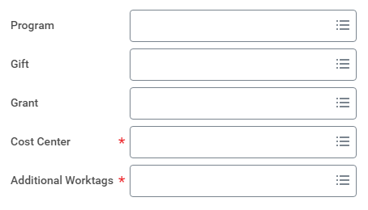

- [FOR SNC EXPENSE CARD] In the Credit Card Transactions section, select the check box of each transaction you want to reconcile. Some details will automatically be loaded into the expense report. You may also use the Select All check box to add all unreconciled transactions.
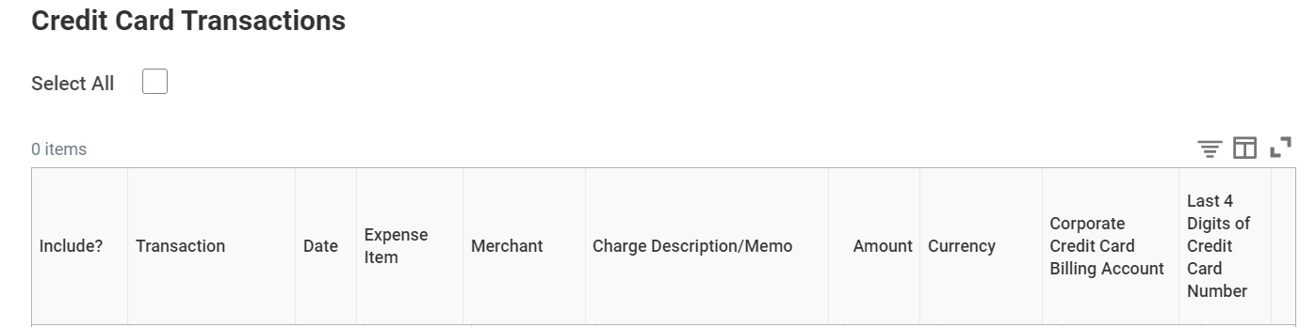

- Select OK to take you to the next screen where you will update the Expense Lines.

- At the top of the next screen, you will see three tabs: Header, Attachments and Expense Lines.
- The Header Tab contains information entered on the first screen. You can edit any of the information listed by selecting Edit.
- The Attachments Tab is where you upload supporting documents (such as receipts or emails) that may be required. Documents can also be attached to each expense line. Attachments may be uploaded to an expense report through the Workday mobile application.
- The Expense Lines Tab is where you enter information for reimbursable and non-reimbursable expenses.

- [FOR SNC EXPENSE CARD] The Expense Lines will automatically populate with some transaction details including the Charge Description, Date, and Total Amount. You may see a red error message if the Expense Item is not populated.

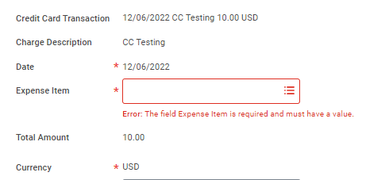

- Expense Item is the classification of the expense that was incurred. Enter the or search for the appropriate Expense Item if this field is blank OR if the pre-populated value is not correct. You can also use the menu to find the appropriate expense item using the spend categories listed.
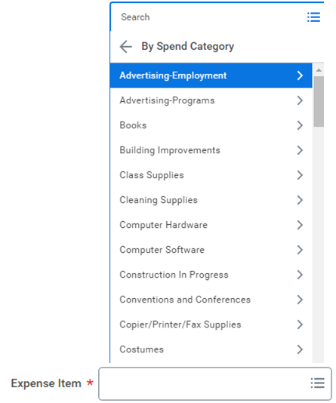

- Some expense items will populate additional fields to complete in the Item Details section. Enter or select values for all fields that populate in this section. Some examples include:
  - If the Expense Item entered = Mileage, then in Item Details, enter Origin Address, Destination Address, and check the Round Trip box if applicable. The Total Amount will auto-calculate based on the applicable Rates Used.
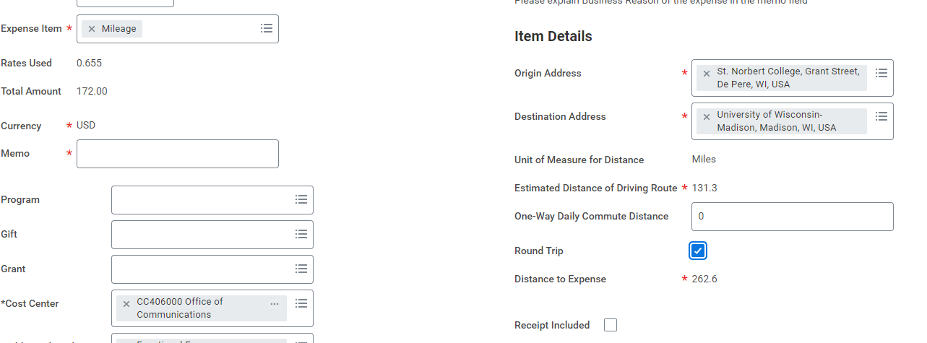

  - If the Expense Item entered = Airfare, then in Item Details, enter Departure Date and Arrival Date.
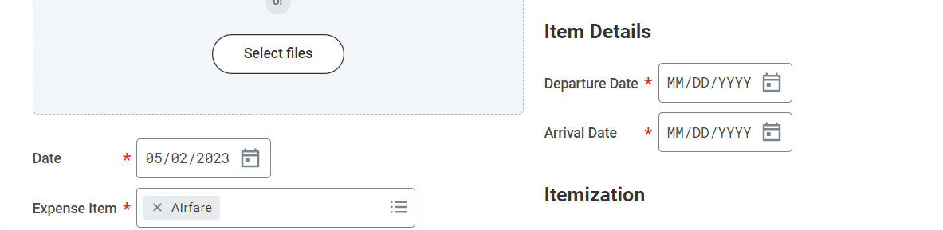

  - If the Expense Item entered = Meals (During Travel), then in Item Details, enter or select the Attendee(s).

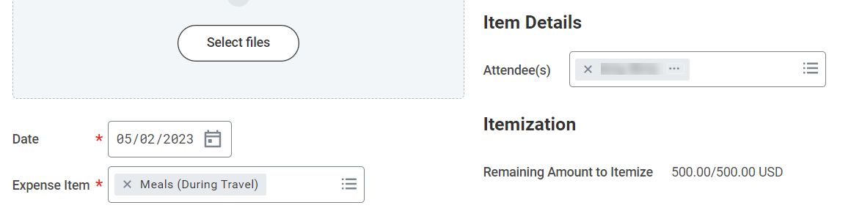

- Enter a Memo that describes the business purpose of your purchase.

- If you did not add a Driver Worktag in the header, enter a driver worktag on the expense line.
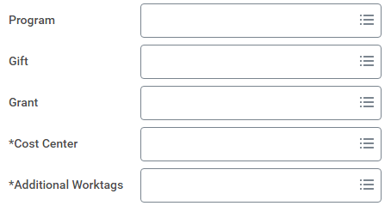
- The Itemization section is used to itemize an expense, such as hotel bill, or split funding for a line across multiple Worktags (refer to the section Itemize an Expense Line below).

- Upload receipts or additional documentation (such as an email) in the Attachments from File section. Receipts are required for any purchases more than $25.
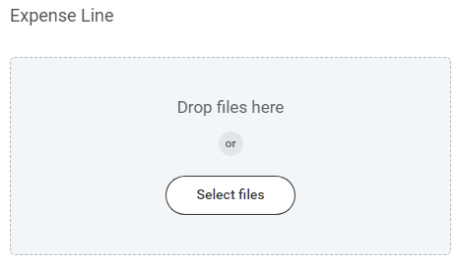

- Check the Receipt Included box if a receipt has been uploaded.
- Additional expense lines can be added by selecting Add at the top of the screen and completing steps 13 through 19 for each item.
- Review the expense line information included in the report. Then select Submit to begin the approval routing process. After you submit, this will send the report for the proper approvals.
  - Note: If you receive errors that prevent you from submitting the process, you must address the error messages first.
    - Select the error band.
    - View the error message(s) and close the window.
    - Address the errors. The red error band will still display.
    - Select Submit. If error messages continue to display, repeat these steps until all errors are resolved.

Itemize an Expense Line
Expense lines may need to be itemized if a single charge includes different expense items. Additionally, itemization allows an expense line to be split across multiple Worktags (Cost Centers or Programs/Gifts/Grant).

- Select Add under Itemize to split out the reimbursement.
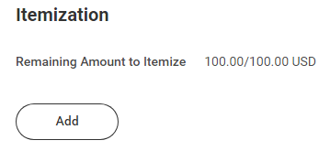

- Information for the expense line will populate in the next window, including the Date, Expense Item, Worktags and additional fields based on Expense Item.
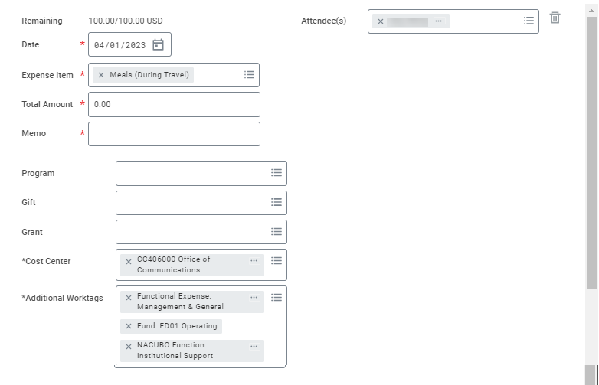

- [FOR SNC EXPENSE CARD] Personal Expense: Select this checkbox only if you have a non-allowable expense that was incurred on your SNC Expense Card. If this box is checked, you will need to issue a check and process through the Bursar Office for repayment to SNC.
- To add a split, scroll to the bottom of the Itemization window and select Add.
- For each split, enter:
  - Total Amount: This is the amount to be allocated to the specified worktags.
  - Memo: Brief business purpose or reason for split
  - Note: The Remaining amount will auto-caluclate as a sum of all total amounts entered. This can be referenced to ensure that the full expense item amount has been fully itemized.
  - Once the Remaining amount is 0.00, select Done.

