Create Receipt Adjustment

Overview
This job aid will outline how an employee can adjust a previously submitted receipt (e.g. The number of items received needs to be updated).

Security Role(s): Employee as Self

- From the Workday Landing Page, search for and select the Create Receipt Adjustment task.
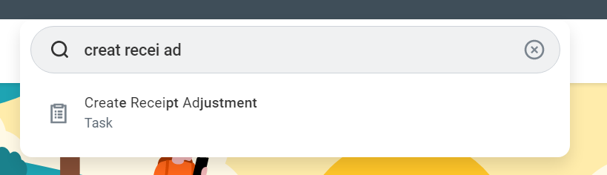

- Select the receipt to adjust. You can type in the receipt number or use the menu to find the receipt by PO or Supplier. If you want to see all available receipts, simply click OK.
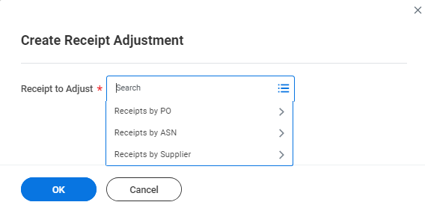

- In the Actual Quantity Received section, enter the correct quantity received.
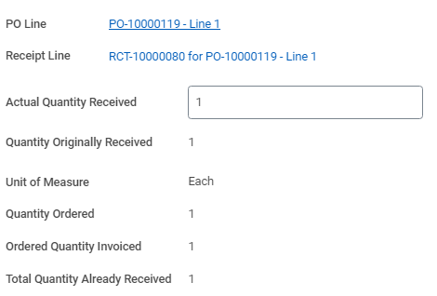

- In the Memo section, enter the reason that you had to make the receipt adjustment.

- Select Submit.
  - Note: If you receive errors that prevent you from submitting the process, you must address the error messages first. Select Submit once all errors above have been addressed.

