Create Requisition and Receipt – Non-Catalog

Overview
This job aid will outline how employees create a Requisition in Workday to request the purchase of goods or services greater than $5,000 from suppliers not available through the Connect to Supplier Website (Punchout) process.

A quote provided by the supplier should be utilized to populate the appropriate good or service details. This job aid also includes the steps to Create Receipt once the good or service has been received. A receipt is needed to ensure the supplier is paid and the purchase is reflected on your SNC budget.

Note: If you are purchasing a good or service from Amazon or Staples, please see the Create Requisition and Receipt – Connect to Supplier Website (Punchout) job aid. If you are purchasing a good or service less than $5,000 and can obtain a supplier invoice, please see the Create Supplier Invoice Request job aid. Contact Accounting Services with any questions. See this folder for additional Workday Finance reference materials including Worktag mappings and categories.

Security Role(s): Employee as Self, Delegate

- From the Workday Landing Page, select Menu.
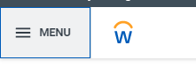
- Select the Purchases application.
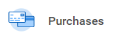
  - Note: When completing this process for the first time and the Purchases application does not display, select Add Apps then search for the Purchases App and select the + icon. Then select Back to Menu.
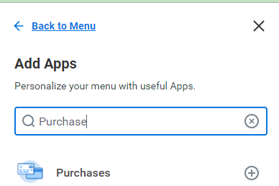

- Under the Actions section, select Request Non-Catalog Items.
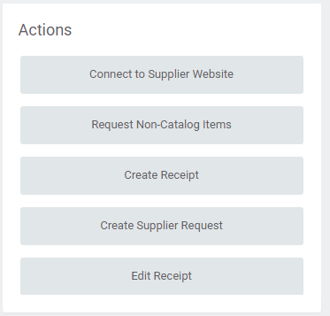

- On the Request Non-Catalog Items page, all the fields will pre-populate based on your Workday account details.
  - Do not update the following fields:
    - Requester: Do not update the pre-populated value.
    - Company: Do not update the pre-populated value.
    - Currency: Do not update the pre-populated value.
    - Requisition Type: Leave blank
    - Deliver-to: Do not update the pre-populated value.
    - Ship-To: Do not update the pre-populated value.
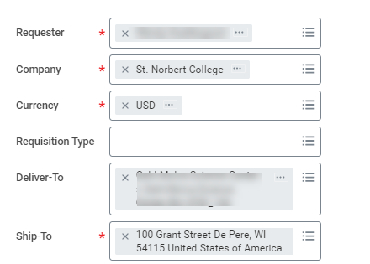

  - Worktags will pre-populate based on your Workday account details. The Cost Center and Additional Worktags will auto-populate with your default Cost Center.
    - If you need to charge to a different account, add the appropriate Driver Worktag – Program, Gift, Grant, or Cost Center, which will auto-populate other required Worktags in the Additional Worktags field.
    - Do not adjust Additional Worktags.
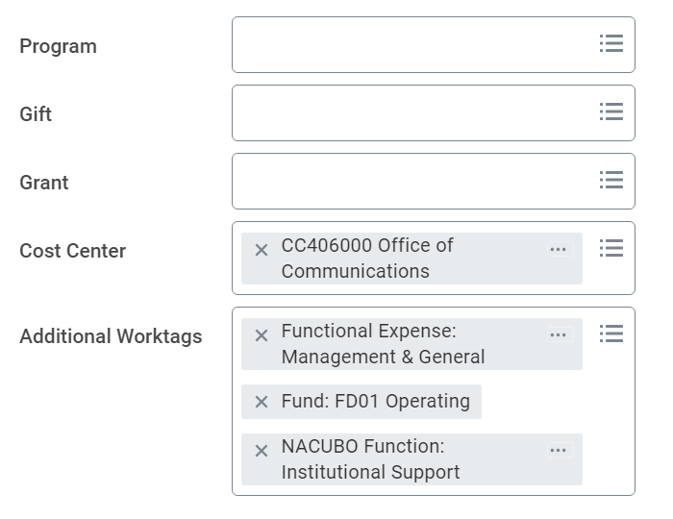

- Select OK to take you to the next page.

- Non-Catalog Request Type Select Request Goods or Request Services to add a line item to the Requisition. The line items entered in Workday should match the line items on the Supplier quote you are referencing.

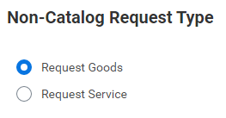

- If Request Goods was selected enter the Goods Request Details using the quote provided by the supplier:
  - Item Description: Enter the product name and details
  - Spend Category: Enter or search for the appropriate Spend Category.
  - Supplier: Enter or use the menu to search for the Supplier.
    - Note: If the Supplier does not display in this menu, select Cancel at the bottom of the page and complete the steps in the Create Supplier Request job aid first.

  - Quantity, Unit Cost, Unit of Measure,: Enter and select what is most relevant. Workday will utilize information from these fields to pre-populate the Extended Amount field.
- For example: If you enter 10 Cases (Quantity, Unit of Measure) at 10 Unit Cost, then Workday will auto-calculate the the Extended Amount = 100.
- Note: If unsure of the correct details to populate, for Unit of Measure, select Each and enter the Quantity and Unit Cost accordingly to populate the Extended Amount.
  - Memo: Enter the business purpose for the purchase 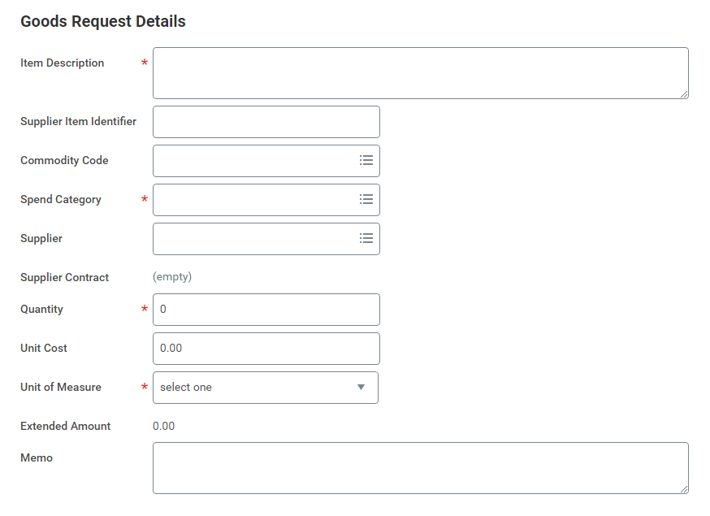

- If Request Service was selected, enter the Goods Request Details using the quote provided by the supplier:
  - Description: Enter a short description of the service
    - Enter or search for the appropriate Spend Category.
    - Select the Supplier you are requesting for the service
Note: If the Supplier does not display in this menu, select Cancel at the bottom of the page and complete the steps in the Create Supplier Request job aid first.
    - Enter the business purpose for the purchase in the Memo
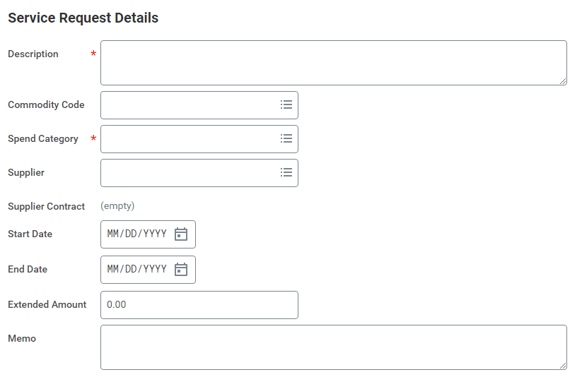
- Select Add to Cart once the request details are populated.
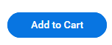

- Repeat the above steps for each additional Request Goods or Request Services

- Once all requests have been added to the cart, select the Cart Icon located at the top right of the page.
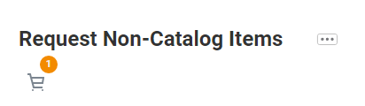

- A pop-up window will display all items in the cart and a Total amount. Select Checkout.

- On the Checkout page:
  - Shipping Address, Requisition Information, Goods, and Services sections will include all previously entered and/or pre populated data. Review the fields and update as needed.
  - Attachments: In thisection, add all quotes/estimates pertaining to the goods and services requested by clicking Select files and uploading the document(s).
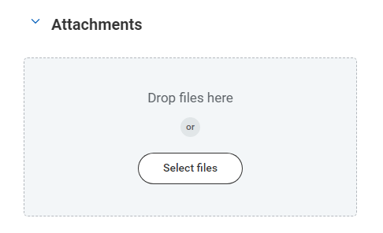

- Confirm the details of each line in the requested good or service. Select Submit. This then routes the Requisition for approvals.
  - Note: If you receive errors that prevent you from submitting the process, you must address the error messages first. Select Submit once all errors above have been addressed.
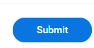

Steps to Download Purchase Order and Send to Supplier -

- You will receive two Workday notifications with your Purchase Order Details. Select the bell icon at the top right of your Workday page to access your Workday Notifications.
- The first notification is sent when the Purchase Order is approved and the second notification sent when the Purchase Order is Ready for Issue.

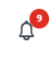

- In the second Workday notification when the Purchase Order has been approved and is ready for issue, select the Purchase Order link to view the details.
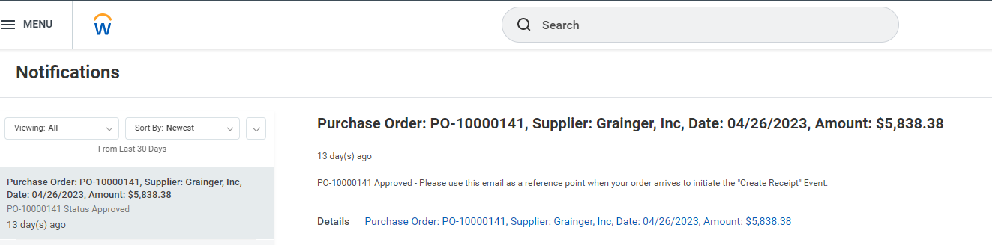

- Scroll down to the bottom of the page to find the Printing Runs section. Select the PDF file to view the generated Purchase Order document.
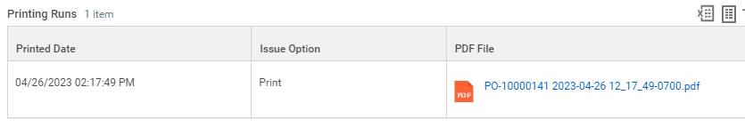

- In the top right of the page, select the arrow icon to Download PDF.

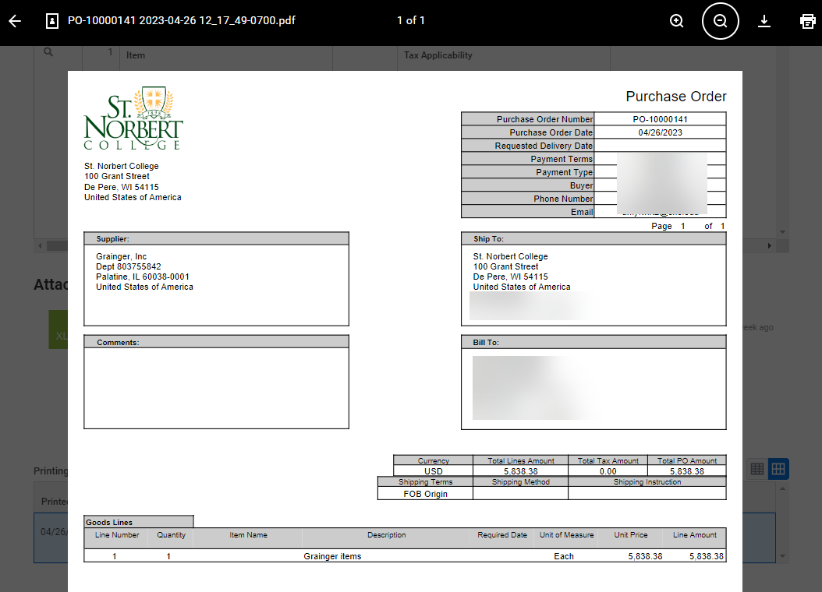
- Another similar window may display again. Select the same arrow icon to choose a file location then select Save.

- Email the PDF of the Purchase Order directly to the supplier.
  - Note: If you do not email the PO to the supplier, you will not receive the good or service requested.

- Once you receive your goods/services from the supplier, follow the Steps for Receipt in Workday below.

Steps for Receipt in Workday - A receipt is needed to ensure the supplier is paid and the purchase is reflected on your SNC budget. You are encouraged to complete these steps in Workday once all of your goods/services have been received (i.e. If your goods shipped in multiple packages, complete this process once all packages are received).

- From the Workday Landing Page, select Menu.

- Select the Purchases application.

- Under the Actions section, select Create Receipt.
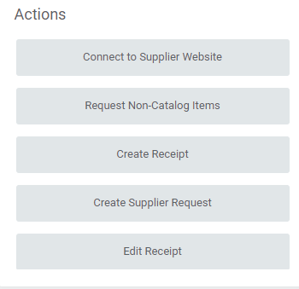

- The Create Receipt window will pop-up. In this window, you will need to complete the steps to select the Purchase Order that relates to the order of goods/services that you have received.
  - Document Number: Select Most Recent Documents in the menu and select the correct Purchase Order.
    - Note: This menu will display all Issued Purchase Orders where you are the Requester. If multiple Purchase Orders display, select the … Related Actions button and view the details (line items, amounts, date, etc.) to find the correct Purchase Order.
  - Fully Receive: OK to leave the field unchecked in this window. More details on this in the steps below.
  - Select OK.
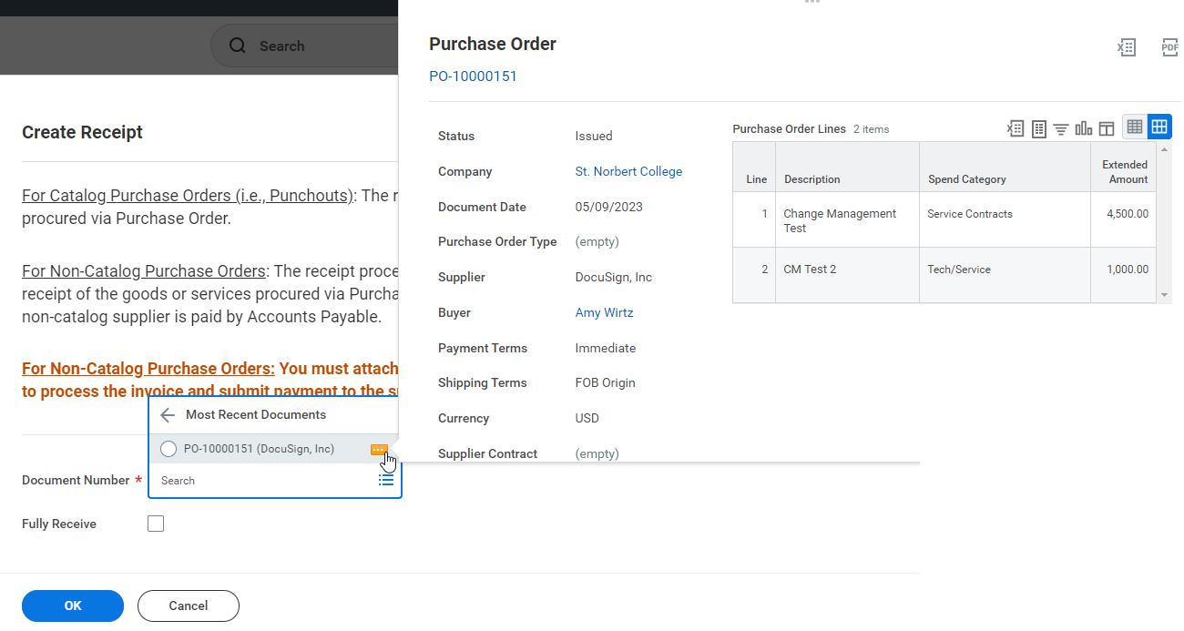

- On the Create Receipt page, each purchased Goods/Service item will display on the Lines tab. Complete the following steps for each line item:
  - Quantity to Receive (for Goods Lines) or Amount to Receive (for Service Lines): Enter the amount received.
  - Fully Receive: Select the checkbox if you received the full quantity that was ordered.
    - Example: If you ordered $4500 worth of services and received that full amount in services, enter $4500 and select the Fully Receive checkbox.
    - Example: If you ordered $4500 worth of services and only received $4,000 in services, enter $4,000 and do not select the Fully Receive checkbox.
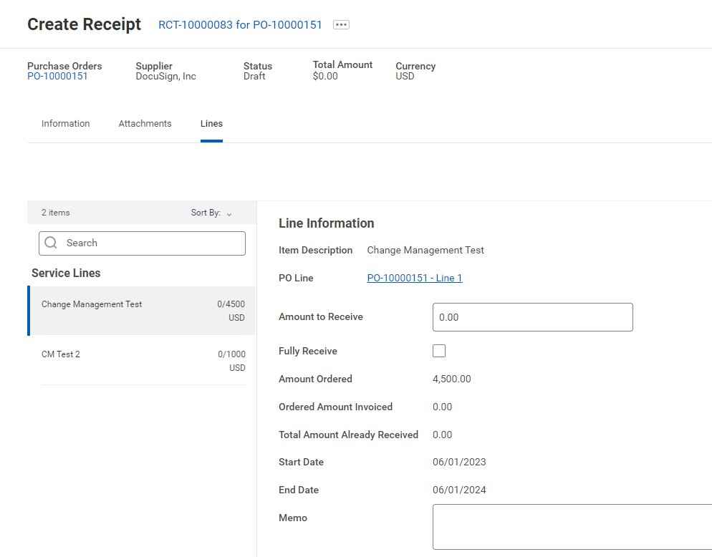

  - Memo: Optional. If you did not select the Fully Receive checkbox above, enter the details here (e.g. missing or incorrect items)

- In the Attachments section, you must attach the supplier invoice in order for the supplier to be paid.
  - Note: If a supplier invoice is not provided, an Error will display and you will not be able to Submit.
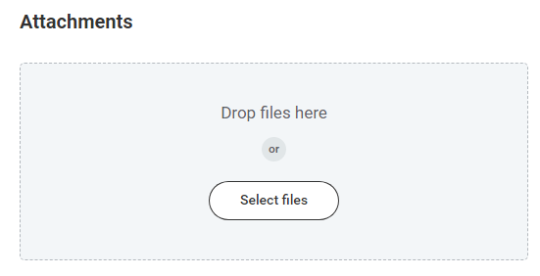

- Select Submit. This step informs the Accounting Department that you have received the item. The supplier is paid once your entire Purchase Order is in a Fully Received status.
  - Note: If you receive errors that prevent you from submitting the process, you must address the error messages first. Select Submit once all errors above have been addressed.

