Amazon Account Tip Sheet

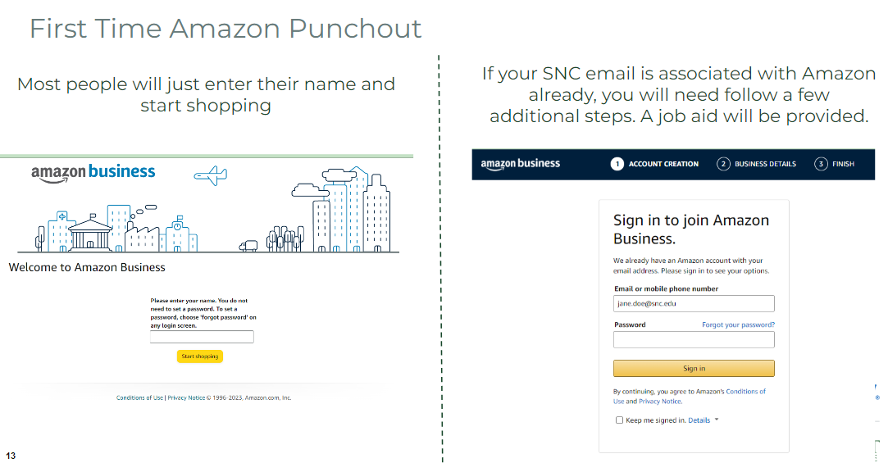
A
B

First time in Amazon Punchout - Which screen did you see?
A
Welcome to Amazon Business – If you got to this screen, enter your Name and select Start Shopping. Follow the steps in the SNC Job Aid - Create Requisition and Receipt – Connect to Supplier Website (Punchout to Amazon or Staples)

B
Sign in to Join Amazon Business - If you got to this screen, and:
- You are an Administrator of an Institutional account that was created in Amazon Business prior to SNC’s Workday Financials rollout, follow the steps in the SNC Job Aid - Amazon Business Institutional Account Administrator– Deregister Account

or

- You are NOT an Administrator of an Institutional Account, follow the steps in the SNC Job Aid - Amazon Personal Account – Change Account Settings

