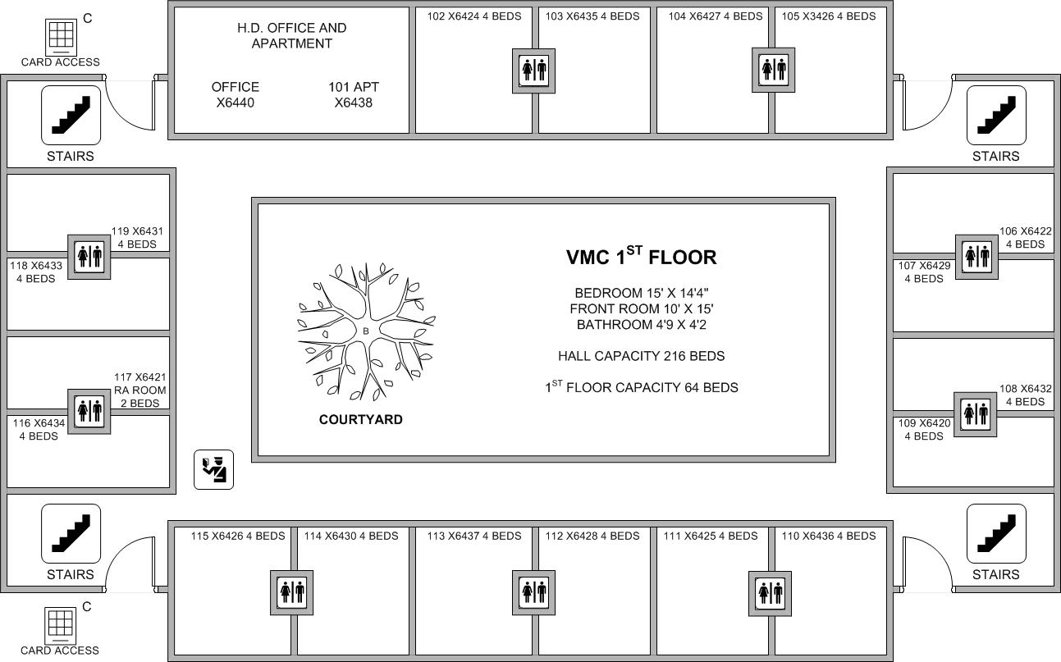

**ALL ROOMS INCLUDE A BATHROOM**

Occupant 1

Occupant 2

Occupant 3

Occupant 4

