Please be aware of some slight changes in your umr.com provider search
We want to make you aware of a slight change you may notice when searching for UnitedHealthcare Choice Plus providers on umr.com. As you know, you will pay less for medical services when you see a preferred provider, sometimes known as in-network providers.

In the past, if you searched for a provider or facility that wasn’t in our Choice Plus network, you likely received a Zero search results message. Now, you may occasionally see the following message:

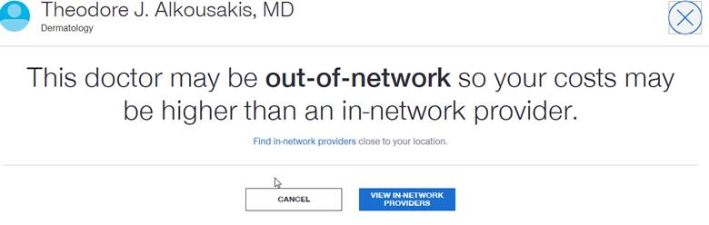

If you receive this message, please select the blue View In-Network Providers option shown above. This will redirect you to a list of providers that have the same specialty, but are in our Choice Plus network, similar to the sample screen below:
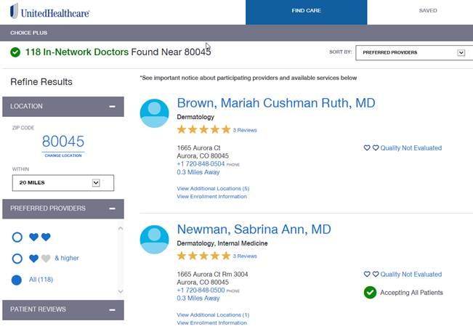

Why this change?
Multiple tests showed that when many members receive the Zero search results message, they believed the online search tool is not working properly and go to Google, a hospital system/provider website or some other website to find a doctor. If that site states that it accepts UnitedHealthcare insurance, they automatically assume the doctor is in their preferred network.

UnitedHealthcare, however, operates multiple networks, so some of those providers may not be part of our particular network.

You may still occasionally see a Zero search results message, but the new out-of-network message is designed to more frequently let you know that the search function is working properly and direct you to providers that are in our network.

If you have any questions, please call the UMR customer service number located on the back your ID card.

