GRAYSTONE CONSULTING 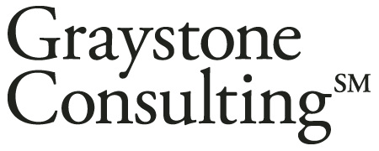

- Graystone Consultant has been contracted to provide retirement counseling services to members on the 403(b) Retirement Plan here at St. Norbert College. Some of the services are:
  - Investment Fund Monitoring
  - Benchmark Plan Fees & Costs
  - On-Site Group Employee Meetings
  - One-on-One Employee Meetings (in-person or on phone)
- Graystone Consulting is a business of Morgan Stanley
- Graystone Consulting is one of the oldest and largest institutional consulting firms in America
- Graystone Consulting consists of 45 teams across the U.S. lead by one or more Institutional Consulting Directors with an average of 20-years of experience.
- Graystone Consulting is committed to:
  - Conflict-free, objective investment advice
  - Open-architecture money management platform
  - Full disclosure and transparency
- Graystone Consulting is a local resource available to participants to provide asset allocation guidance and retirement planning

Our Address:

111 N. Washington St.
Green Bay, WI 54301

Your Contacts:
Becky McCormick Becky.A.Mccormick@msgraystone.com (920) 436-5612
Corey Coonen Corey.Coonen@morganstanley.com (920) 433-6513

Toll Free Number: 833-825-5594

