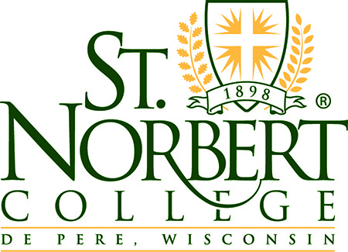

REQUEST FOR CERTIFICATE OF INSURANCE (COI)

Sometimes a vendor, supplier, company, etc. will require St. Norbert College to submit a Certificate of Insurance to them. This form must be completed and submitted to Pat Dart or Dave Nalepka for authorization and processing.

Date of Request: Date Needed By

Requestor Information
Name
Department:
Email Address
Telephone Number: |  | Fax Number:

Certificate Holder Information
Company Name
Address:
City, State, Zip Code:
Attention:
E-mail:
Fax#:
Other Information:
Note: Please attach copy of request from your customer, vendor, supplier, etc., if available

If specific policy coverage and/or limits are being requested, please note below:
Type of Coverage | Place “X” | Note any limit requests ( $)
General Liability:
Auto Liability:
Excess Liability:
Workers Compensation:

*Is St. Norbert College being asked to list the requesting party as an Additional Insured or have any other special Interest requests? (Check all that apply)
Additional Insured: |  | Vendor:
Loss Payee: |  | Other:
Lessor:

*If required to list company, supplier, vendor, etc. as an additional insured, a copy of the contract / agreement MUST be submitted with this Certificate of Insurance Request form.

Please forward request and/or questions to Pat.Dart@snc.edu or Dave.Nalepka@snc.edu

